Duval County Multi-Hazard Mitigation Plan
2020

"Under the Federal Disaster Mitigation Act of 2000 (DMA 2000 or "the Act"), Duval County (County) is required to have a Federal Emergency Management Agency ("FEMA") - approved Local Hazard Mitigation Plan ("the Plan") in order to be eligible for certain pre- and post-disaster mitigation funds. Adoption of this Plan by the County and approval by FEMA will serve the dual objectives of providing direction and guidance on implementing hazard mitigation in the County, and qualify the County to obtain federal assistance for hazard mitigation. Solely to help achieve these objectives, the Plan attempts to systematically identify and address hazards that can affect the County. Nothing in this Plan is intended to be an admission, either expressed or implied, by or on behalf of the County, of any County obligation, responsibility, duty, fault or liability for any particular hazard or hazardous condition, and no such County obligation, responsibility, duty, fault or liability should be inferred or implied from the Plan, except where expressly stated."

Table of Contents
1. Introduction and Background 12
1) Participating Jurisdictions 12
2) Hazard Mitigation Plan History 12
Omission Statements 13
2. Planning Process 15
1) Existing Plans, Reports, Ordinances, and Technical Information Sources 18
2) Project Meetings 20
3) Public Input 20
4) Plan Maintenance 21
5) Plan Monitoring 22
6) Plan Evaluation 23
7) Plan Update 24
3. Determining Risk 25
1) Risk Assessment 25
2) Distribution of Property by Parcel Count and Potential Damage Values 25
3) Distribution of Vulnerable Populations 25
Age, Disability and Income 26
Distribution of Vulnerable Populations 27
Low Income and Subsidized Housing 32
Housing Type and Condition 32
Manufactured / Mobile Homes 32
Homes in Substandard Condition 32
4. Flood 34
1) Flood History 34
City of Benavides 34
City of Freer 35
City of San Diego 35
Duval County 35
Duval County Conservation and Reclamation District 35
Freer Water Control & Improvement District 35
San Diego Municipal Utility District 36
A) National Flood Insurance Program 36
Repetitive Loss Properties 37
Severe Repetitive Loss Properties 37
2) Likelihood of Future Events 38
3) Extent 38
4) Location and Impact 38
A) Location 38
I. Impact 48
5) Vulnerability 49
A) Population 49
B) Critical Facilities 49
C) Vulnerable Parcels 49
5. Hurricane / Tropical Storm 52
1) Hurricanes / Tropical Storms History 52
2) Likelihood of Future Events 53
3) Extent 53
4) Location and Impact 54
A) Location 54
B) Impact 54
5) Vulnerability 54
A) Population 54
B) Critical Infrastructure – US 59, SH 16, SH 44, SH 285, SH 359 55
C) Critical Facilities 55
D) Vulnerable Parcels 59
6. Wildfire 60
1) Wildfire History 60
A) Duval County 60
B) City of Benavides 60
C) City of Freer 61
D) City of San Diego 61
2) Likelihood of Future Events 61
A) Duval County 61
B) City of Benavides 62
C) City of Freer 62
D) City of San Diego 62
E) Freer Water Control and Improvement District 62
F) San Diego Municipal Utility District 62
3) Extent 62
4) Location and Impact 64
A) Location 64
I. Duval County Location 65
II. City of Benavides Location 67
III. City of Freer Location 69
IV. City of San Diego Location 71
V. Freer Water Control and Improvement District Location 72
VI. San Diego Municipal Utility District Location 73
B) Impact 74
5) Vulnerability 74
A) Population 74
B) Critical Facilities 75
C) Vulnerable Parcels 76
7. Tornado 78
1) Tornado History 78
Duval County 78
City of San Diego 78
2) Likelihood of Future Events 79
3) Extent 79
4) Location and Impact 81
A) Location 81
B) Impact 81
5) Vulnerability 81
A) Population 81
B) Critical Facilities and Infrastructure 82
A) Vulnerable Parcels 85
8. Drought 86
1) Drought History 88
2) Likelihood of Future Events 89
3) Extent 89
4) Location and Impact 91
A) Location 91
B) Impact 91
5) Vulnerability 92
A) Population 92
B) Critical Facilities 92
A) Vulnerable Parcels and Infrastructure 96
I. Agricultural Production 97
9. Dam / Levee Failure 98
1) Dam / Levee Failure History 98
2) Likelihood of Future Occurrence 98
3) Extent 98
4) Location and Impact 100
A) Location 100
B) Impact 101
10. Extreme Heat 102
1) Extreme Heat History 102
2) Likelihood of Future Events 103
3) Extent 103
4) Location and Impact 106
A) Location – All Jurisdictions 106
B) Impact – All Jurisdictions 106
5) Vulnerability 106
A) Population 106
B) Critical Facilities 106
11. Hailstorm 107
1) Hailstorm History 107
A) Duval County 107
B) City of Benavides 107
C) City of Freer 107
D) City of San Diego 108
2) Likelihood of Future Events 108
3) Extent 108
4) Location and Impact 109
A) Location 109
B) Impact 110
5) Vulnerability 110
A) Population 110
B) Critical Facilities 110
C) Vulnerable Structures 112
12. Severe Winter Storm 113
1) Severe Winter Storm History 114
2) Likelihood of Future Events 115
3) Extent 115
4) Location and Impact 117
A) Location – All Jurisdictions 117
B) Impact – All Jurisdictions 118
5) Vulnerability 118
13. Windstorm 120
1) Windstorm History 120
A) Duval County 120
B) City of Benavides 120
C) City of Freer 121
D) City of San Diego 121
2) Likelihood of Future Events 121
3) Extent 121
4) Location and Impact 123
A) Location 123
B) Impact 123
5) Vulnerability 123
A) Population 123
B) Critical Facilities 124
C) Vulnerable Parcels 128
14. Lightning 129
1) Lightning History 129
2) Likelihood of Future Events 129
3) Extent 130
4) Location and Impact 131
A) Location 131
B) Impact 131
5) Vulnerability 132
A) Critical Facilities 132
B) Vulnerable Parcels 134
15. Mitigation Strategy 135
1) Capability Assessment 135
2) Goals and Objectives Overview 138
3) Long-term vision 138
4) Goals 138
A) Goal 1: To reduce loss of life and injury to persons 138
B) Goal 2: To reduce disruptions to essential public services and infrastructure 139
C) Goal 3: To reduce economic impacts to individuals, businesses, and area institutions 139
D) Goal 4: To reduce losses to civic, cultural, and environmental resources 139
5) Mitigation Action Plan 140
A) Mitigation Action Prioritization 140
B) Incorporation and Integration of Existing Capabilities and Hazard Mitigation 141
C) Mitigation Actions by Jurisdiction and by Hazard 144
Duval County 145
Multi-Hazard Actions 145
Single-Hazard Actions 148
City of Benavides 153
Multi-Hazard Actions 153
Single-Hazard Actions 156
City of Freer 159
Multi-Hazard Actions 159
Single-Hazard Actions 161
City of San Diego 162
Multi-Hazard Actions 162
Single-Hazard Actions 165
Duval County Conservation and Reclamation District 168
Multi-Hazard Actions 168
Single-Hazard Actions 169
Freer Water Control & Improvement District 170
Multi-Hazard Actions 170
San Diego Municipal Utility District 171
Multi-Hazard Actions 171
Single-Hazard Actions 173

List of Figures
Figure 1: Duval County Vulnerability Index 28
Figure 2: City of Benavides Vulnerability Index 29
Figure 3: City of Freer Vulnerability Index 30
Figure 4: City of San Diego Age Distribution by Census Blockgroup, Under 17 31
Figure 5: Duval County FEMA 100-Year and 500-Year Floodplain 39
Figure 6: City of Benavides FEMA 100-Year and 500-Year Floodplain 40
Figure 7: City of Freer FEMA 100-Year and 500-Year Floodplain 41
Figure 8: City of San Diego FEMA 100-Year and 500-Year Floodplain 42
Figure 9: Census-Designated Place of Concepcion FEMA Special Flood Hazard Areas 44
Figure 10: Census-Designated Place of Realitos FEMA Special Flood Hazard Areas 45
Figure 11: Freer Water Control and Improvement District FEMA Special Flood Hazard Areas 46
Figure 12: San Diego Municipal Utility District FEMA Special Flood Hazard Areas 47
Figure 13: Duval County Wildland Urban Interface 65
Figure 14: Duval County Wildland Urban Interface by Land Use Type 66
Figure 15: City of Benavides Wildland Urban Interface 67
Figure 16: City of Benavides Wildland Urban Interface Land Use 68
Figure 17: City of Freer Wildland Urban Interface 69
Figure 18: City of Freer Wildland Urban Interface by Land Use Type 70
Figure 19: City of San Diego Wildland Urban Interface 71
Figure 20: Freer Water Control and Improvement District Wildland Urban Interface 72
Figure 21: San Diego Municipal Utility District Wildland Urban Interface 73
Figure 22: Sequence of Drought Occurrence and Impacts for Commonly Accepted Drought Types 87
Figure 23: Duval County Drought History 88
Figure 24: Duval County Dam Locations 100
Figure 25: Maximum Recorded Daily Temperature 2000-2018 103
Figure 26: NOAA's NWS Heat Index Chart 104
Figure 27: Minimum Recorded Daily Temperature, 2000-2018 114
Figure 28: NWS Wind Chill Index 117

List of Tables
Table 1: Hazards Addressed 12
Table 2: Local Planning Team Representatives 15
Table 3: Plan Schedule 17
Table 4: Plan Data Sources and Incorporation 18
Table 5: Local Stakeholders Contacted 19
Table 6: Maintenance Responsibility 21
Table 7: Estimated Values by Location 25
Table 8: Vulnerable Populations by Jurisdiction 26
Table 9: City of Benavides Flood History 34
Table 10: City of Freer Flood History 35
Table 11: City of San Diego Flood History 35
Table 12: Duval County Flood History 35
Table 13: NFIP Claims and Payments 37
Table 14: Vulnerable Parcels by Flood Zone in Duval County 50
Table 15: Vulnerable Parcels by Flood Zone in the City of Benavides 50
Table 16: Vulnerable Parcels by Flood Zone in the City of San Diego 50
Table 17: Duval County Hurricane History 52
Table 18: Saffir-Simpson Scale 53
Table 19: Critical Facilities Vulnerable to Tropical Storms and Hurricanes and Potential Impacts 56
Table 20: Parcels Vulnerable to Hurricanes / Tropical Storms 59
Table 21: Duval County Wildfire History 60
Table 22: City of Benavides Wildfire History 60
Table 23: City of Freer Wildfire History 61
Table 24: City of San Diego Wildfire History 61
Table 25: Characteristic Fire Intensity Scale 62
Table 26: National Wildfire Coordinating Group Size Class of Fire 63
Table 27: Critical Facilities Vulnerable to Wildfire and Potential Impacts 75
Table 28: Duval County Parcels Vulnerable to Wildfire 76
Table 29: City of Benavides Parcels Vulnerable to Wildfire 76
Table 30: City of Freer Parcels Vulnerable to Wildfire 76
Table 31: City of San Diego Parcels Vulnerable to Wildfire 76
Table 32: San Diego Municipal Utility District Parcels Vulnerable to Wildfire 77
Table 33: Freer Water Control and Improvement District Parcels Vulnerable to Wildfire 77
Table 34: Duval County Tornado History 78
Table 35: City of San Diego Tornado History 78
Table 36: Fujita Scale 79
Table 37: Enhanced Fujita Scale 80
Table 38: Critical Facilities Vulnerable to Tornados and Potential Impacts 83
Table 39: Parcels Vulnerable to Tornados 85
Table 40: Drought Classifications 86
Table 41: Palmer Drought Index 89
Table 42: Palmer Drought Category Descriptions 90
Table 43: Critical Facilities Vulnerable to Drought and Potential Impacts 94
Table 44: Parcels Vulnerable to Drought 96
Table 45: Dam Failure Extent Classification 98
Table 46: Heat Intensity 105
Table 47: Hailstorm Intensity, 108
Table 48: Critical Facilities Vulnerable to Hailstorms and Potential Impacts 110
Table 49: Parcels Vulnerable to Hailstorms 112
Table 50: Duval County Severe Winter Weather Hazard History 114
Table 51: Winter Weather Extent Scale 115
Table 52: Critical Facilities Vulnerable to Winter Storms 119
Table 53: Beaufort Wind Scale 121
Table 54: Critical Facilities Vulnerable to Windstorms and Potential Impacts 125
Table 55: Parcels Vulnerable to Windstorms 128
Table 56: Duval County Lightning History 129
Table 57: City of Freer Lightning History 129
Table 58: Lightning Activity Levels 130
Table 59: Critical Facilities Vulnerable to Lightning and Potential Impacts 132
Table 60: Parcels Vulnerable to Lightning 134
Table 61: Capability Assessment by Jurisdiction 135
Table 62: Plan Integration 141
Table 63: Integration Process 142

Introduction and Background

Participating Jurisdictions
The Duval County Multi-Hazard Mitigation plan includes seven participating jurisdictions: Duval County, the City of Benavides, the City of Freer, the City of San Diego, the San Diego Municipal Utility District (MUD), the Duval County Conservation and Reclamation District (CRD), and the Freer Water Control & Improvement District (WCID).

Hazard Mitigation Plan History
Duval County, the City of Benavides, the City of Freer, and the City of San Diego were participating jurisdictions in the Cover the Border Plan 2008 – 2013 (CBP).
However, that plan expired in 2013, and all three jurisdictions have been without a plan since then. The Duval County Multi-Hazard Mitigation Plan is a new plan. It will rely on information from the CBP plan, but it is not an update of that plan.
The mitigation planning regulation of the Disaster Mitigation Act requires that mitigation plans be reviewed and updated every five years to maintain eligibility for mitigation grant funding. As part of this plan, Duval County will develop a schedule to ensure that its hazard mitigation plan is regularly updated.
Each participating jurisdiction will address the following natural hazards:
Table 1: Hazards Addressed
Hazard | Jurisdictions
 | Duval County | City of Benavides | City of Freer | City of San Diego | Duval County Conservation and Reclamation District | Freer Water Control & Improvement District | San Diego Municipal Utility District
Flood | x | x | x | x | x | x | x
Hurricanes / Tropical Storms | x | x | x | x | x | x | x
Wildfire | x | x | x | x |  | x | x
Tornados | x | x | x | x | x | x | x
Drought | x | x | x | x |  | x | x
Riverine Erosion
Dam Failure | x
Earthquakes
Expansive Soils
Extreme Heat | x | x | x | x |  | x | x
Hailstorms | x | x | x | x |  | x | x
Land Subsidence
Severe Winter Storms | x | x | x | x
Windstorms | x | x | x | x | x | x | x
Lightning | x | x | x | x | x | x | x

Omission Statements
Duval County determined that the history of impacts associated with Riverine Erosion, Earthquakes, Expansive Soils, and Land Subsidence have been negligible (or non-existent), therefore it is expected that future impacts will be negligible as well.
The City of Benavides determined that the history of impacts associated with Riverine Erosion, Dam Failure, Earthquakes, Expansive Soils, and Land Subsidence have been negligible (or non-existent), therefore it is expected that future impacts will be negligible as well.
The City of Freer determined that the history of impacts associated with Riverine Erosion, Dam Failure, Earthquakes, Expansive Soils, and Land Subsidence have been negligible (or non-existent), therefore it is expected that future impacts will be negligible as well.
The City of San Diego determined that the history of impacts associated with Riverine Erosion, Dam Failure, Earthquakes, Expansive Soils, and Land Subsidence have been negligible (or non-existent), therefore it is expected that future impacts will be negligible as well.
The Duval County Conservation and Reclamation District determined that the history of impacts associated with Wildfire, Drought, Riverine Erosion, Dam Failure, Earthquakes, Expansive Soils, Extreme Heat, Hailstorms, Land Subsidence, and Severe Winter Storms have been negligible (or non-existent), therefore it is expected that future impacts will be negligible as well.
The Freer Water Control & Improvement District determined that the history of impacts associated with Riverine Erosion, Dam Failure, Earthquakes, Expansive Soils, Land Subsidence, and Severe Winter Storms have been negligible (or non-existent), therefore it is expected that future impacts will be negligible as well.
The San Diego Municipal Utility District determined that the history of impacts associated with Riverine Erosion, Dam Failure, Earthquakes, Expansive Soils, Land Subsidence, and Severe Winter Storms have been negligible (or non-existent), therefore it is expected that future impacts will be negligible as well.

Planning Process
The Duval County Multi-Hazard Mitigation Plan is a multi-jurisdiction plan. Representatives to the local planning team were selected by each jurisdiction. Planning team members represented the following offices and departments:
Table 2: Local Planning Team Representatives
Title | Jurisdiction
County Judge | Duval County
County Judge Administrator | Duval County
County Services EMC/Risk Manager | Duval County
City Coordinator | City of Benavides
City Administrator | City of Freer
City Director | City of San Diego
General Manager | San Diego Municipal Utility District
General Manager | Duval County Conservation and Reclamation District
WCID Director | Freer Water Control & Improvement District

Once the planning team was established, members developed a schedule with specific goals and proposed meeting dates over the planning period.
Hazard mitigation planning team (HMPT) members contributed to the following activities throughout the planning process:
- Providing technical assistance and necessary data to the HMPT.
- Scheduling, coordinating, and facilitating community meetings.
- Providing necessary materials for public planning meetings.
- Collecting and analyzing data.
- Developing mitigation goals and implementation strategies.
- Preparing the first draft of the plan and providing technical writing assistance for review, editing, and formatting.
Each member of the HMPT participated in the following activities associated with development of the plan:
- Identifying, contacting, coordinating, and implementing input from stakeholders.
- Attending, conferencing in, or providing meeting support and information for regular HMPT meetings.
- Identifying hazards and estimating potential losses from future hazard events.
- Developing and prioritizing mitigation actions to address identified risks.
- Coordinating public meetings to develop the plan.
- Identifying community resources available to support planning effort.
- Submitting proposed plan to all appropriate departments for review and comment, and working with the city to incorporate the resulting comments into the proposed plan.

Table 3: Plan Schedule
Timeline
Planning Tasks | 2018 |  |  |  |  |  |  |  |  | 2019 |  |  |  |  |  |  |  |  |  |  |  | 2020 |  |  | Completed
 | April | May | June | July | Aug | Sept | Oct | Nov | Dec | Jan | Feb | Mar | April | May | June | July | Aug | Sept | Oct | Nov | Dec | Jan | Feb | Mar
Organize Resources and Identify Planning Team
Create Outreach Strategy
Review Community Capabilities
Conduct Risk Assessment
Identify Mitigation Goals and Actions
Develop Action Plan for Implementation
Identify Plan Maintenance Procedures
Review Plan Draft
Submit Plan to State and FEMA
Adopt Plan
Meetings
Planning Team |  |  |  |  |  |  |  |  |  |  |  |  |  |  |  |  |  |  |  |  |  |  |  |  | 4/25/2018  3/20/2019
Public Outreach |  |  |  |  |  |  |  |  |  |  |  |  |  |  |  |  |  |  |  |  |  |  |  |  | 4/25/2018  3/20/2019  2/13/2020
Stakeholder Outreach |  |  |  |  |  |  |  |  |  |  |  |  |  |  |  |  |  |  |  |  |  |  |  |  | May 2019

Existing Plans, Reports, Ordinances, and Technical Information Sources
Each planning team member worked to collect and provide the input and information necessary to develop the hazard mitigation strategy. Research was coordinated and conducted by local planning team members. The local planning team reviewed the following documents during the planning process:
Table 4: Plan Data Sources and Incorporation
Data Source | Data Incorporation | Purpose
Duval County Conservation and Reclamation District Drought Contingency Plan | Local drought controls | Identify opportunities to increase drought controls and opportunities for water conservation to reduce drought's impact.
City of Freer Building Code Adoption Ordinance | Building code requirements | Identifying building code requirements and opportunities to increase ordinance enforcement to reduce hazard impacts.
Freer Water Control and Improvement District Drought Contingency Plan | Local drought controls | Identify opportunities to increase drought controls and opportunities for water conservation to reduce drought's impact.
City of Freer Dangerous or Substandard Buildings Ordinance | Dangerous building definitions and methods for remedy | Identifying measures permitted by an existing ordinance to address issues that may change the impact of natural hazard events
City of Freer Flood Damage Prevention Ordinance | Flood damage prevention building requirements | Identifying building requirements and restrictions for structures in the floodplain
City of Freer Nuisance Ordinance | Nuisance definitions and methods for remedy | Identifying measures permitted by an existing ordinance to address issues that may change the impact of natural hazard events
City of San Diego Flood Damage Prevention Ordinance | Flood damage prevention building requirements | Identifying building requirements and restrictions for structures in the floodplain
City of San Diego Junked Vehicles Ordinance | Nuisance abatement capabilities as they relate to junked vehicles | Identify opportunities to increase abatement enforcement to reduce hazard threats
San Diego MUD Drought Contingency Plan | Local drought controls | Identify opportunities to increase drought controls and opportunities for water conservation to reduce drought's impact.
San Diego On-Site Sewerage Rules Adoption Ordinance | Local OSSF controls
Federal Emergency Management Agency (FEMA) DFIRM Flood Zones | Flood zone maps | GIS mapping of flood zones
International Building Code | Building standards and best practices | Identifying opportunities to improve structural resiliency by updating current building codes.
National Climatic Data Center (NCEI) | Hazard occurrences | Previous event occurrences, damage dollars, and mapping for all hazards
National Dam Inventory | Dam information | High-hazard dam list
National Flood Insurance Program | NFIP Policy and Loss Data | Identifying NFIP policies in force, paid losses, and repetitive and severe repetitive loss property data.
State of Texas Hazard Mitigation Plan 2013 Update | Hazard Descriptions | Official descriptions of hazards and their potential impacts
Texas Forest Service-Texas Wildfire Risk Assessment Summary Report | Wildfire Threat and Urban Interface | Mapping and wildfire vulnerability data
Texas State Data Center | Population and demographics | Population counts, parcel data, and land use data
Duval County 2013 CHAMPS Report | Natural hazard data | Review previously compiled natural hazard histories.
Duval County Appraisal Data | Population and demographics | Population counts, parcel data, and land use data

Additional information sources included: USDA Census of Agriculture, United States Geological Survey, Vaisala, and specific details about previous natural hazard events from planning team participants. Sources are noted throughout the document. Report titles and links to the most recently accessed websites hosting the related information are also noted, where appropriate.
Area stakeholders contacted to participate in the planning process included the following offices and departments within the participating jurisdictions and neighboring jurisdictions. In many cases of non-participation, the title listed is reflective of the office the planning team tried to contact.
Table 5: Local Stakeholders Contacted
Title | Agency or Department | Participated
Emergency Management Coordinator | Jim Wells County | Y
Emergency Management Coordinator | Brooks County | N
Emergency Management Coordinator | McMullen County | N

Area stakeholders were contacted by phone and email. In an effort to increase participation, each stakeholder was contacted at least twice. Area stakeholders who chose to participate provided important supplemental input and information that helped shape mitigation strategies for each hazard, in particular by making the planning team aware of hazard areas that had not been previously identified.

Project Meetings
The planning team met on three separate occasions. Additional communication was regularly carried out via email and over the phone.
The first planning team meeting was held on April 25, 2018. During this meeting, the planning team decided which hazards needed to be addressed in the mitigation plan and which were not relevant. To make these decisions, a hazard handout was produced to show previous occurrences of each hazard, associated deaths and injuries, and total dollar damages.
The team agreed to use the collected hazard data, as the foundation for its hazard risk assessment and ongoing research into hazard extent, impact, and vulnerability.
Planning team members reviewed and modified a list of proposed critical facilities and area stakeholders. At the end of the meeting, Planning team members were tasked with collecting relevant existing plans, studies, and ordinances. Planning team members also agreed to complete local capability assessments.
The second planning team meeting was held on March 20th, 2019. Prior to the meeting, planning team members were provided with a meeting agenda and additional information about the meeting’s scope based on the information the team had gathered between meetings.
To stay on schedule, the planning team needed to meet these objectives: Collect outstanding ordinances and other plan data sources, review and approve the critical facilities list, review and approve the area stakeholders list, and create a plan to identify mitigation actions for each of the hazards.
The planning team met its objectives.
Through phone calls and emails between the second meeting and the final public hearing on February 13th, 2020, the planning team decided on mitigation actions, reviewed the plan draft, discussed final changes and reviewed the plan submission process in preparation of submitting the plan for official review on April 8, 2020.

Public Input
Members of the public from each jurisdiction were invited to attend three public hearings to provide input and feedback during the planning process. The participating jurisdictions advertised the first and second public hearing in the local paper at least 72 hours in advance, and they posted flyers in public locations at least 72 hours in advance for the third public hearing.
In an effort to provide an open process and collect any missing information related to hazard history, vulnerability, and impact, members of the public were given the opportunity to provide input on natural hazards for Duval County at the first and second public hearing on April 25th, 2018 and March 20th, 2019. The public was also given an opportunity to review and comment on the completed draft at the final public hearing on February 13th, 2020 before it was submitted for the formal review process.
Despite planning team efforts to generate public interest and collect input, no member of the public attended any of the public hearings or offered comments on the plan drafts made available during the planning process.

Plan Maintenance
The hazard mitigation plan is not a static document. As conditions change and mitigation actions are implemented, the plan will need to be updated to reflect new and changing conditions in each jurisdiction.
The planning team has identified specific departments to oversee action implementation in each jurisdiction. The planning team has also identified potential funding sources and an implementation timeframe for each mitigation action. The expected timeframes will be an important component in determining whether or not actions are implemented efficiently. The departments or persons identified for each jurisdiction include but are not limited to:
Table 6: Maintenance Responsibility
Title | Jurisdiction
County Judge | Duval County
County Judge Administrator | Duval County
County Services EMC/Risk Manager | Duval County
City Coordinator | City of Benavides
City Administrator | City of Freer
City Director | City of San Diego
General Manager | San Diego Municipal Utility District
General Manager | Duval County Conservation and Reclamation District
WCID Director | Freer Water Control & Improvement District

Within one year of adoption of this plan, each department or agency will review and, as appropriate, integrate implementation of their respective mitigation actions with their existing internal plans and policies relating to capital improvements, land use, design and construction, and emergency management.
On a biannual basis, representatives from each jurisdiction serving as the planning team will evaluate progress on implementing the plan’s mitigation actions. The planning team will review departmental / agency findings, public input, and future development plans to evaluate the effectiveness and appropriateness of the plan.
In light of changing funding sources, hazard vulnerability, and local mitigation priorities, the planning team will identify changes to plan goals and priorities for their respective jurisdictions, and they will report their findings to the rest of the planning team. It will be the planning team’s responsibility to identify relevant reasons for delay or obstacles to completing the plan’s mitigation actions, along with recommended strategies to overcome any deficiencies.
Any significant change to the plan, including but not limited to changing mitigation actions, abandoning mitigation actions, or pursuing new mitigation actions, will require the County and participating jurisdictions to provide opportunities for the public to make its views and concerns known. Duval County and the participating jurisdictions will provide notice to the public through announcements in the local paper, fliers posted at city hall, and on the city’s website.

Plan Monitoring
The Emergency Management Coordinator (EMC) will be responsible for the overall continued coordination and monitoring of the mitigation plan and the actions assigned for each hazard. The agency or department identified above in Table 6 shall serve as the responsible party for each respective jurisdiction. The plan monitoring worksheet outlined below will serve as the basis for revision of the plan.
At a minimum, the mitigation plan will be reviewed by the EMC and planning team representatives from each jurisdiction quarterly, during budget workshops, and as other plans are being developed or revised including: comprehensive plans, capital improvement project plans, and emergency plans.
To execute the monitoring requirement, the EMC will produce a plan monitoring worksheet to be completed by each jurisdiction’s representative. The worksheet will identify and track the following for each mitigation action: the expected implementation schedule, setbacks or delays, changes to the local risk assessment, changes in jurisdictional capabilities, and current and future opportunities for integration with other local plans.
Regularly monitoring the plan implementation process in each participating jurisdiction will ensure that every component of the plan gets reviewed for potential amendments.
After adoption of this plan, it will be posted to each participating jurisdiction’s website or Facebook page, and a printed copy will be available for review in the Office of Emergency Management. The goal is to create the opportunity for constant and continued feedback from local officials, stakeholders, and the general public.

Plan Evaluation
Proper evaluation will measure the progress and effectiveness of the mitigation actions identified in the plan. On a bi-annual basis the Emergency Management Coordinator along with the planning team representatives from each jurisdiction will use the following criteria, along with additional metrics as necessary, to assess the effectiveness of the plan:
- Do the specified goals and objectives still address current and expected conditions?
- Has the nature, magnitude, and/or risk of any hazard changed?
- Have there been changes in land development that the plan needs to address?
- Are available resources suitable for implementing the plan?
- Is funding budgeted or available to successfully implement prioritized mitigation actions?
- Are there opportunities in the local budgeting process or local, state, and national grant funding cycles to increase funding to implement mitigation actions?
Other steps will include site visits to completed mitigation projects in each jurisdiction to measure and ensure their success. In the event that a mitigation project fails to meet its goal, the planning team will evaluate the causes of the shortcoming. The planning team will use their assessment to amend the project and related projects in other jurisdictions, allocate additional resources to achieve the desired outcome for the project and related projects in other jurisdictions, or replace the project and similar projects in other jurisdictions with better projects.
The EMC and planning team members will also work to implement any additional revisions required to ensure that the plan and their respective jurisdiction is in full compliance with federal regulations and state statutes.

Plan Update
The plan is designed to address a five-year period. In accordance with 44CFR Section 201.6, it will be updated every five years to maintain compliance with State and Federal regulations. However, at least every two years from the date of approval, and quarterly on the fifth and final year of the plan, the EMC and planning team representatives from each participating jurisdiction will thoroughly review any significant changes in their respective jurisdictions that might impact the plan update.
During the update process, planning team representatives will do the following for their respective jurisdictions: collect data on recent occurrences of each natural hazard identified in the plan, record how each natural hazard impacted their jurisdiction during the preceding years, determine whether or not implemented mitigation actions produced the desired outcomes in their jurisdiction, and determine whether or not to modify their jurisdiction’s list of hazards to be addressed in the update.
Additional considerations to address on a jurisdictional level include but are not limited to: changes in local development, changes in exposure to natural hazards, the development of new mitigation capabilities or techniques, and revisions to state or federal legislation.
The update process will provide continued opportunity for the public and elected officials to determine which actions succeeded, failed, or are no longer relevant. It is also an opportunity for each jurisdiction to identify recent losses due to natural hazards and to consider whether or not any of those losses could have been avoided.

Determining Risk

Risk Assessment
Throughout the plan, each hazard addressed will be considered in light of its history, likelihood of future events, extent, jurisdictional vulnerability, location and impact.
Likelihood of Future Events is measured based on a hazard’s expected frequency of occurrence in light of its previous frequency. Each hazard’s likelihood of future events will be considered using the following standardized parameters:
- Highly likely – event probable in the next year
- Likely – event probable in the next three years
- Occasional – event possible in the next five years
- Unlikely – event possible in the next 10 years
Given this plan’s five-year duration, hazards likely to occur during that period will be given priority when selecting and prioritizing mitigation actions.

Distribution of Property by Parcel Count and Potential Damage Values
Table 7: Estimated Values by Location
Jurisdiction | Estimated Parcel Count | Estimated Potential Damage Value
County | 10,583 | $1,275,876,637
City of Benavides | 958 | $26,174,315
City of Freer | 1,721 | $52,024,280
City of San Diego | 2,190 | $58,698,302
San Diego Municipal Utility District | 2 | $2,680
Duval County Conservation and Reclamation District | 2 | $152,660
Freer Water Control & Improvement District | 3 | $298,610

Distribution of Vulnerable Populations
The planning team identified a set of indicators it could use to identify each jurisdiction’s vulnerable population. The indicators include demographic data like age and income, as well as geographic data including the location of low income or subsidized housing units, concentrations of manufactured and mobile homes, and concentrations of homes in substandard condition.

Age, Disability and Income
The populations of each jurisdiction were broken down into four categories: young residents, elderly residents, disabled residents, and low-income residents. Residents falling into these categories were deemed most likely to suffer disproportionate losses due to natural hazards because of their potentially limited means to prepare for and recover from a hazard event.
Table 8: Vulnerable Populations by Jurisdiction
Jurisdiction | Estimated Vulnerable Population Totals
 | Young | Elderly | Extremely Low Income Households  (≤ $25,000 Annually)
Duval County | 2,467 | 1,891 | 1,733
City of Benavides | 409 | 292 | 312
City of Freer | 553 | 388 | 264
City of San Diego | 987 | 652 | 836

Demographic Category | Duval County | City of Benavides | City of Freer | City of San Diego | Texas | U.S.
Population Under Age 5 | 6.9% | 5.9% | 8.0% | 7.1% | 7.2% | 6.2%
Population Over Age 65 | 18.0% | 19.0% | 13.9% | 12% | 11.7% | 14.9%
Disability Status | 25.7% | 24.2% | 24.9% | 21.0% | 11.6% | 12.6%
Individuals Below Poverty Level | 25.2% | 21.8% | 16.1% | 38.4% | 16.0% | 14.6%

Distribution of Vulnerable Populations
The vulnerable populations map is based on a social vulnerability index created specifically for the planning area. The index considers six relevant Census Block Group-level factors: poverty rate, population of residents 65 years old and older, population of residents younger than 18, the population of residents without a high school diploma or GED, the population of residents with a low English proficiency, and the number of homes constructed before 1980.
To create the index, each factor is re-scaled by assigning the largest population in each category a score of 1. The remaining population counts for each category are then given a score based the ratio of the relevant population to the largest population. Once each factor has a re-scaled score, the scores for each factor are totaled to create an overall index number for each Census Block Group. The vulnerable populations map is representative of each Census Block Group’s overall vulnerability, based on the six factors outlined above, relative to the other Census Block Groups in the planning area.

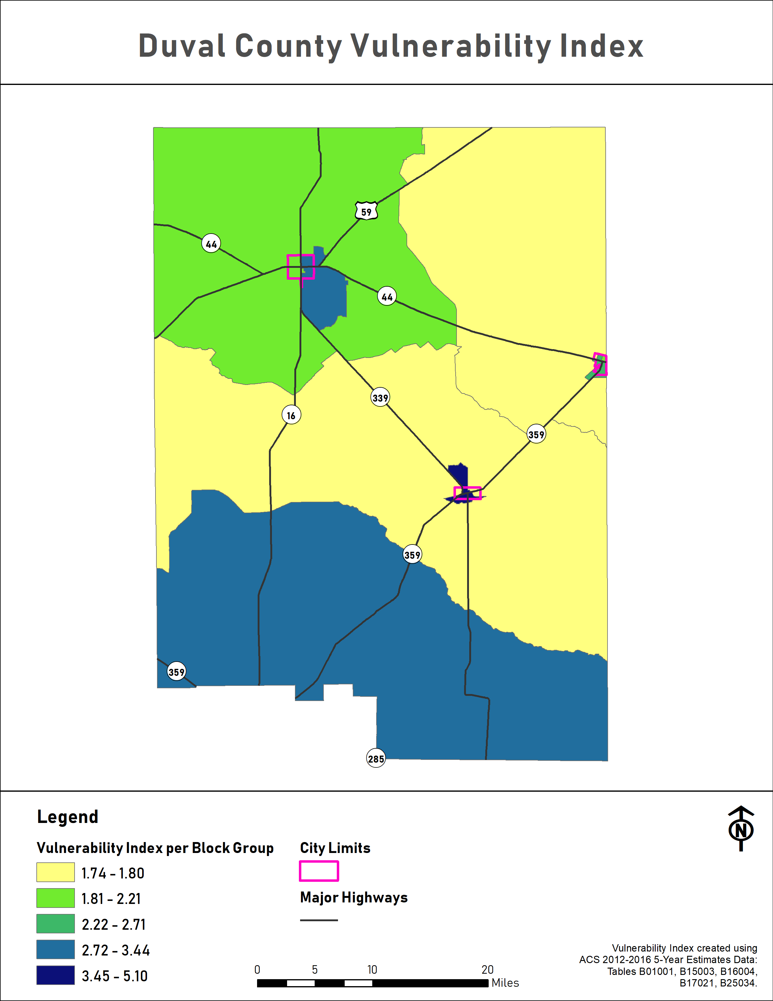
  - Figure 1: Duval County Vulnerability Index
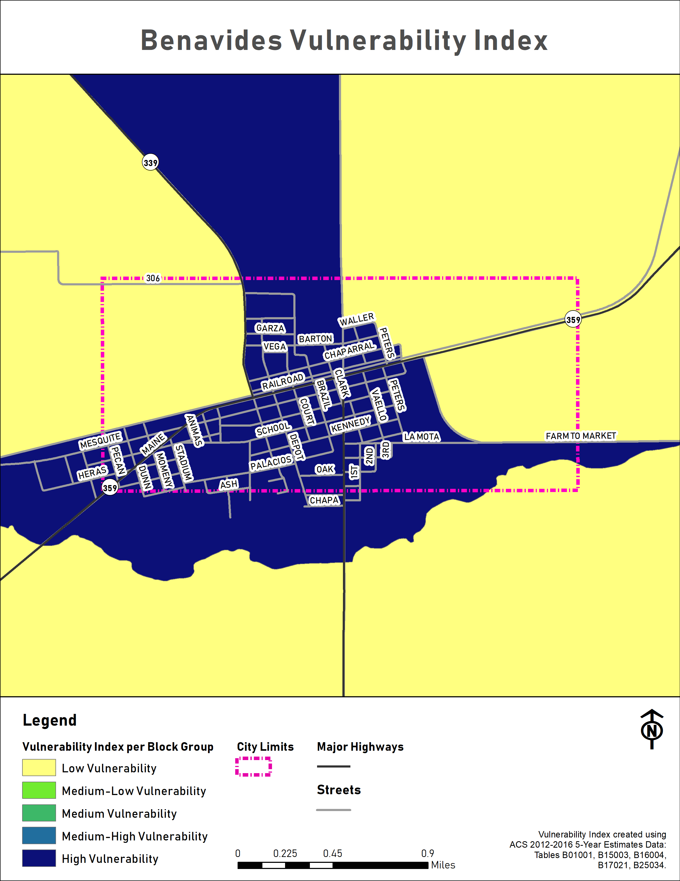
  - Figure 2: City of Benavides Vulnerability Index

  - 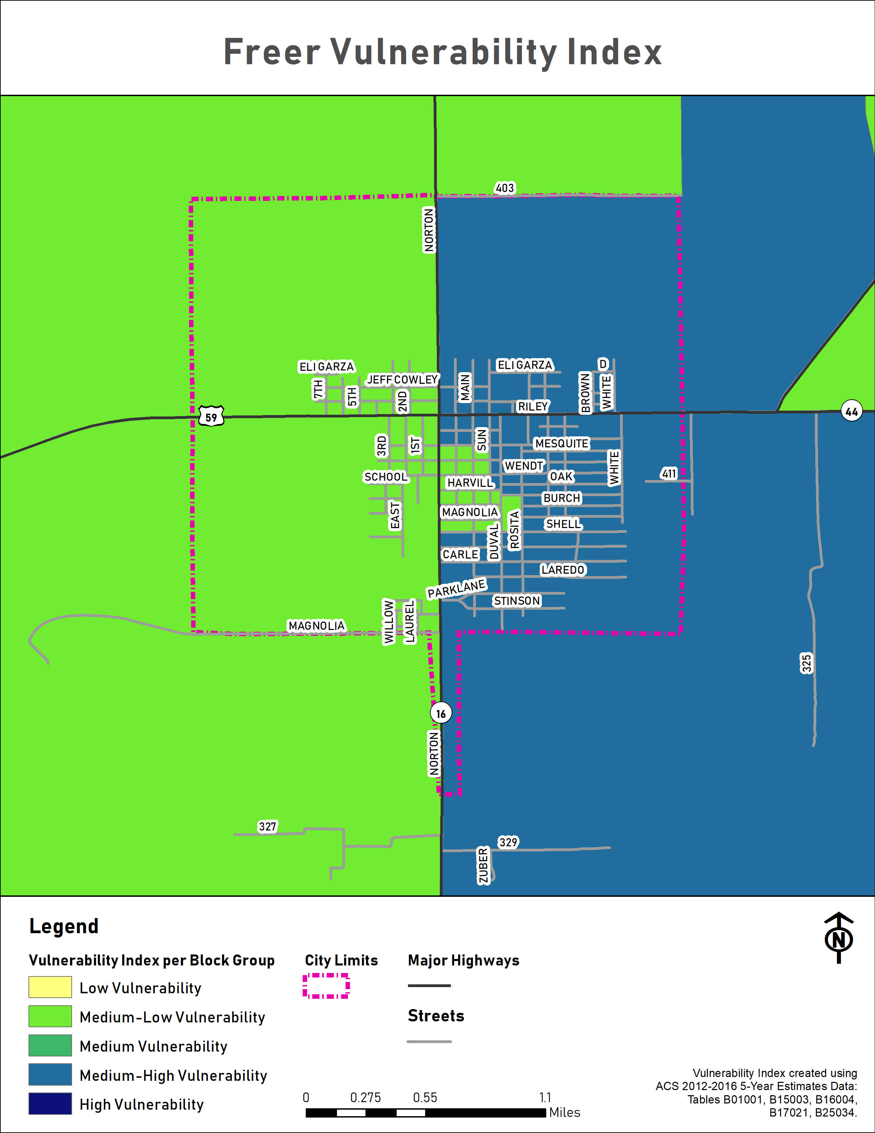

  - Figure 3: City of Freer Vulnerability Index
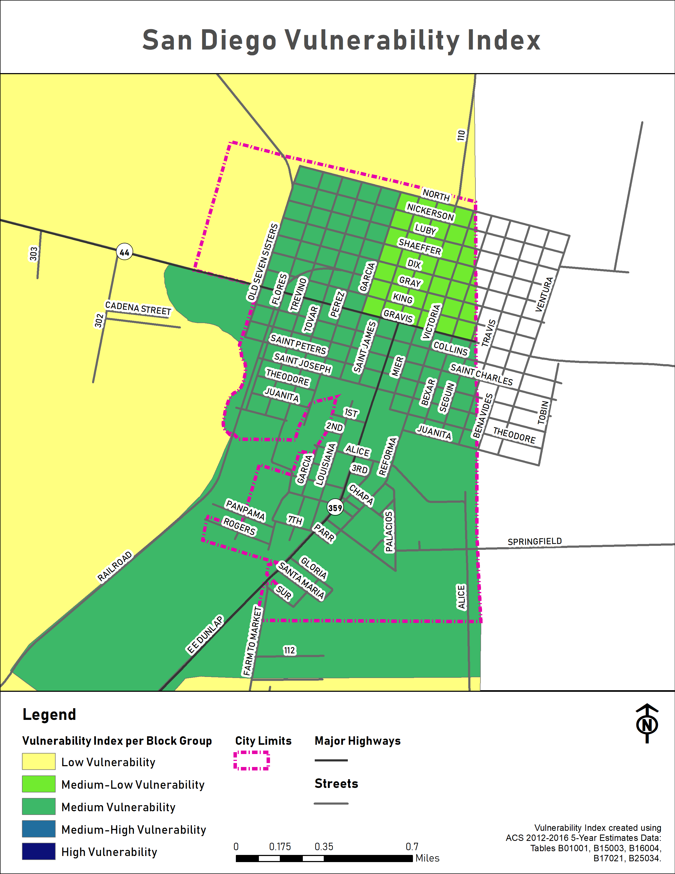
  - Figure 4: City of San Diego Age Distribution by Census Blockgroup, Under 17

Low Income and Subsidized Housing
The Duval County Housing Authority operates the 53-unit 4541 S FM 1329 complex in the City of San Diego. All rents are based on tenant incomes and may be subsidized. There are four other affordable apartment complexes offering 159 units in the City of San Diego.
There are three affordable apartment complexes offering 40 units in the City of Freer. Two of the complexes take Housing Choice Vouchers.
Residents of low-income housing and/or subsidized housing facilities are expected to suffer disproportionate losses due to natural hazards because of their potentially limited means to prepare for and recover from a hazard event.

Housing Type and Condition
The participating jurisdictions have used housing type and housing conditions to identify additional vulnerable areas and concentrations of vulnerable residents.

Manufactured / Mobile Homes
The participating jurisdictions have identified areas with large numbers of mobile/manufactured housing as being disproportionately vulnerable to certain hazards including but not limited to: hurricanes and tropical storms, floods, tornados, droughts, and windstorms.
Mobile and manufactured homes can be found throughout Duval County.
There are three RV parks in the City of Freer: Double M RV Park, Hook Up-Jo’s RV Park, and 16 South RV Park.

Homes in Substandard Condition
The jurisdictions have determined that homes in sub-standard condition, regardless of structure type, may indicate that residents are low-income or otherwise means-limited and thus more vulnerable to certain hazards.
To be considered standard condition, a home must show few or no minor visible exterior defects such as:
- cracked, peeling, or missing paint
- cracked, sagging, rotting, or missing siding, steps, porch planks, or other wooden surfaces
- cracked or broken window panes
- cracked masonry, brick, or mortar surfaces
- missing or damaged roof shingles
- small rust spots on mobile homes
The home must generally meet building codes, and there can’t be any detriment to health and safety present.
Structures in sub-standard condition may provide less protection to residents during certain hazard events like tropical storms, tornados, or hurricanes. Furthermore, because they’re already in a state of disrepair, additional damages due to hazard events may compound existing ones and potentially make these homes uninhabitable.

Flood
According to the Texas State Hazard Mitigation Plan, Floods are defined as:
[T]he accumulation of water within a water body and the overflow of excess water into adjacent floodplain lands.
In hydrologic analysis, runoff is that portion of rainfall which, in combination with other factors, contributes to the stream flow of any surface drainage way. When runoff exceeds the carrying capacity of the stream or drainage, flooding occurs. Runoff is a product of two major groups of factors, climate and physiographic. Climatic factors may include precipitation, evaporation, transpiration and interception. Physiographic factors would include the characteristics of the watershed such as size, shape and slope of the basin’s drainage area, the general land use within the basin. Average annual runoff decreases unevenly moving east to west across Texas, the localized variations based on these factors listed above.
When surface water runoff enters into streams, rivers, or dry creek beds, riverine flooding conditions occur whenever the water carrying capacity of the water channel is compromised by excess runoff.
If the local basin drainage area is relatively flat, shallow, slow-moving floodwater can last for days. In drainage areas with substantial slope, or the channel is narrow and confined, rapidly moving and extreme high-water conditions, called a flash flood, can occur.

Flood History
The planning team relied on data from the National Centers for Environmental Information (NCEI), formerly the National Climatic Data Center, and the Duval County 2013 CHAMPS report to develop a flood history for the County and each participating jurisdiction. The data gathered reflects the most up-to-date flood data available for each jurisdiction at the time of writing.

City of Benavides
Table 9: City of Benavides Flood History
Location | Date Range | Number of Flood Events | Flood Types | Local Fatalities | Local Injuries | Local Property Damage  $2018 | Local Crop Damage  $2018
Benavides | 4/2/1997 - 5/12/2015 | 4 | Flash Flood | 0 | 0 | $0 | $0

City of Freer
Table 10: City of Freer Flood History
Location | Date Range | Number of Flood Events | Flood Types | Local Fatalities | Local Injuries | Local Property Damage  $2018 | Local Crop Damage  $2018
Freer | 6/20/2006 - 5/13/2015 | 6 | Flash Flood | 0 | 0 | $0 | $0

City of San Diego
Table 11: City of San Diego Flood History
Location | Date Range | Number of Flood Events | Flood Types | Local Fatalities | Local Injuries | Local Property Damage  $2018 | Local Crop Damage  $2018
San Diego | 4/2/1997 - 10/24/2015 | 4 | Flood, Flash Flood | 0 | 0 | $0 | $0

Duval County
Table 12: Duval County Flood History
Location | Date Range | Number of Flood Events | Flood Types | Local Fatalities | Local Injuries | Local Property Damage  $2018 | Local Crop Damage  $2018
Duval County | 10/28/1960 - 6/17/2015 | 28 | Flood, Flash Flood | 0 | 2 | $5,236,718 | $10,062

Duval County Conservation and Reclamation District
Flood data is generally recorded at the county level, so there is no specific information regarding flood events on Duval County Conservation and Reclamation District property. However, given its boundaries are the same as the City of Benavides, the Census-Designated Place of Concepcion, and the Census-Designated Place of Realitos, its flood history is known to be similar to those cities.

Freer Water Control & Improvement District
Flood data is generally recorded at the county level, so there is no specific information regarding flood events on Freer Water Control & Improvement District property. Moreover, the FWCID’s property is located outside of any FEMA Special Flood Hazard Area. However, the FWCID is vulnerable to flooding’s indirect effects.

San Diego Municipal Utility District
Flood data is generally recorded at the county level, so there is no specific information regarding flood events at San Diego Municipal Utility District or its associated properties. However, given its boundaries are the same as the City of San Diego, its flood history is known to be similar to the City of San Diego’s.

National Flood Insurance Program
The National Flood Insurance Program (NFIP) is administered by FEMA to provide flood insurance coverage to the nation. Duval County, the City of Benavides, the City of Freer, and the City of San Diego are all listed as participating in the National Flood Insurance Program.
The City of Freer and the City of San Diego have adopted and enforce flood damage prevention ordinances in their respective jurisdictions. While Duval County is listed as a participant in the Community Status Workbook, they currently do not have a flood damage prevention ordinance. In order to be in compliance with the NFIP, Duval County has proposed a mitigation action in Chapter 15 that will create and implement a flood damage prevention ordinance and identify a floodplain manager. The City of Benavides is also listed as a participant in the Community Status Workbook, but they are currently in the process of creating or updating their flood damage prevention ordinance. In order to be in compliance with the NFIP, the City of Benavides has proposed a mitigation action in Chapter 15 that will create and implement a flood damage prevention ordinance and identify a floodplain manager. In the City of Freer the City Secretary is the designated Floodplain Administrator and enforces its flood damage prevention ordinance. In the City of San Diego, the Building Inspector is also the designated Floodplain Administrator and enforces its flood damage prevention ordinance.
In Freer, there are no identified areas of special flood hazard, but a Floodplain Development Permit will be required for any new development so the development complies with the flood damage prevention ordinance. San Diego’s flood damage prevention ordinance requires the lowest level of new structures in the floodplain to meet the base flood elevation.
Their respective floodplain management ordinances and any future updates will guide each enforcing jurisdiction as it continues to comply with NFIP requirements through local permitting, inspection, and recordkeeping, especially for new and substantially redeveloped construction. Each enforcing jurisdiction will continue to encourage property owners to purchase flood insurance to reduce their flood risk.
The current FIRM maps covering Duval County and the participating jurisdictions became effective on February 4, 2011.
There are no Letters of Map Changes (LOMC) in Duval County or the participating jurisdictions.
As of March 31, 2019, there are 11 NFIP policies in force in unincorporated Duval County. These policies cover property worth $3,203,000.
There are seven NFIP policies in force in the City of Benavides covering property worth $946,000.
There are four NFIP policies in force in the City of Freer covering property worth $980,000.
There are 14 NFIP policies in force in the City of San Diego covering property worth $1,880,000.
Table 13: NFIP Claims and Payments
Jurisdiction Name | Total Losses | Closed Losses | Open Losses | Losses  Closed Without Payment | Total Payments
Duval County | 8 | 6 | 0 | 2 | $157,687.59
City of Benavides | 1 | 1 | 0 | 0 | $597.02
City of Freer | 0 | 0 | 0 | 0 | $0.00
City of San Diego | 2 | 2 | 0 | 0 | $7,326.50

Repetitive Loss Properties
A Repetitive Loss (RL) property is any insurable building for which two or more claims of more than $1,000 were paid by the NFIP within any rolling ten-year period, since 1978. According to the data available, there is one RL property in greater Duval County. There is also one RL property in the City of San Diego. There are no RL properties in any other participating jurisdictions. Duval County RL properties have claimed four (4) losses.
According to the NFIP data, both of the RL properties in Duval County are classified as single family. Total payments on all RL properties in Duval County come to $59,596.10.

Severe Repetitive Loss Properties
A severe repetitive loss property is: “a single family property (consisting of 1 to 4 residences) that is covered under flood insurance by the NFIP and has incurred flood-related damage for which 4 or more separate claims payments have been paid under flood insurance coverage, with the amount of each claim payment exceeding $5,000 and with cumulative amount of such claims payments exceeding $20,000; or for which at least 2 separate claims payments have been made with the cumulative amount of such claims exceeding the reported value of the property. According to the information available, there are no severe repetitive loss properties in Duval County or any of the participating jurisdictions.

Likelihood of Future Events
In the case of the FEMA 100-year floodplain, there’s a 1% annual chance, and in the 500-year floodplain it’s a 0.02% annual chance. The likelihood of a 100-year flood event is therefore occasional. The likelihood of a 500-year flood event is therefore unlikely.
However, based on the frequency of previous flood events, every jurisdiction can expect to experience some type of flooding that may or may not meet the definition of a 100-year or 500-year event on a more regular basis.
In Duval County, previous flood history indicates that a future flood event is likely, meaning that one is probable in the next three years, in every participating jurisdiction.

Extent
Throughout Duval County and the participating jurisdictions, the worst flood events have been associated with flooding due to combinations of heavy rainfall, flash flooding, and riverine flooding.
The worst flooding events in Duval County and the participating jurisdictions have inflicted as high as $3.6 million in property damages. Crop damages during the worst flooding in Duval County and the participating jurisdictions have been as high as $10,013. The worst flood events in Duval County and the participating jurisdictions have caused two injuries but no fatalities.
The worst flooding throughout the County and the participating jurisdictions has been estimated at 5’ deep.
Future flood events in Duval County and the participating jurisdictions may meet previous worst-case 5’ flood depths.

Location and Impact

Location
Roughly 11% (125,476.14 acres out of 1,149,172.09) of Duval County is in the FEMA 100-year floodplain. In contrast, less than 0.01% (38.27 acres out of 1,149,172.09) of Duval County is in the FEMA 500-year floodplain. Nearly every type of land use found in Duval County can be found in both the FEMA 100-year and FEMA 500-year floodplains.

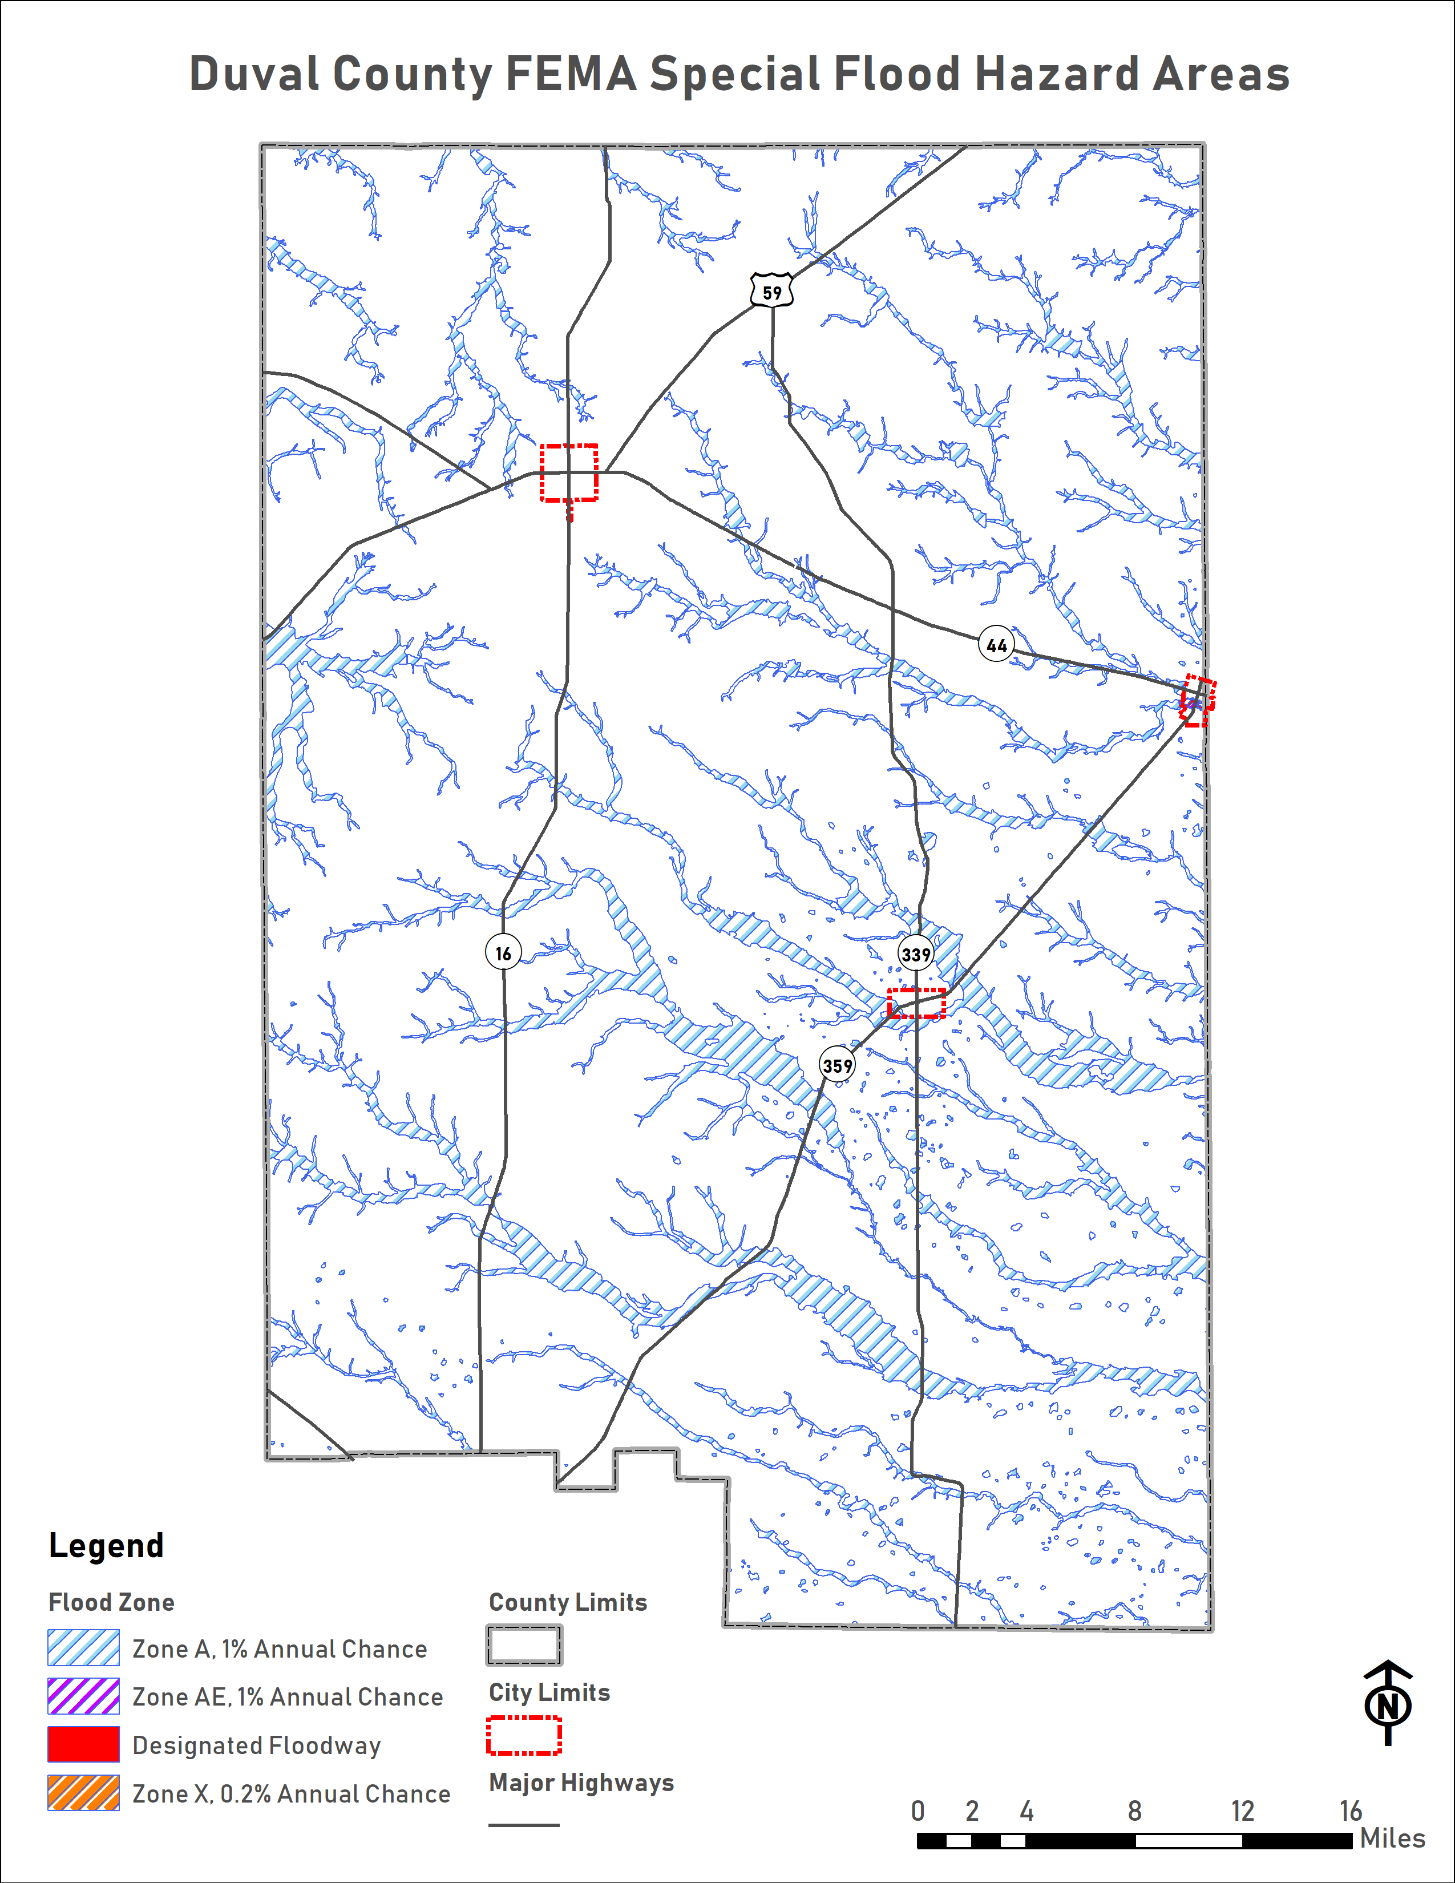
  - Figure 5: Duval County FEMA 100-Year and 500-Year Floodplain

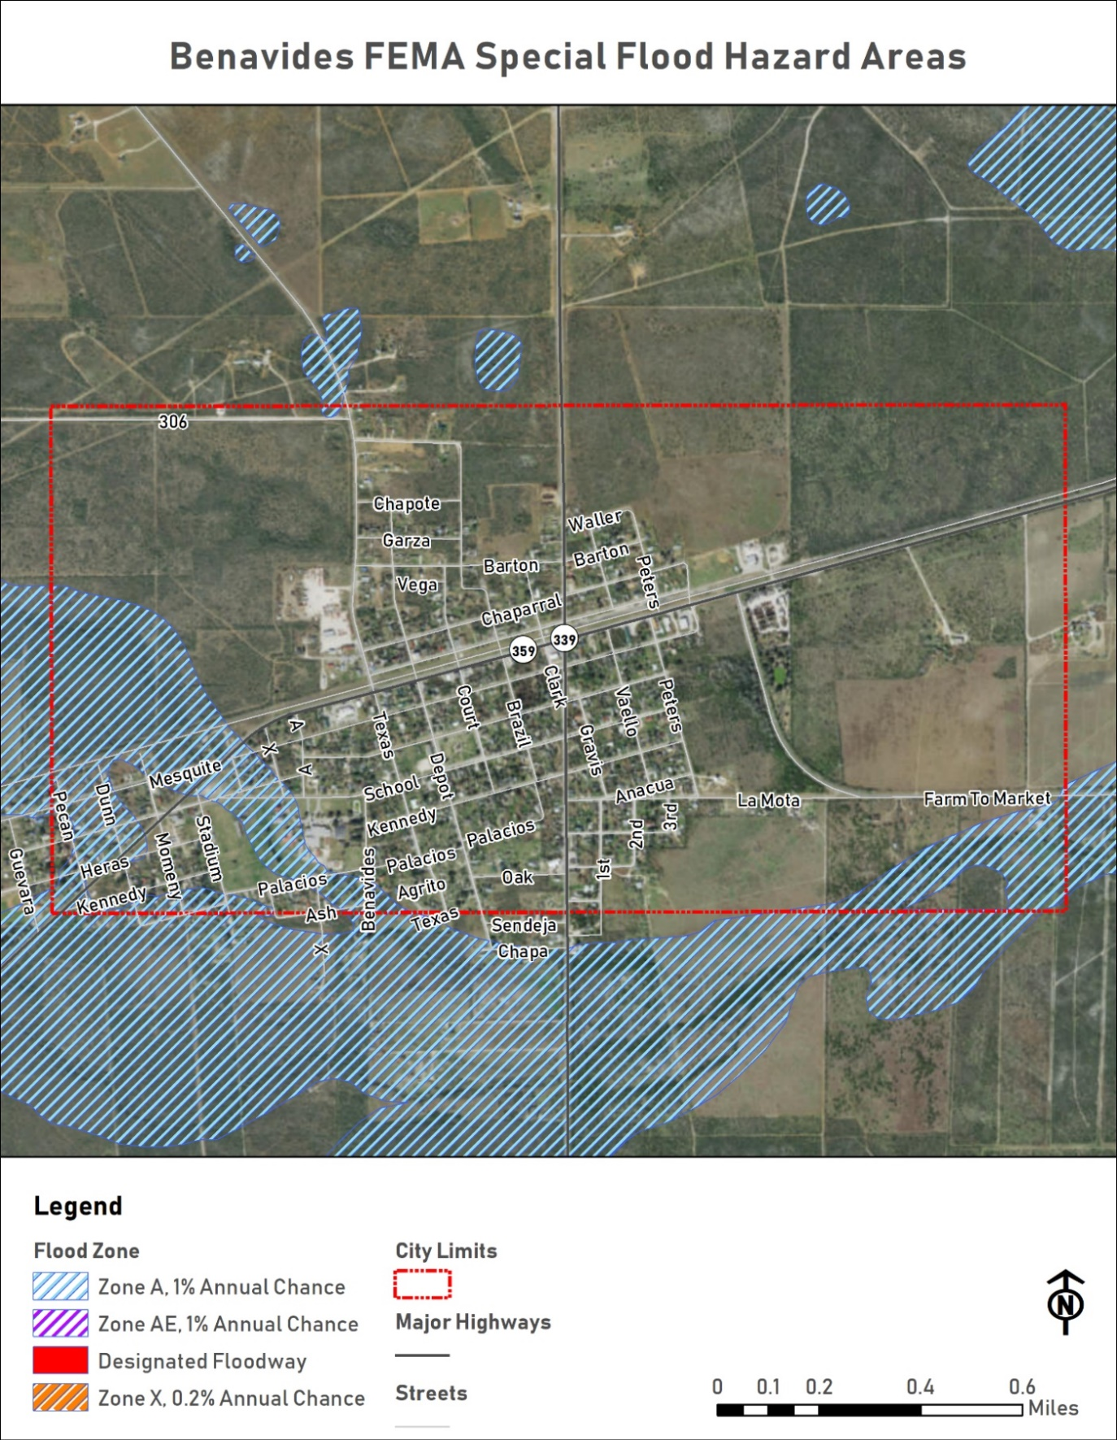
  - Figure 6: City of Benavides FEMA 100-Year and 500-Year Floodplain

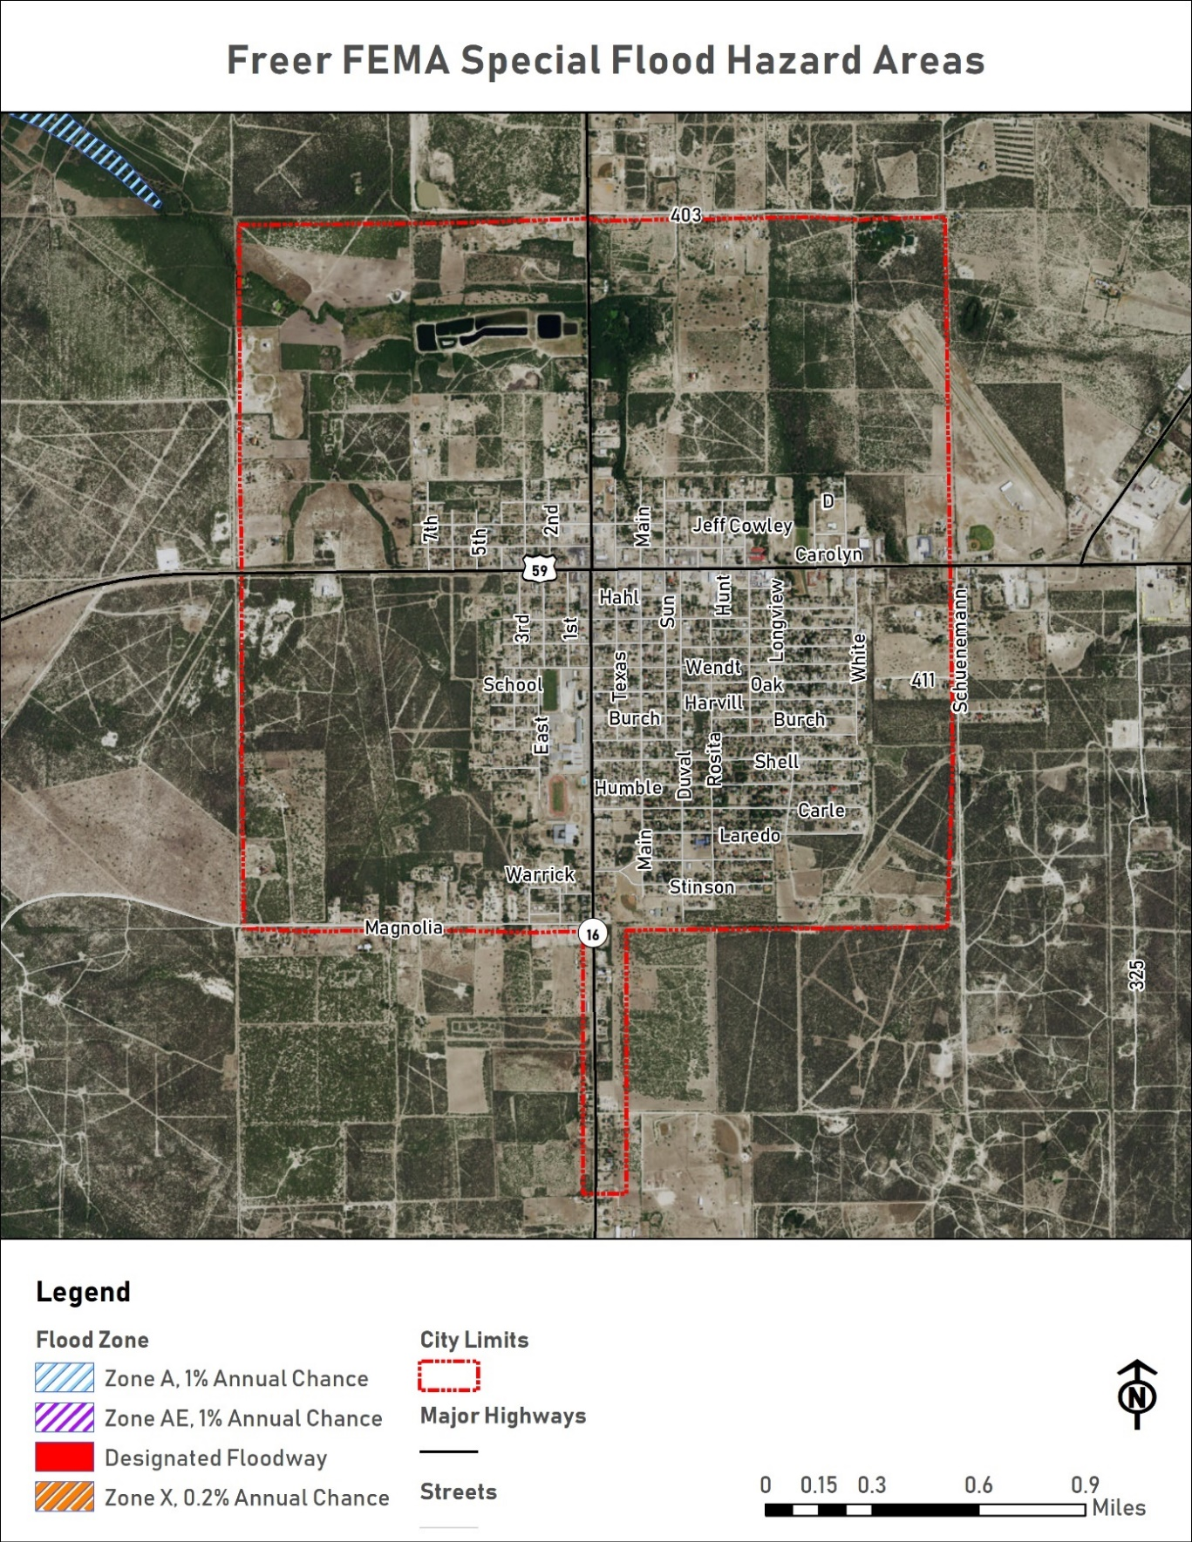
  - Figure 7: City of Freer FEMA 100-Year and 500-Year Floodplain
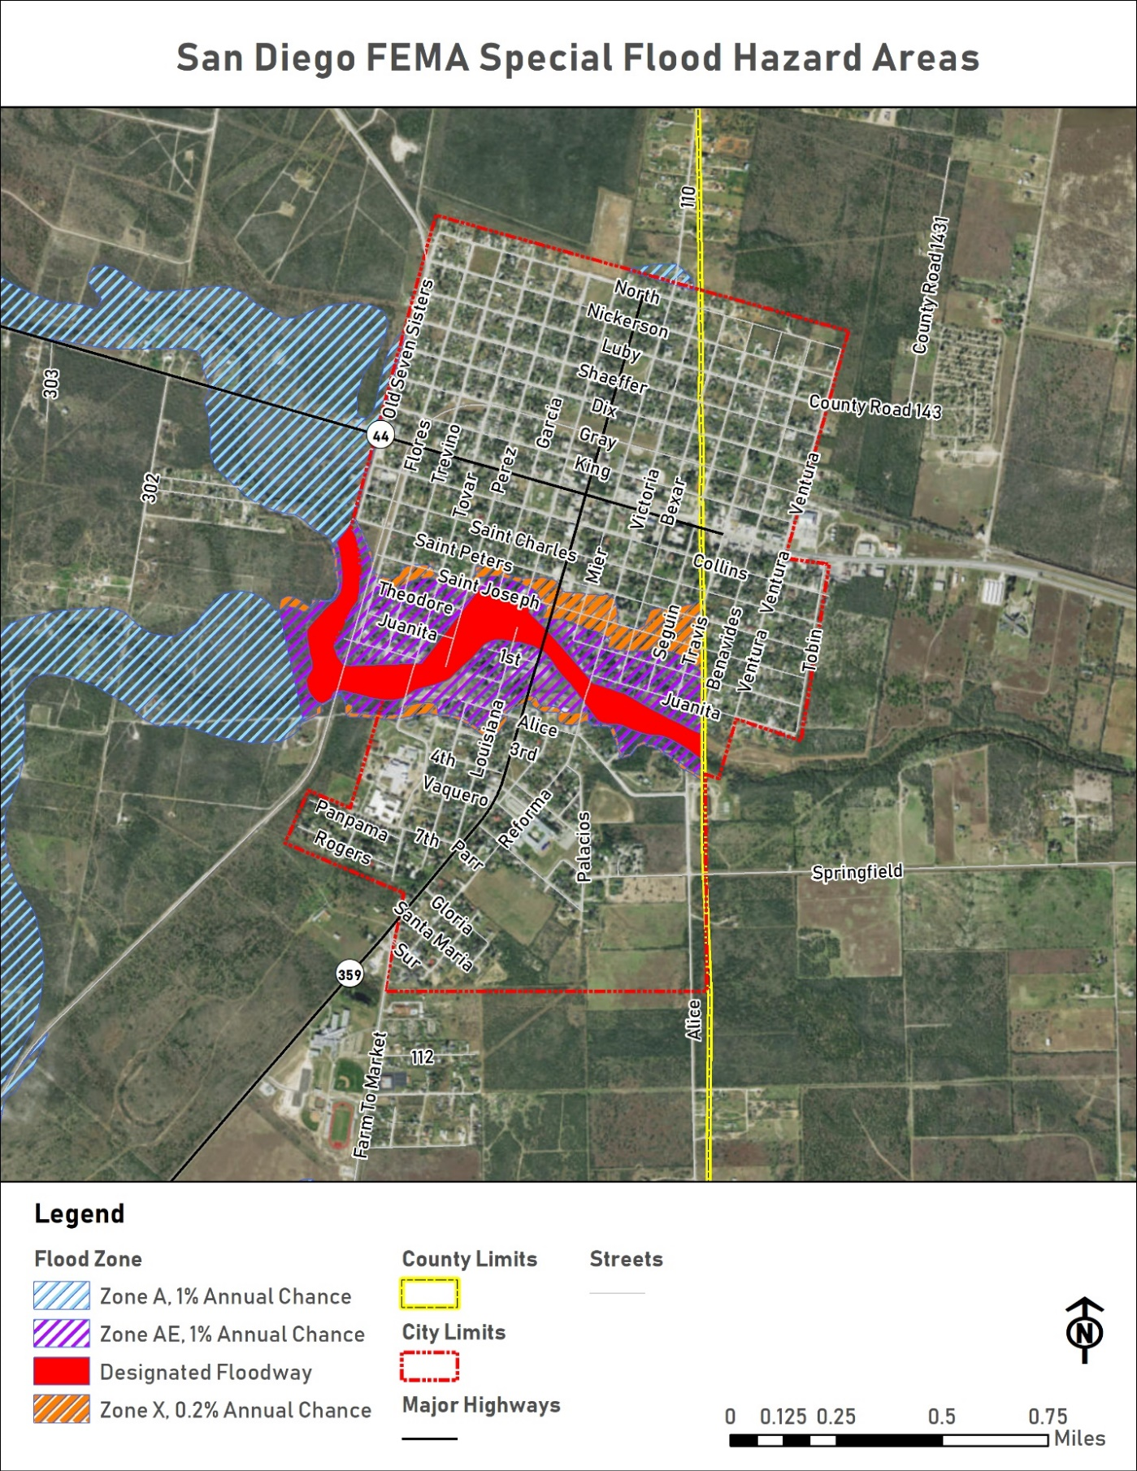
  - Figure 8: City of San Diego FEMA 100-Year and 500-Year Floodplain

In addition to the City of Benavides, the DCCRD also covers the Census-Designated Places of Concepcion and Realitos.
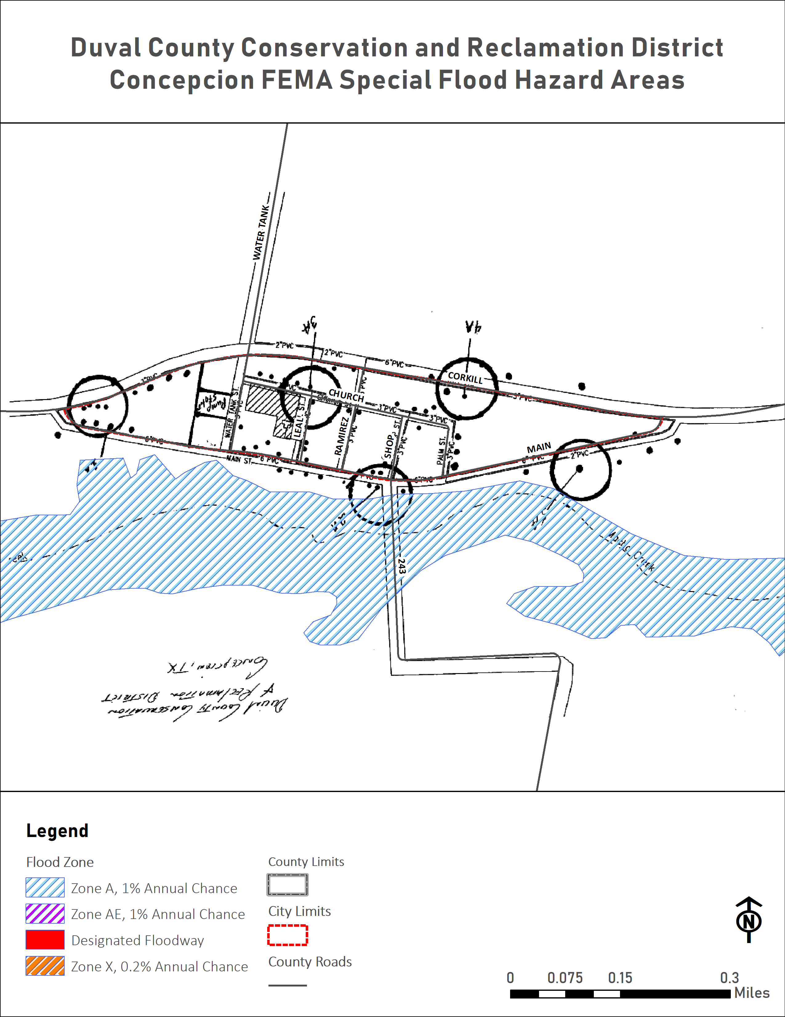
  - Figure 9: Census-Designated Place of Concepcion FEMA Special Flood Hazard Areas
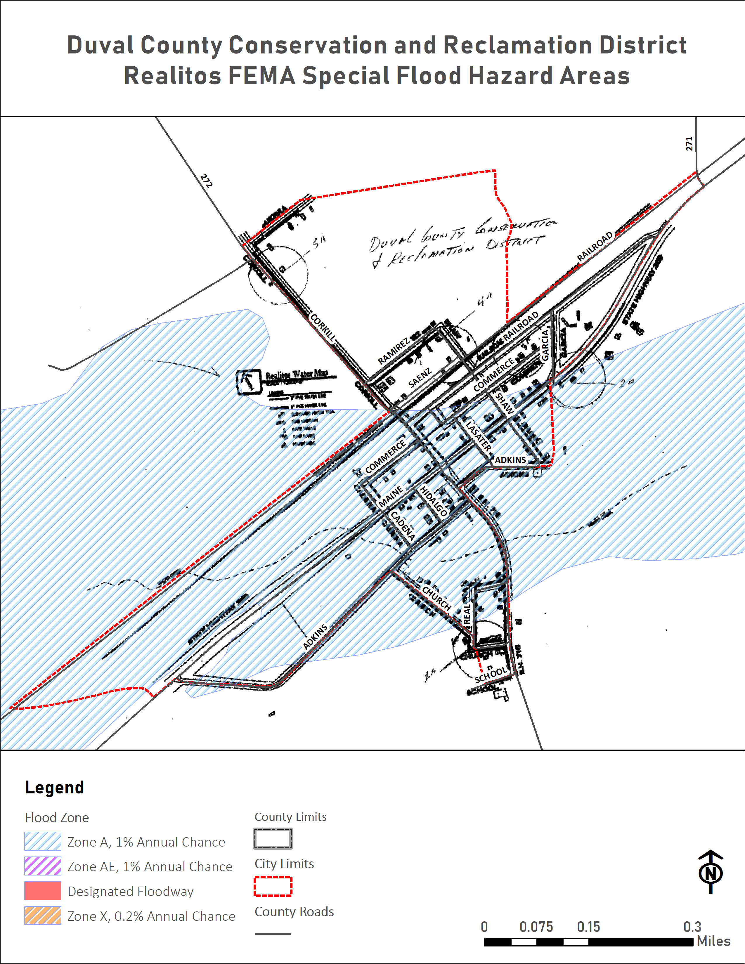
  - Figure 10: Census-Designated Place of Realitos FEMA Special Flood Hazard Areas

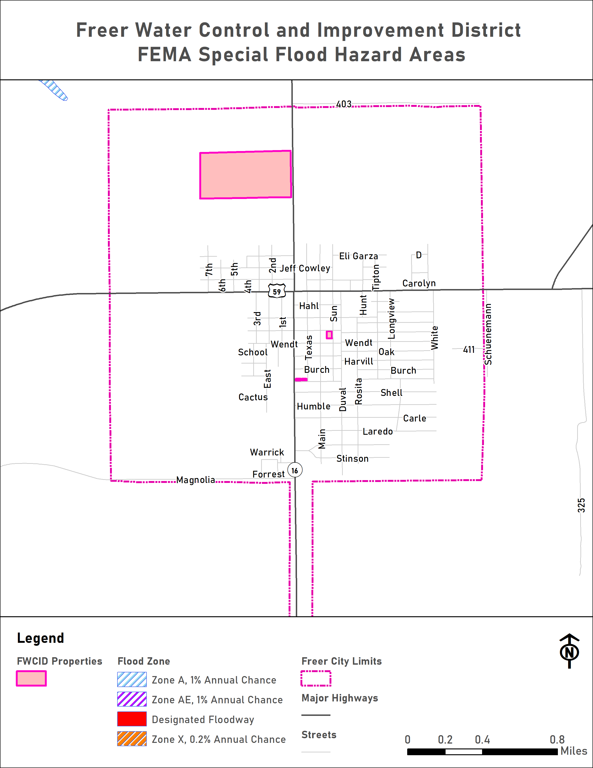
  - Figure 11: Freer Water Control and Improvement District FEMA Special Flood Hazard Areas
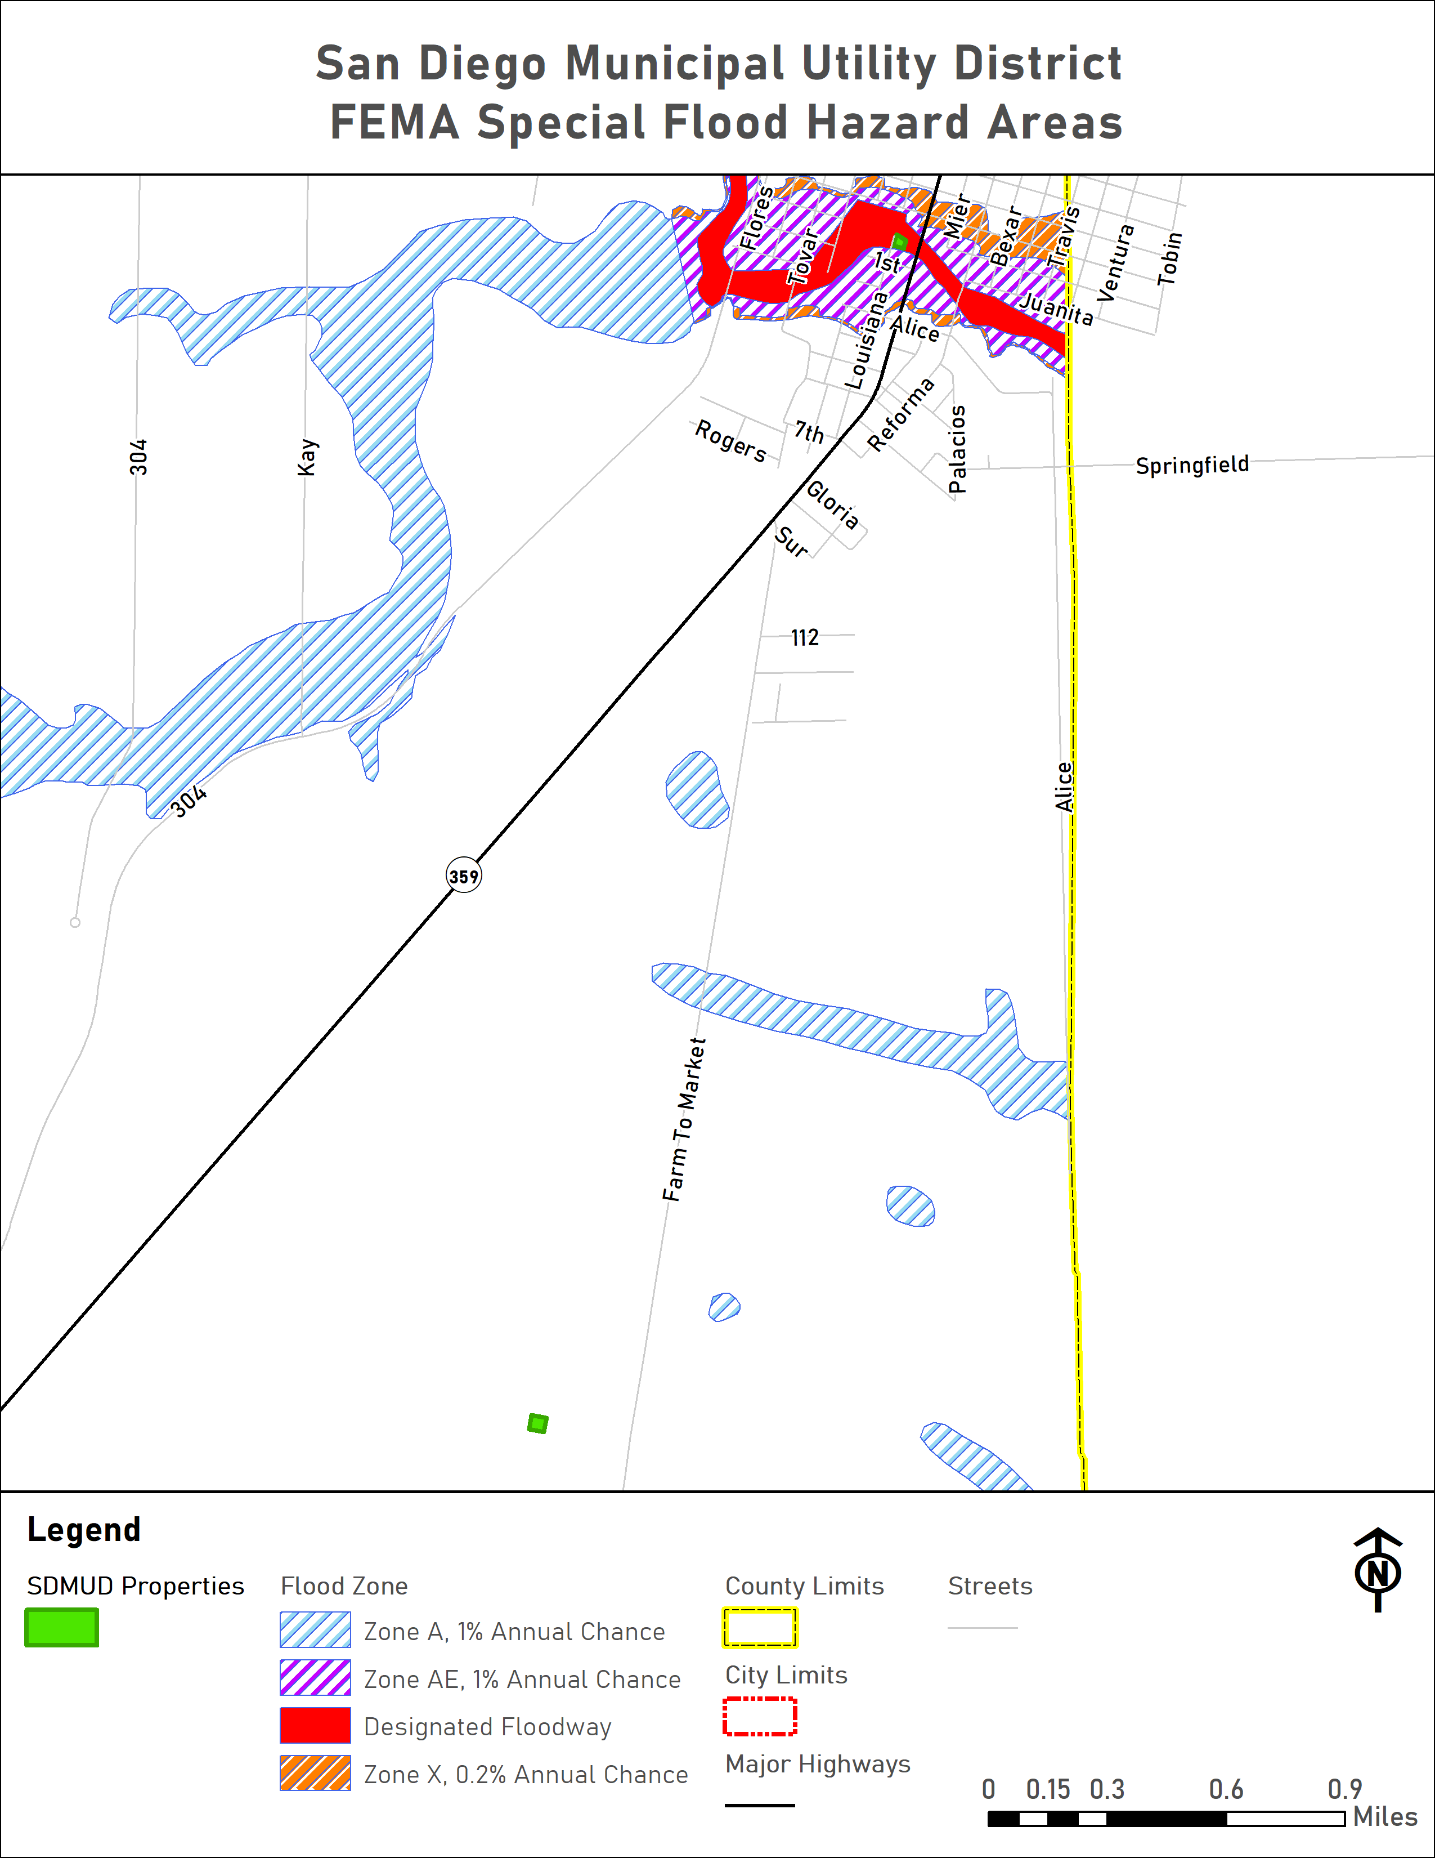
  - Figure 12: San Diego Municipal Utility District FEMA Special Flood Hazard Areas

Impact
Although the likelihood of a FEMA 100-year flood event remains occasional, 1% in any given year, the floodplain crosses all of Duval County’s major thoroughfares, potentially limiting travel across, within, and around the County.
The impact of a FEMA 100-year flood event will vary depending on the location, size of the affected area, and number of structures affected. Residents outside of the participating jurisdictions are evenly distributed throughout the county. Flooding in the County’s Census Designated Places will impact more residents than flooding in less developed parts of the County. Residents in unincorporated Duval County may temporarily lose power due to downed power lines. Motorists and residents throughout the County may be left stranded and needing rescue. Affected structures may be flooded, damaged by floodborne contaminants, damaged by debris flow, or even completely washed away. Crops may be damaged or destroyed. Estimated damage totals to vulnerable parcels affected during a 100-year flood event may meet the totals outlined in Tables 14-16 below.
Despite the unlikely probability of a so-called 500-year flood, 0.02% in any given year, the danger isn’t negligible. Moreover, the relatively limited information on the 500-year flood zone should not be interpreted to mean that a 500-year flood will only occur in the areas depicted in the 500-year flood zone on the County’s NFIP maps. Parts of the County may temporarily lose power due to downed power lines. Motorists and residents may be left stranded and needing rescue. Affected structures may be flooded, damaged by floodborne contaminants, damaged by debris flow, or even completely washed away. Crops may be damaged or destroyed. A 500-year flood event is expected to affect a larger area and more structures than a 100-year flood. Estimated damage totals to vulnerable parcels affected during a 500-year flood event may meet the totals outlined in Tables 14-16 below.

Vulnerability

Population
As described in Section 3 of Chapter 3 above, Duval County and the participating jurisdictions are home to many vulnerable residents. Increased vulnerability may be due to many factors including but not limited to: age, physical ability, financial means, housing type, and housing condition. Many of these vulnerabilities often overlap.
The participating jurisdictions recognize that vulnerable populations may need additional help preparing for and recovering from a flood.
Residents of mobile / manufactured housing are of particular concern. These structures are never considered safe during a flood, and depending on tie-down methods, may threaten surrounding structures.
Residents of sub-standard structures are also of particular concern. Structures in sub-standard condition ahead of a flood, whether due to structural damages, missing windows or doors, holes in exterior walls or the roof, may be less safe during a flood than structures in standard condition. Existing structural weaknesses may mean increased damages, injuries, or loss of life.

Critical Facilities
The planning team identified 61 critical facilities spread across the County and participating jurisdictions. Nine are located in a known FEMA Special Flood Hazard Area (SFHA).
Critical Facilities
San Diego City Hall / Police Department
San Diego EMS
San Diego MUD - Cadena Lift Station
San Diego MUD - Creek Lift Station
San Diego MUD - Hinojosa Well
San Diego MUD - Luera Lift Station
San Diego MUD - Tower Well
San Diego MUD Water Treatment Plant
San Diego Municipal Utility District Office

Vulnerable Parcels
The planning team developed a parcel inventory to identify estimated damage values during a flood event. Parcels vulnerable to flooding have been identified by their complete or partial location within the FEMA 100-year floodplain and the FEMA 500-year floodplain. The City of Freer does not have any Special Flood Hazard Areas within the city limits. The Duval County Conservation and Reclamation District and Freer Water Control & Improvement District do not have any parcels within any FEMA Special Flood Hazard Areas.
Actual damages will vary based on the location and extent of flooding.
Table 14: Vulnerable Parcels by Flood Zone in Duval County
Jurisdiction | Total Parcels | Estimated Potential Damage Value
FEMA 100-Year Flood Zone A
Duval County | 2,934 | $670,991,075
FEMA 500-Year Flood Zone
Duval County | 170 | $6,406,020

Table 15: Vulnerable Parcels by Flood Zone in the City of Benavides
Jurisdiction | Total Parcels | Estimated Potential Damage Value
FEMA 100-Year Flood Zone A
City of Benavides | 133 | $6,261,700

Table 16: Vulnerable Parcels by Flood Zone in the City of San Diego
Jurisdiction | Total Parcels | Estimated Potential Damage Value
FEMA 100-Year Flood Zone A
City of San Diego | 332 | $6,624,257
FEMA 500-Year Flood Zone
City of San Diego | 167 | $6,194,560

Jurisdiction | Total Parcels | Estimated Potential Damage Value
Designated Floodway
San Diego Municipal Utility District | 1 | $1,200

Hurricane / Tropical Storm
Once a tropical depression has intensified to the point where its maximum sustained winds are between 35-64 knots (39 – 73 mph), it becomes a tropical storm. At these wind speeds the storm becomes more organized and begins to become more circular in shape – resembling a hurricane. The rotation of a tropical storm is more recognizable than for a tropical depression. Tropical storms can cause many problems without becoming a hurricane. However, most of the problems a tropical storm causes stem from heavy rainfall and high winds.
According to National Oceanic and Atmospheric Administration (NOAA), a hurricane is an intense tropical weather system of strong thunderstorms with a well-defined surface circulation and maximum sustained winds of 74 mph or higher. Hurricanes are categorized according to the strength of their winds using the Saffir-Simpson Hurricane Scale. A Category 1 storm has the lowest wind speeds, while a Category 5 hurricane has the highest. These are relative terms, because lower category storms can sometimes inflict greater damage than higher category storms, depending on where they strike and the particular hazards they bring. In fact, tropical storms can also produce significant damage and loss of life, mainly due to flooding.
The ingredients for a hurricane include a pre-existing weather disturbance, warm tropical oceans, moisture, and relatively light winds aloft. If the right conditions persist long enough, they can combine to produce the violent winds, incredible waves, torrential rains, and floods associated with this phenomenon.

Hurricanes / Tropical Storms History
The planning team relied on data from the National Climatic Data Center (NCDC) and the Duval County 2013 CHAMPS report to develop a hurricane history for the County and each participating jurisdiction. The data gathered reflects the most up-to-date hurricane and tropical storm data available for each jurisdiction. All data is reported at the County level, but because of every jurisdiction’s proximity to each other, the countywide data is considered representative of local hurricane and tropical storm impacts.
Table 17: Duval County Hurricane History
Location | Date Range | Number of Hurricane & Tropical Storm Events | Hurricane & Tropical Storm Category Range | Maximum Wind Speed Range | Local Fatalities | Local Injuries | Local Property Damage  $2018 | Local Crop Damage  $2018
Duval County | 9/8/1961 - 7/23/2008 | 11 | Up to Category 5 | 190 | 0 | 13 | $54,201,325 | $16,183,882

Likelihood of Future Events
Hurricanes occur in seasonal patterns between June 1 and November 30. Based on historical frequency of hurricanes and tropical storms in Duval County and the participating jurisdictions outlined above, the likelihood of a hurricane or tropical storm affecting any or all of the participating jurisdictions is occasional, meaning an event is possible in the next five years.

Extent
The Saffir‐Simpson Scale categorizes hurricane intensity linearly based upon maximum sustained winds, barometric pressure, and storm surge potential. Wind, pressure, and surge are combined to estimate potential damage. Categories 3, 4 and 5 are classified as “major” hurricanes. Major hurricanes comprise only 20 percent of total tropical cyclone landfalls but they account for over 70 percent of the damage in the United States. Damage from hurricanes can result from spawned tornados, coastal flooding from storm surge, and inland flooding from heavy rainfall.
Table 18: Saffir-Simpson Scale
Category | Maximum Sustained Wind Speed (MPH) | Minimum Surface Pressure (Millibars) | Storm Surge (Feet)
1 | 74-95 | Greater than 980 | 3-5
2 | 96-110 | 979-965 | 6-8
3 | 111-130 | 964-945 | 9-12
4 | 131-155 | 944-920 | 13-18
5 | 155+ | Less than 920 | 19+

Duval County and the participating jurisdictions are located far enough from the coast that storm surge is unlikely to have a local impact.
The worst hurricanes and tropical storms in Duval County and the participating jurisdictions have measured as high as Category 5 on the Saffir-Simpson scale, dropped over 6.5” in rainfall, injured up to 6 people, and caused property and crop damages in excess of $16.5 million and $8.2 million respectively.
Future hurricanes and tropical storms may meet previous worst-case Category 5 storms in terms of strength, rainfall, flooding, damage dollars, injuries, and deaths.

Location and Impact

Location
Location is often referred to in terms of Tier I and II counties, designated by the Texas Department of Insurance (TDI) for windstorm insurance purposes, to represent differing levels of loss exposure to coastal counties and adjacent counties. Tier I are those counties adjacent to the Gulf of Mexico and Tier II are those counties adjacent to Tier I counties.
Duval County is not a Tier I or Tier II county. However, the County and all participating jurisdictions are located within 200 miles of the Gulf coast. Although tropical storm and hurricane effects begin to diminish as they move inland, the winds alone from Hurricane Harvey reached as far as 140 miles from the eye of the storm. The County and all participating jurisdictions are considered especially susceptible to indirect impacts from hurricanes and tropical storms including high winds and flooding.
Tropical storms and hurricanes vary tremendously in terms of size, location, intensity and duration. According to the Duval County 2013 CHAMPS Report, Duval County’s proximity to the coast places it among the middle-top 20% of all Texas counties in terms of recorded hurricane and tropical storm impacts including damage dollars, injuries, and deaths.

Impact
The planning team determined that Duval County is uniformly exposed to tropical storms and hurricanes.
Impacts from a hurricane or tropical Storm in Duval County and the participating jurisdictions may include but are not limited to: loss of power due to downed lines caused by flying debris or fallen trees, flooding, flooding due to damaged or destroyed roofs, damaged or broken windows, damage due to flying debris, wind damage, escaped livestock and pets, injured or killed livestock and pets, crop damage or destruction. In the worst storms, people may be injured or killed.

Vulnerability

Population
As described in Section 3 of Chapter 3 above, Duval County and the participating jurisdictions are home to many vulnerable residents. Increased vulnerability may be due to many factors including but not limited to: age, physical ability, financial means, housing type, and housing condition. Many of these vulnerabilities often overlap.
The participating jurisdictions recognize that vulnerable populations may need additional help preparing for and recovering from a hurricane or tropical storm.
Residents of mobile / manufactured housing are of particular concern. These structures are never considered safe during a hurricane, and depending on tie-down methods, may also be unsafe during strong tropical storms.
Residents of sub-standard structures are also of particular concern. Structures in sub-standard condition ahead of a tropical storm or hurricane, whether due to structural damages, missing windows or doors, holes in exterior walls or the roof, may be less safe during a hurricane or tropical storm than structures in standard condition. Existing structural weaknesses may mean increased damages, injuries, or loss of life.

Critical Infrastructure – US 59, SH 16, SH 44, SH 285, SH 359
United States Highway 59, State Highway 16, State Highway 44, State Highway 285, and State Highway 359 are TxDOT-designated major hurricane evacuation routes.
State Highway 359 runs through the City of Benavides. United States Highway 59, State Highway 16, State Highway 44 all pass through the City of Freer. State Highway 44 and State Highway 359 pass through the City of San Diego.
Flooding along any of these routes during a hurricane evacuation could strand motorists trying to escape the storm. These drivers may need to be rescued, and could be injured or killed.

Critical Facilities
The planning team identified 61 critical facilities spread across the County and participating jurisdictions. Because of Duval County’s proximity to the Gulf coast, the planning team determined that all critical facilities, no matter their jurisdictional location, are equally vulnerable to a hurricane or tropical storm.
Table 19: Critical Facilities Vulnerable to Tropical Storms and Hurricanes and Potential Impacts
 | Potential Hurricane / Tropical Storm Impacts
 | Loss of Power | Flying Debris | Uprooted Trees | Flooding | Flooding Due to Physical Damages | Damaged or Destroyed Roofs | Damaged or Broken Windows | Wind Damage | Injuries | Death
Benavides Branch Library | x | x | x |  | x | x | x | x | x | x
Benavides City Hall / Police Station / VFD | x | x | x |  | x |  | x |  | x | x
Benavides Civic Center | x | x |  |  | x | x | x |  | x | x
Benavides EMS | x | x |  |  | x |  |  | x | x | x
Concepcion Civic Center | x | x |  |  | x | x |  | x | x | x
Duval County Conservation and Reclamation District Office | x | x | x |  | x |  |  | x | x | x
Duval County Courthouse | x | x | x |  | x | x | x | x | x | x
Duval County Pct. 1 Shop | x | x |  |  | x | x |  | x | x | x
Duval County Pct. 2 Shop - Concepcion | x | x | x |  | x | x | x | x | x | x
Duval County Pct. 2 Shop - San Diego | x | x | x |  | x | x |  | x | x | x
Duval County Pct. 3 Shop | x | x |  |  | x | x |  | x | x | x
Duval County Pct. 4 Shop - Freer | x | x |  |  | x | x |  | x | x | x
Duval County Sheriff's Department | x | x | x |  | x | x | x | x | x | x
Duval Freer Airport | x | x |  |  |  | x |  | x | x | x
Freer Branch Library | x | x | x |  | x | x | x | x | x | x
Freer City Hall / Police Department | x | x | x |  | x |  |  | x | x | x
Freer Civic Center | x | x | x |  | x | x | x | x | x | x
Freer VFD / EMS | x | x | x |  |  | x |  | x | x | x
Freer Water Control & Improvement District | x | x | x |  | x | x | x | x | x | x
Freer WCID Wastewater Treatment Plant |  |  |  |  |  |  |  |  | x | x
Freer WCID Water Treatment Plant | x | x | x |  | x |  |  | x | x | x
FWCID Ground Storage Tank | x | x | x |  |  |  |  |  | x | x
FWCID Well #10 | x |  |  |  |  |  |  |  | x | x
FWCID Well #14 | x |  |  |  |  |  |  |  | x | x
FWCID Well #16 | x |  |  |  |  |  |  |  | x | x
FWCID Well #19 | x |  |  |  |  |  |  |  | x | x
FWCID Well #21 | x |  |  |  |  |  |  |  | x | x
FWCID Well #22 | x |  |  |  |  |  |  |  | x | x
FWCID Well #23 | x |  |  |  |  |  |  |  | x | x
FWCID Well #24 | x |  |  |  |  |  |  |  | x | x
Realitos Civic Center | x | x | x |  | x | x | x | x | x | x
San Diego Branch Library | x | x | x |  | x | x |  | x | x | x
San Diego City Hall / Police Department | x | x | x | x | x | x | x | x | x | x
San Diego Civic Center | x | x | x |  | x | x |  | x | x | x
San Diego EMS | x | x | x | x | x | x | x | x | x | x
San Diego MUD - 4 A's Well | x |  |  |  |  |  |  |  | x | x
San Diego MUD - Briones Lift Station | x | x | x |  |  |  |  |  | x | x
San Diego MUD - Cadena Lift Station | x | x | x | x | x |  |  |  | x | x
San Diego MUD - City Well | x |  |  |  |  |  |  |  | x | x
San Diego MUD - Creek Lift Station | x |  |  | x | x |  |  |  | x | x
San Diego MUD - Everett Well | x |  |  |  |  |  |  |  | x | x
San Diego MUD - Hinojosa Well | x |  |  | x | x |  |  |  | x | x
San Diego MUD - Labbe Well | x |  |  |  |  |  |  |  | x | x
San Diego MUD - Luera Lift Station | x | x | x | x | x |  |  |  | x | x
San Diego MUD - Mauro Lift Station | x |  |  |  |  |  |  |  | x | x
San Diego MUD - Mi Tierra Lift Station | x |  |  |  |  |  |  |  | x | x
San Diego MUD - Nunez Well | x |  |  |  |  |  |  |  | x | x
San Diego MUD - Prison Lift Station | x | x | x |  |  |  |  |  | x | x
San Diego MUD - Prison Pump House | x |  |  |  |  |  |  |  | x | x
San Diego MUD - Prison Well | x |  |  |  |  |  |  |  | x | x
San Diego MUD - Rotary Lift Station | x |  |  |  |  |  |  |  | x | x
San Diego MUD - Salazar Lift Station | x | x | x |  |  |  |  |  | x | x
San Diego MUD - Sandoval Lift Station | x | x | x |  |  |  |  |  | x | x
San Diego MUD - Solis Well | x |  |  |  |  |  |  |  | x | x
San Diego MUD - Tovar Lift Station | x | x | x |  |  |  |  |  | x | x
San Diego MUD - Tower Well | x |  |  | x | x |  |  |  | x | x
San Diego MUD - Vic Lift Station | x |  |  |  |  |  |  |  | x | x
San Diego MUD Wastewater Treatment Plant | x | x |  |  | x |  |  |  | x | x
San Diego MUD Water Treatment Plant | x |  |  | x | x |  |  |  | x | x
San Diego Municipal Utility District Office | x | x | x | x | x | x | x | x | x | x
San Jose Civic Center | x | x |  |  | x | x | x | x | x | x

Vulnerable Parcels
Central Appraisal District data was used to estimate potential damage values for each participating jurisdiction. Given the broad nature of vulnerability, damage values were calculated on the jurisdictional level.
Table 20: Parcels Vulnerable to Hurricanes / Tropical Storms
Jurisdiction | Estimated Parcel Count | Estimated Potential Damage Value
Duval County | 10,583 | $1,275,876,637
City of Benavides | 958 | $26,174,315
City of Freer | 1,721 | $52,024,280
City of San Diego | 2,190 | $58,698,302
Duval County Conservation and Reclamation District | 2 | $152,660
Freer Water Control & Improvement District | 3 | $298,610
San Diego Municipal Utility District | 2 | $2,680

Wildfire
Wildfire is defined as a sweeping and destructive conflagration and can be further categorized as wildland, interface, or intermix fires.
Wildland fires are fueled almost exclusively by natural vegetation wildland/urban interface (WUI) fires include both vegetation and the built-environment. The wildfire disaster cycle begins when homes are built adjacent to wildland areas. When what would have been rural wildfires occur, they advance through all available fuels, which can include homes and structures.

Wildfire History
The Texas A&M Forest Service Wildfire Risk Assessment Portal provides wildfire data on fires that occurred between 2005 – 2015 in Duval County. The following wildfire histories for each jurisdiction reflect the most current wildfire data available. No wildfires are known to have occurred in any participating jurisdiction more recently than those listed below. No damage dollars, neither structural nor agricultural, were reported for any of the wildfire events for any jurisdiction.

Duval County
Table 21: Duval County Wildfire History
Location | Date Range | Number of Wildfire Events | Range of Acres Burned | Total Acres Burned | Fatalities | Injuries | Property Damage  $2018 | Crop Damage  $2018
Duval County | 9/12/2007 - 10/3/2011 | 57 | Up to 3,500 | 15,246 | 0 | 0 | $55,471 | $0

City of Benavides
Table 22: City of Benavides Wildfire History
Location | Date Range | Number of Wildfire Events | Range of Acres Burned | Total Acres Burned | Fatalities | Injuries | Property Damage  $2018 | Crop Damage  $2018
Benavides | 11/1/2005 | 1 | 15 | 15 | 0 | 0 | $0 | $0

City of Freer
Table 23: City of Freer Wildfire History
Location | Date Range | Number of Wildfire Events | Range of Acres Burned | Total Acres Burned | Fatalities | Injuries | Property Damage  $2018 | Crop Damage  $2018
Freer | 1/1/2006 - 1/26/2011 | 64 | Up to 1,000 | 3,728 | 0 | 0 | $0 | $0

City of San Diego
Table 24: City of San Diego Wildfire History
Location | Date Range | Number of Wildfire Events | Range of Acres Burned | Total Acres Burned | Fatalities | Injuries | Property Damage  $2018 | Crop Damage  $2018
San Diego | 12/31/2005 - 3/18/2012 | 60 | Up to 350 | 1,565 | 0 | 0 | $0 | $0

While the Duval County Conservation and Reclamation District, the Freer Water Control & Improvement District, and the San Diego Municipal Utility District do not have specific information about wildfire history, their histories are assumed to be the same as Duval County, the City of Benavides, the City of Freer, and the City of San Diego’s.
Wildfire history isn’t broken down beyond the city level. However, given the participating jurisdictions’ locations within the planning area, and specifically the number of their facilities located in the wildfire hazard area, participating jurisdictions determined they’re vulnerable to hazard despite lacking a specific history of previous wildfire events.
The Duval County Conservation and Reclamation District determined that the history of impacts of wildfires have been negligible (or non-existent), therefore it is expected that future impacts will be negligible as well, and isn’t addressing the hazard.

Likelihood of Future Events

Duval County
According to the data, fire departments respond to nearly 14 wildfires per year in greater Duval County. Given prior frequency of wildfire events, a wildfire event in Duval County is highly likely, meaning an event is probable within the next year.

City of Benavides
According to the data, the City of Benavides responds to one or more wildfires per year, but has not reported a wildfire since 2005. Given prior frequency of wildfire events, a wildfire event in the City of Benavides is occasional, meaning an event is possible in the next five years.

City of Freer
According to the data, the City of Freer responds to 12 or more wildfires per year, but has not reported a wildfire since 2011. Given prior frequency of wildfire events, a wildfire event in the City of Freer is likely, meaning an event is probable in the next three years.

City of San Diego
According to the data, the City of San Diego responds to eight or more wildfires per year, but has not reported a wildfire since 2012. Given prior frequency of wildfire events, a wildfire event in the City of San Diego is likely, meaning an event is probable in the next three years.

Freer Water Control and Improvement District
Given its location within the City of Freer, the Freer Water Control and Improvement District considers the likelihood of a future wildfire event to be similar to the City of Freer’s. The City of Freer responds to 12 or more wildfires per year, but has not reported a wildfire since 2011. Given prior frequency of wildfire events, a wildfire event in the Freer Water Control and Improvement District is likely, meaning an event is probable in the next three years.

San Diego Municipal Utility District
Given its location within the City of San Diego, the San Diego Municipal Utility District considers the likelihood of a future wildfire event to be similar to the City of San Diego’s. The City of San Diego responds to eight or more wildfires per year, but has not reported a wildfire since 2012. Given prior frequency of wildfire events, a wildfire event in the San Diego Municipal Utility District is likely, meaning an event is probable in the next three years.

Extent
The Texas A&M Forest Service’s Characteristic Fire Intensity Scale (FIS) specifically identifies areas where significant fuel hazards and associated dangerous fire behavior potential exist. The FIS is a fire behavior output, which is influenced by three environmental factors - fuels, weather, and topography. According to Texas A&M Forest Service data, Duval County and the participating jurisdictions are rated between Class 1 and Class 4.
Table 25: Characteristic Fire Intensity Scale
Class 1 Very Low | Very small, discontinuous flames, usually less than one foot in length; very low rate of spread; no spotting. Fires are typically easy to suppress by firefighters with basic training and non-specialized equipment.
Class 2 Low | Small flames, usually less than two feet long; small amount of very short range spotting possible. Fires are easy to suppress by trained firefighters with protective equipment and specialized tools.
Class 3 Moderate | Flames up to 8 feet in length; short-range spotting is possible. Trained firefighters will find these fires difficult to suppress without support from aircraft or engines, but dozer and plows are generally effective. Increasing potential for harm or damage to life and property.
Class 4 High | Large flames, up to 30 feet in length; short-range spotting common; medium range spotting possible. Direct attack by trained firefighters, engines, and dozers is generally ineffective, indirect attack may be effective. Significant potential for harm or damage to life and property.
Class 5 Very High | Very large flames up to 150 feet in length; profuse short-range spotting, frequent long-range spotting; strong fire-induced winds. Indirect attack marginally effective at the head of the fire. Great potential for harm or damage to life and property.

The National Wildfire Coordinating Group (NWCG) provides an additional way to measure extent by accounting for fire size. Based on NWCG numbers, the largest fires in Duval County and the participating jurisdictions have been Class F events. Based on Texas A&M Forest Service data, the average fire in Duval County and the participating jurisdictions is a Class C event.
Table 26: National Wildfire Coordinating Group Size Class of Fire
Class A | ¼ acre or less
Class B | More than ¼ acre, but less than 10 acres
Class C | 10 acres or more, but less than 100 acres
Class D | 100 acres or more, but less than 300 acres
Class E | 300 acres or more, but less than 1,000 acres
Class F | 1,000 acres or more, but less than 5,000 acres
Class G | 5,000 acres or more

Previous wildfires in Duval County and the jurisdictions addressing the hazard have ranged between Class 1 and Class 4 on the Characteristic Fire Intensity Scale, with flames up to 30’ in length, and between Class A and Class F on the National Wildfire Coordinating Group Size Class of Fire scale (NWCGSCF). Most fires have been small and were contained quickly. However, the worst reported fire in Duval County burned 3,000 acres.
Future fire events in Duval County and the participating jurisdictions may meet previous worst-case Class F (NWCGSCF) and Class 4 (FIS) wildfires in terms of intensity, acreage burned, and inflicted damage.

Location and Impact

Location
Due to wildfire’s ability to inflict damages to both structures and landscapes, wildfire location has been assessed by parcel, rather than by structure. Parcels have been identified by land use type, and have been determined to be either partially or completely vulnerable to wildfire based on TxWRAP’s Wildland Urban Interface boundaries. Certain parcels may contain various land uses. However, parcels have been identified based on the primary land use type.
Because wildfires are dynamically unpredictable, the following maps and tables may not be representative of every location and parcel at risk of wildfire.

Duval County Location
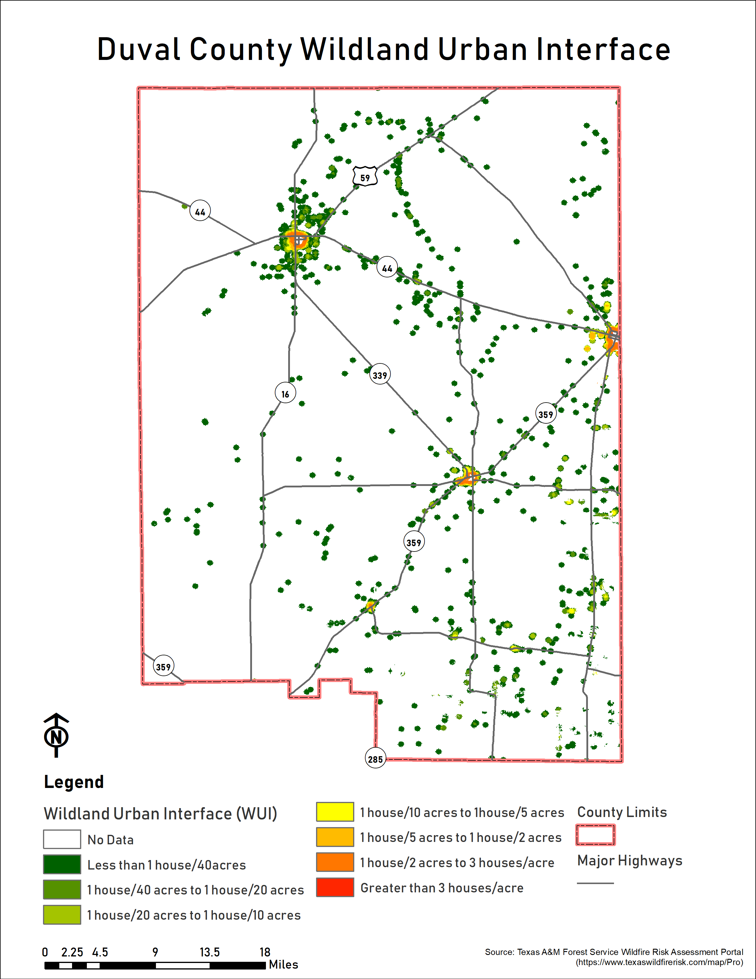
  - Figure 13: Duval County Wildland Urban Interface
  - 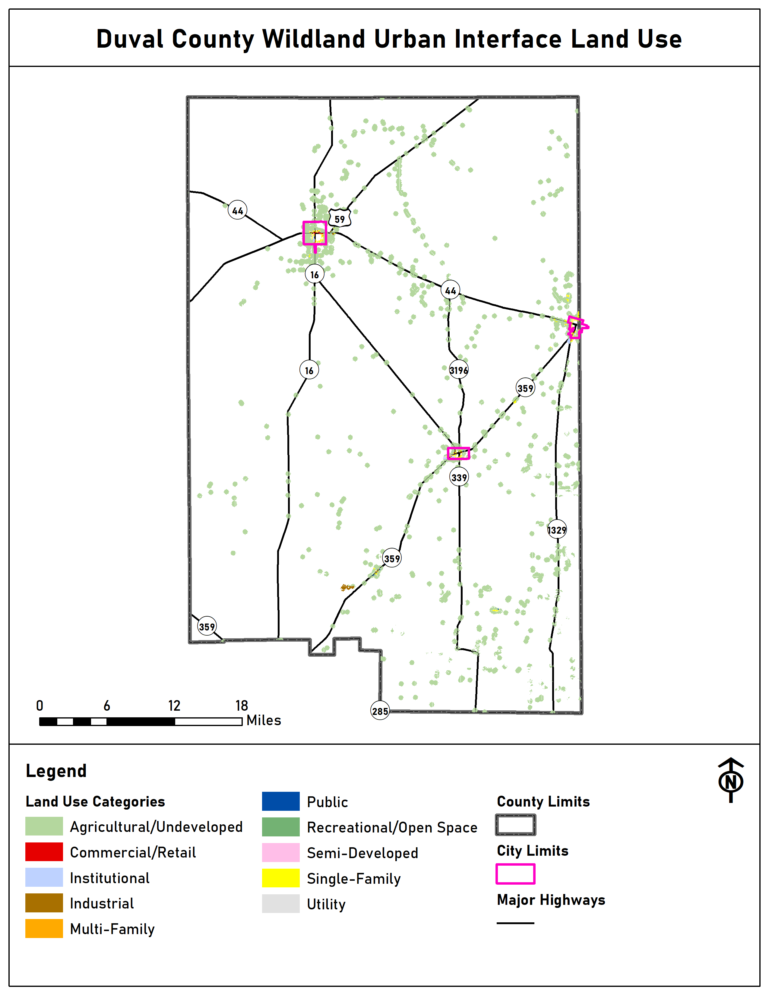
  - Figure 14: Duval County Wildland Urban Interface by Land Use Type

City of Benavides Location
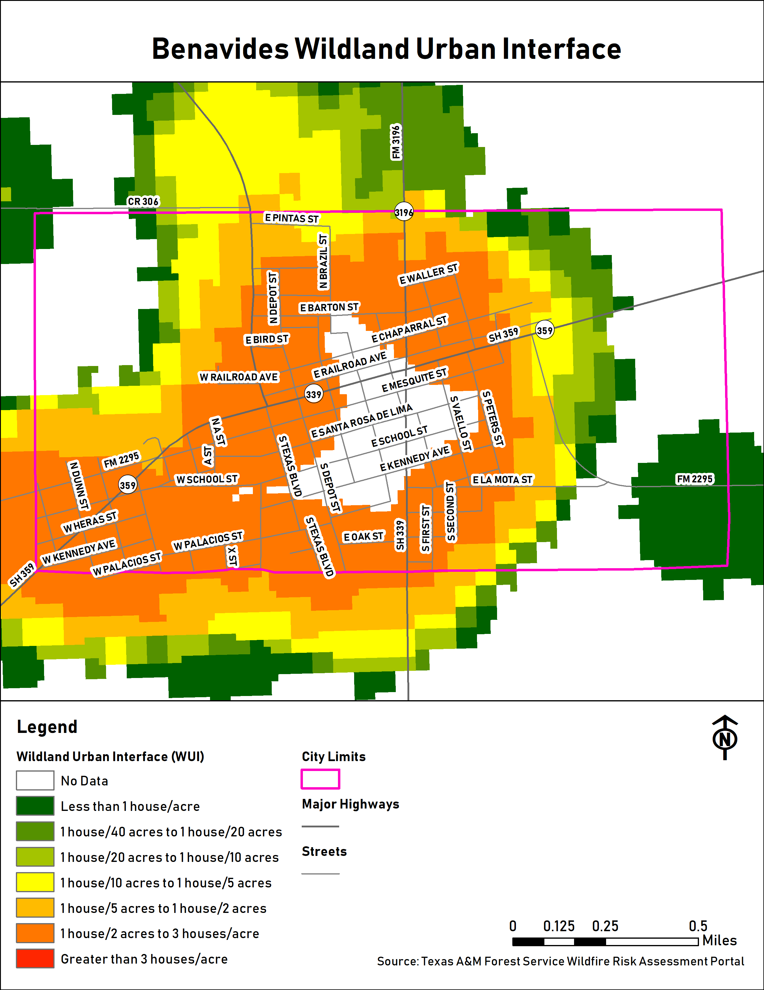
  - Figure 15: City of Benavides Wildland Urban Interface
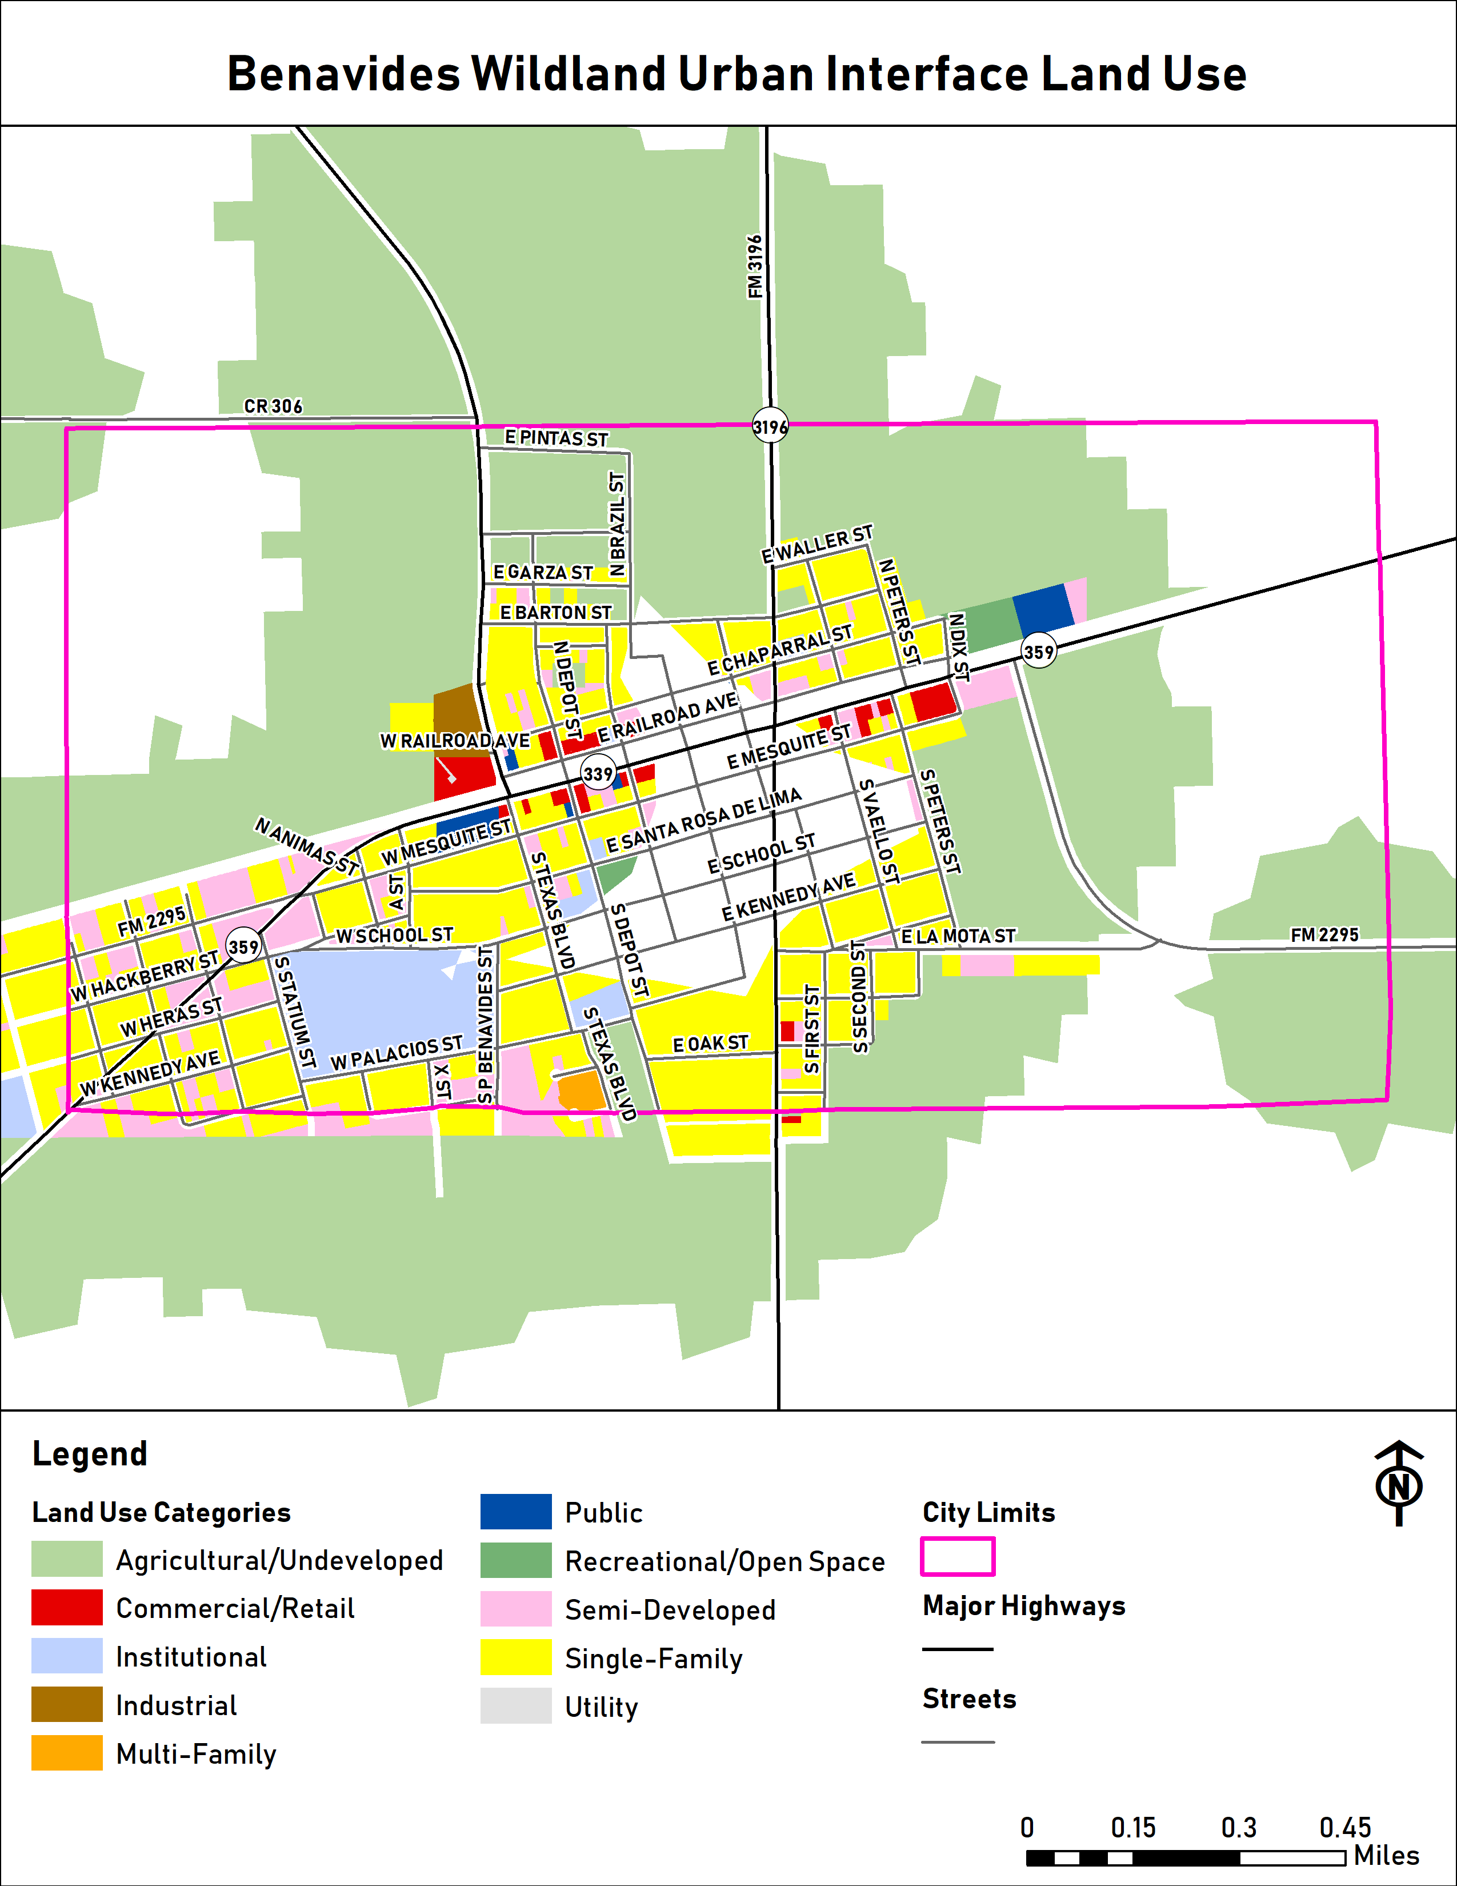
  - Figure 16: City of Benavides Wildland Urban Interface Land Use

City of Freer Location
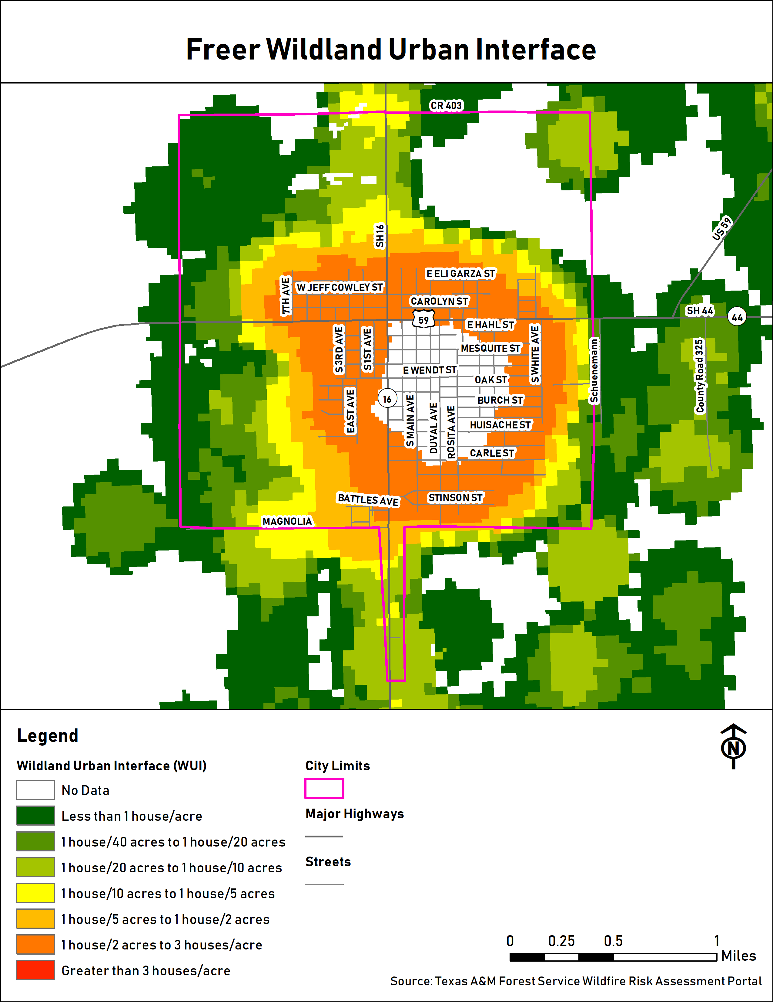
  - Figure 17: City of Freer Wildland Urban Interface
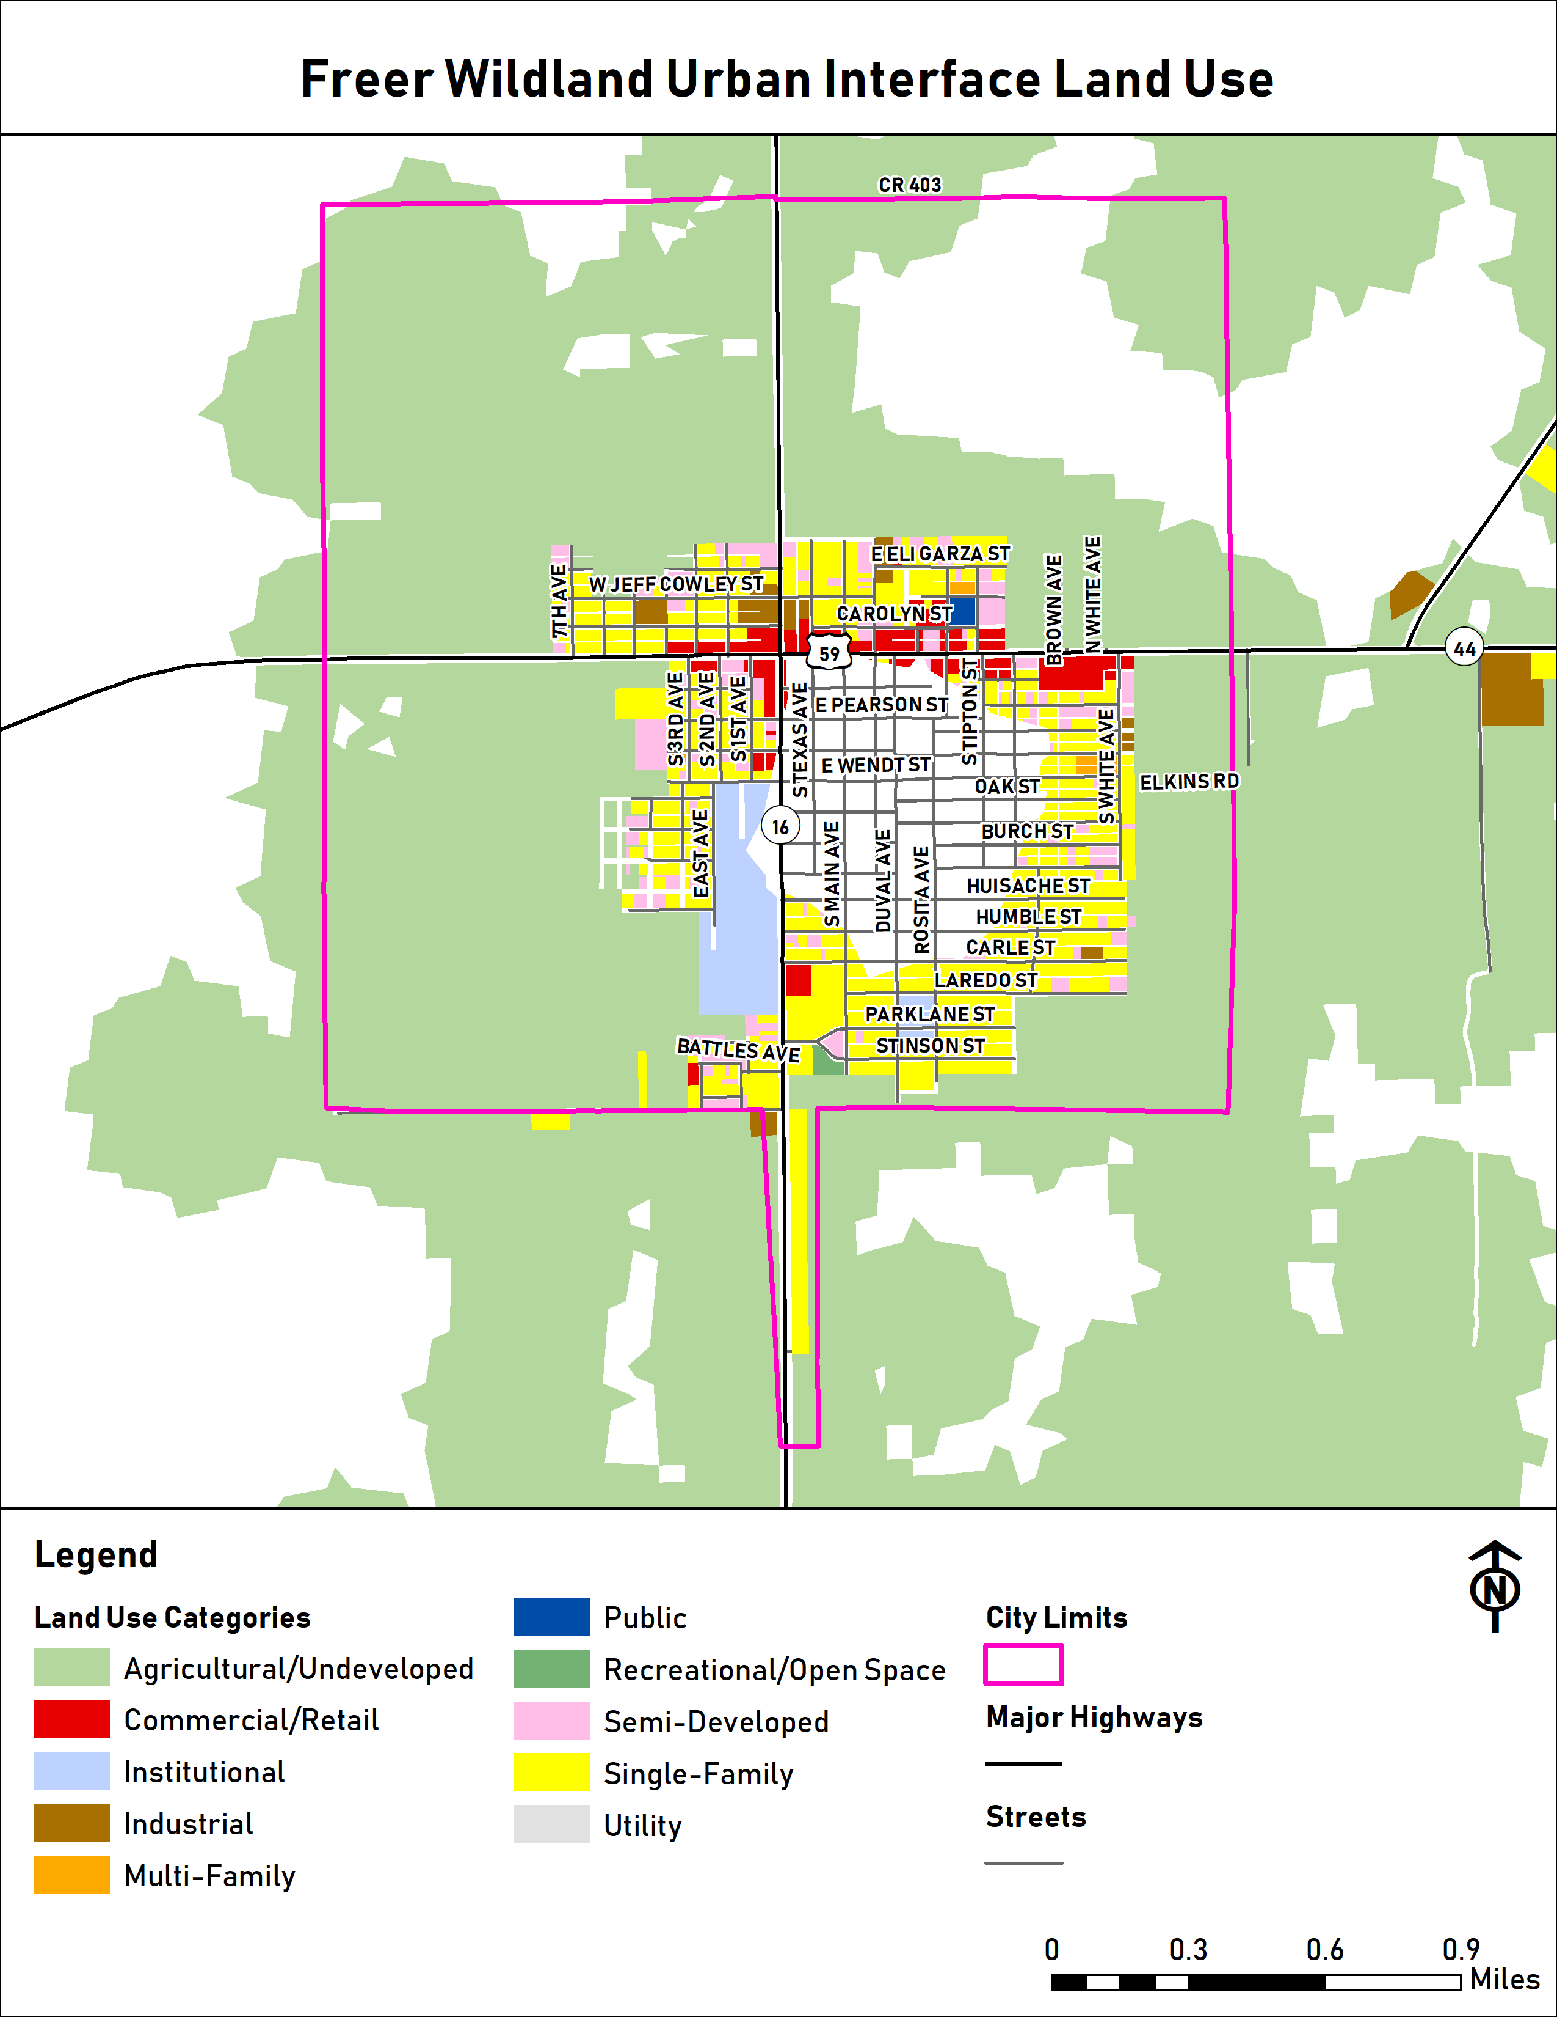
  - Figure 18: City of Freer Wildland Urban Interface by Land Use Type

City of San Diego Location
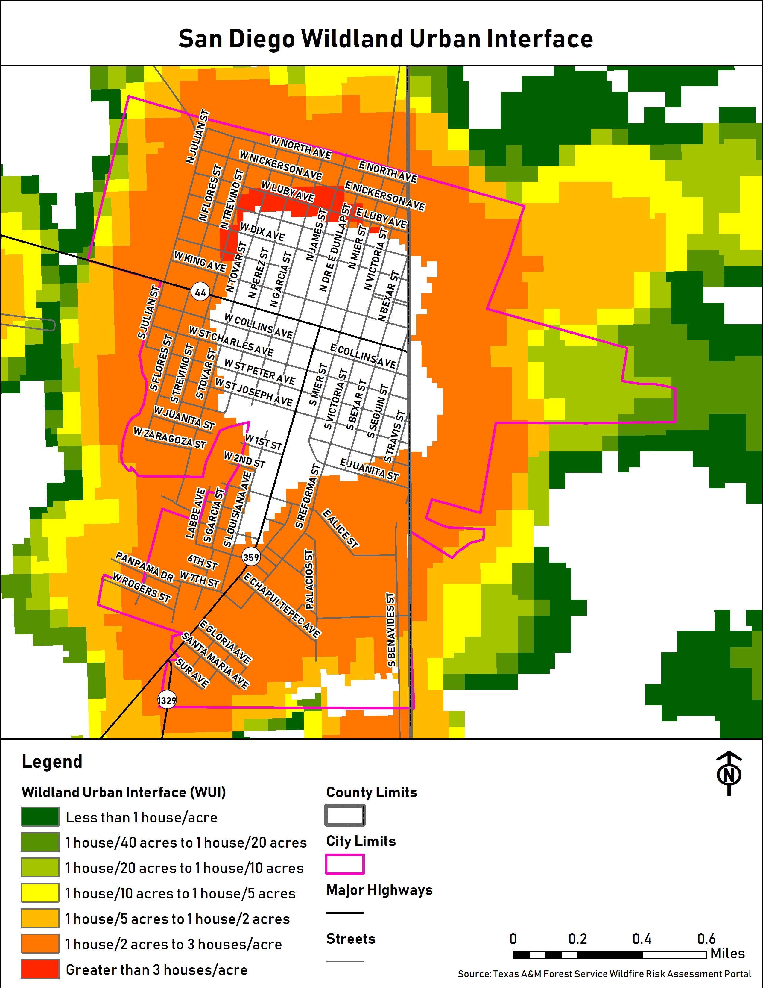
  - Figure 19: City of San Diego Wildland Urban Interface

Freer Water Control and Improvement District Location
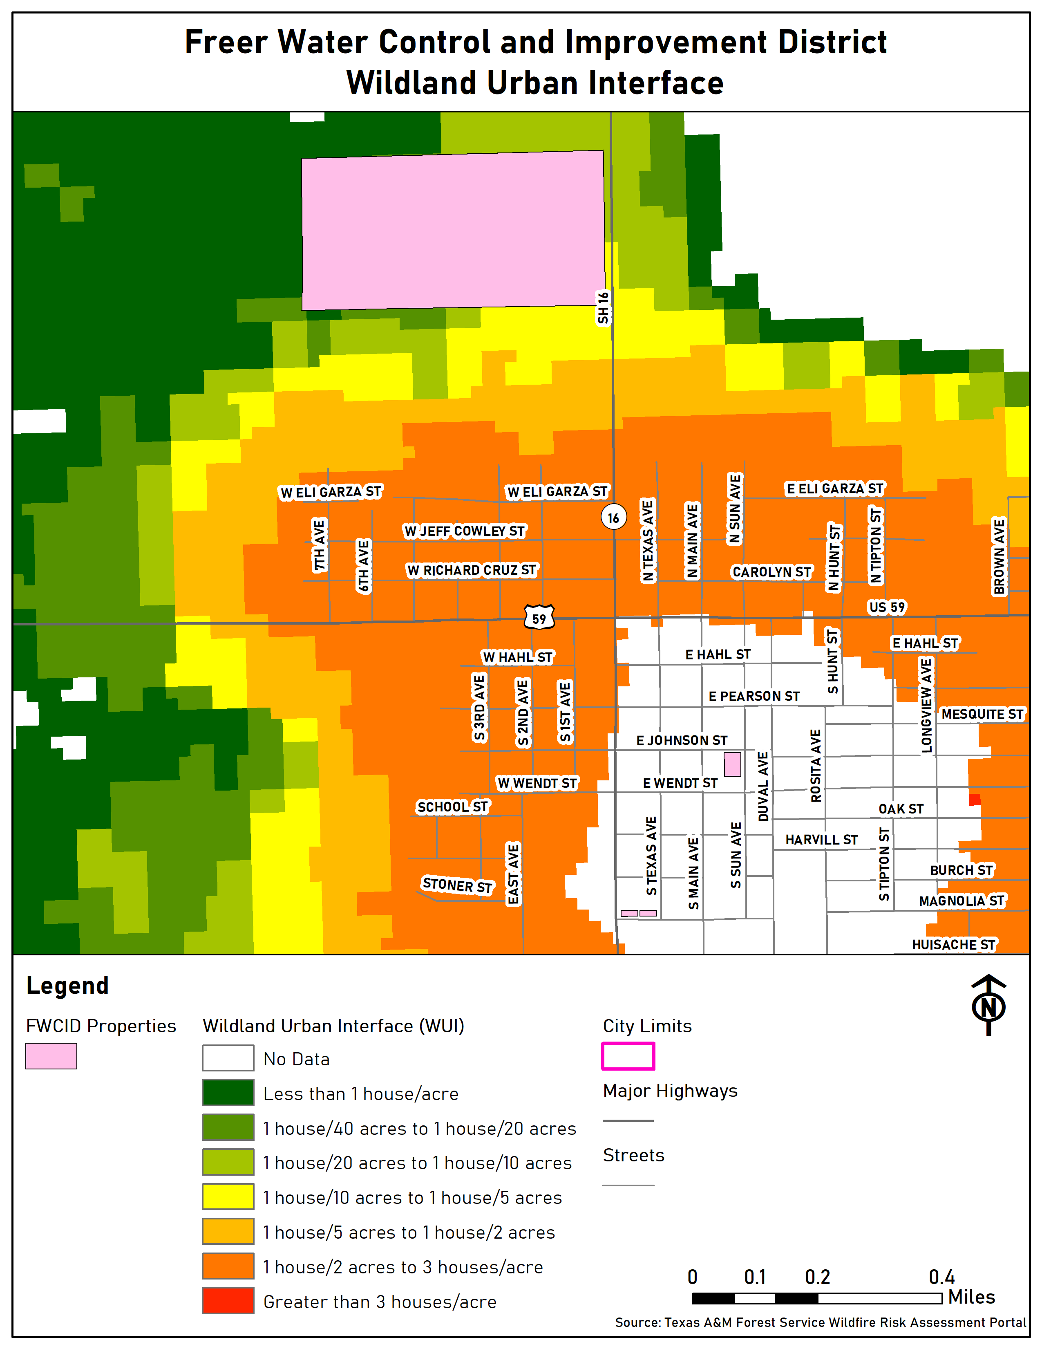
  - Figure 20: Freer Water Control and Improvement District Wildland Urban Interface

San Diego Municipal Utility District Location
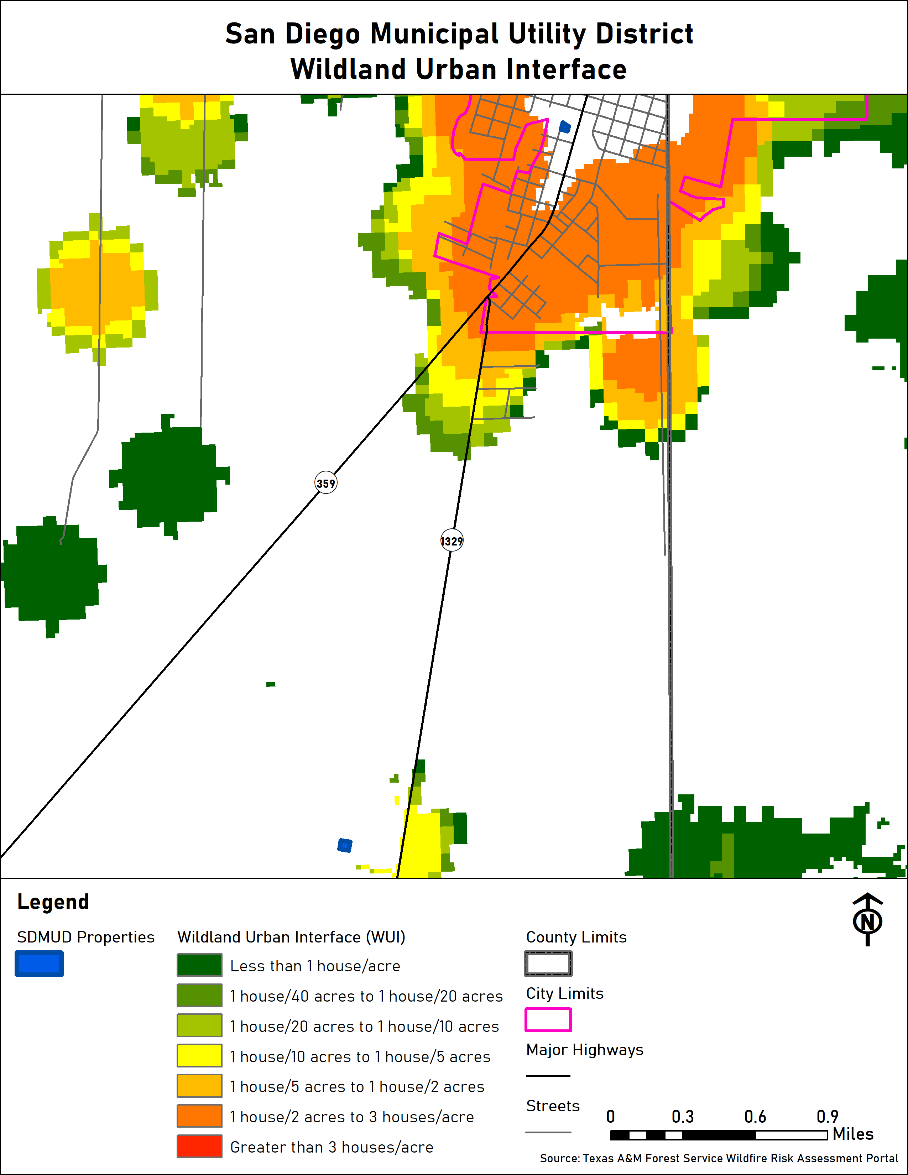
  - Figure 21: San Diego Municipal Utility District Wildland Urban Interface

Impact
Impacts from a wildfire in Duval County and the participating jurisdictions may include but are not limited to: crop damage or destruction, damaged or destroyed agricultural, residential, commercial, and industrial buildings, escaped, lost, injured or killed livestock and pets. In the worst cases, residents may be injured or killed.

Vulnerability

Population
As described in Section 3 of Chapter 3 above, Duval County and the jurisdictions addressing wildfire are home to many vulnerable residents. Increased vulnerability may be due to many factors including but not limited to: age, physical ability, financial means, housing type, and housing condition. Many of these vulnerabilities often overlap.
The jurisdictions recognize that vulnerable populations may need additional help preparing for and recovering from a wildfire.
Residents of mobile homes, specifically those built before HUD’s Manufactured Housing and Standards requirements were introduced in 1976, are of particular concern. These structures are more prone to fire and have a higher incidence of occupant death than modern manufactured homes.
Residents of sub-standard structures are also of particular concern. Structures in sub-standard condition ahead of a wildfire, whether due to structural damages, missing windows or doors, holes in exterior walls or the roof, may be less safe during a wildfire than structures in standard condition. Exterior damages may make the homes more prone to fire by more readily exposing flammable materials to flame. Missing windows and other exterior gaps may leave residents and structures prone to smoke inhalation and smoke damage.
All of these issues may increase damages and lead to injuries or loss of life.

Critical Facilities
There are 61 critical facilities located throughout the County and jurisdictions addressing wildfire. 18 of their critical facilities are located in the wildland urban interface (WUI), as defined by the Texas A&M Forest Service. Because of their location in the WUI, the density of development, and proximity to wildland areas, these facilities are believed to be particularly susceptible to future wildfire threats.
Table 27: Critical Facilities Vulnerable to Wildfire and Potential Impacts
Critical Facilities | Potential Wildfire Impacts
 | Destruction | Partial Destruction | Heat Damage | Smoke Damage | Water Damage
Benavides Branch Library | x | x | x | x | x
Benavides Civic Center | x | x | x | x | x
Concepcion Civic Center | x | x | x | x | x
Duval County Pct. 1 Shop | x | x | x | x | x
Duval County Pct. 2 Shop - Concepcion | x | x | x | x | x
Duval County Pct. 3 Shop | x | x | x | x | x
Freer Branch Library | x | x | x | x | x
Freer Civic Center | x | x | x | x | x
Freer WCID Water Treatment Plant | x | x | x | x | x
Realitos Civic Center | x | x | x | x | x
San Diego MUD Wastewater Treatment Plant | x | x | x | x | x
San Jose Civic Center | x | x | x | x | x
San Diego MUD - Luera Lift Station | x | x | x | x | x
San Diego MUD - Nunez Well | x | x | x | x | x
San Diego MUD - Mi Tierra Lift Station | x | x | x | x | x
San Diego MUD - Vic Lift Station | x | x | x | x | x
Duval County Pct. 4 Shop - Freer | x | x | x | x | x

Vulnerable Parcels
Table 28: Duval County Parcels Vulnerable to Wildfire
Jurisdiction | Total | Estimated Potential Damage Value
Duval County | 2,177 | $382,806,272

Table 29: City of Benavides Parcels Vulnerable to Wildfire
Jurisdiction | Total | Estimated Potential Damage Value
City of Benavides | 719 | $20,053,985

Table 30: City of Freer Parcels Vulnerable to Wildfire
Jurisdiction | Total | Estimated Potential Damage Value
City of Freer | 1,089 | $35,925,520

Table 31: City of San Diego Parcels Vulnerable to Wildfire
Jurisdiction | Total | Estimated Potential Damage Value
City of San Diego | 1,111 | $26,334,672
Table 32: San Diego Municipal Utility District Parcels Vulnerable to Wildfire
Jurisdiction | Total | Estimated Potential Damage Value
San Diego Municipal Utility District | 2 | $2,680

Table 33: Freer Water Control and Improvement District Parcels Vulnerable to Wildfire
Jurisdiction | Total | Estimated Potential Damage Value
Freer Water Control & Improvement District | 3 | $298,610

Tornado
A tornado is defined as a rapidly rotating vortex or funnel of air extending ground-ward from a cumulonimbus cloud. Most of the time, vortices remain suspended in the atmosphere and are visible as a funnel cloud. However, when the lower tip of a vortex touches the ground, the tornado becomes a force of destruction. Tornado strength is currently measured using the Enhanced Fujita (EF) Scale. Like the previously used Fujita scale, the EF Scale uses damage to estimate tornado wind speeds and assign a number between 0 and 5. A rating of EF0 represents minor to no damage whereas a rating of EF5 represents total destruction of buildings.

Tornado History
According to data from the National Climatic Data Center, there were 19 tornados in Duval County between 1961 – 2015. No tornados have been recorded in any participating jurisdiction since 2015.

Duval County
Table 34: Duval County Tornado History
Location | Date Range | Number of Tornados | F / EF  Magnitude Range | Fatalities | Injuries | Property Damage  $2018 | Crop Damage  $2018
Duval County | 9/8/1961 - 5/15/2015 | 17 | F0 - F2  EF0 | 0 | 4 | $5,767,355 | $4,117,182

City of San Diego
Table 35: City of San Diego Tornado History
Location | Date Range | Number of Tornados | F / EF  Magnitude Range | Fatalities | Injuries | Property Damage  $2018 | Crop Damage  $2018
San Diego | 2/21/1998 - 7/20/2005 | 2 | F0 | 0 | 0 | $0 | $0

The San Diego Municipal Utility District has the same boundaries as the City of San Diego and is assumed to have the same history of tornados.
Although the City of Benavides, the Duval County Conservation and Reclamation District, the City of Freer, and the Freer Water Control & Improvement District have not recorded any previous tornados, their locations and tornados’ unpredictable nature means they’re as vulnerable to tornados as every other participant.

Likelihood of Future Events
Based on the frequency of previous tornados in Duval County and the participating jurisdictions, a future event that may impact any or all of them is occasional, meaning one is possible in the next five years.

Extent
Before 2007, the Fujita Scale was used for rating tornado strength. The Fujita Scale is based on damage intensity instead of wind speed, with estimated wind speed ranges based on the extent of observed damage.
Table 36: Fujita Scale
Fujita Scale
Enhanced Fujita Category | Wind Speed (MPH) | Character | Potential Damage
Zero (F0) | 40-72 | Weak | Light Damage. Some damage to chimneys; branches broken off trees, shallow-rooted trees uprooted, sign boards damaged.
One (F1) | 73-112 | Weak | Moderate damage. Roof surfaces peeled off; mobile homes pushed foundations or overturned; moving autos pushed off road.
Two (F2) | 113-157 | Strong | Considerable damage. Roofs torn from frame houses; mobile homes demolished; boxcars pushed over; large trees snapped or uprooted; light objects become projectiles.
Three (F3) | 158-206 | Strong | Severe damage. Entire stories of well-constructed houses destroyed; severe damage to large buildings such as shopping malls; trains overturned; trees debarked; heavy cars lifted off the ground and thrown; structures with weak foundations blown away some distance.
Four (F4) | 207-260 | Violent | Devastating damage. Well-constructed houses and whole frame houses completely leveled; cars thrown and small missiles generated.
Five (F5) | 260-318 | Violent | Incredible damage. Strong frame houses leveled off foundations and swept away; automobile-sized missiles fly through the air in excess of 100 m (109 yds.); high-rise buildings have significant structural deformation; incredible phenomena will occur.

Adopted after 2007, The Enhanced Fujita Scale, or EF Scale, is the scale for rating the strength of tornados via the damage they cause. Six categories from zero to five represent increasing degrees of damage. The scale considers how most structures are designed, and is thought to be an accurate representation of the surface wind speeds in the most violent tornados.
Table 37: Enhanced Fujita Scale
Enhanced Fujita (EF) Scale
Enhanced Fujita Category | Wind Speed (MPH) | Potential Damage
EF0 | 65-85 | Light damage. Peels surface off some roofs; some damage to gutters or siding; branches broken off trees; shallow-rooted trees pushed over.
EF1 | 86-110 | Moderate damage. Roofs severely stripped; mobile homes overturned or badly damaged; loss of exterior doors; windows and other glass broken.
EF2 | 111-135 | Considerable damage. Roofs torn off well-constructed houses; foundations of frame homes shifted; mobile homes completely destroyed; large trees snapped or uprooted; light-object missiles generated; cars lifted off ground.
EF3 | 136-165 | Severe damage. Entire stories of well-constructed houses destroyed; severe damage to large buildings such as shopping malls; trains overturned; trees debarked; heavy cars lifted off the ground and thrown; structures with weak foundations blown away some distance.
EF4 | 166-200 | Devastating damage. Well-constructed houses and whole frame houses completely leveled; cars thrown and small missiles generated.
EF5 | 200+ | Incredible damage. Strong frame houses leveled off foundations and swept away; automobile-sized missiles fly through the air in excess of 100 m (109 yds.); high-rise buildings have significant structural deformation; incredible phenomena will occur.

Previous tornados ranged in strength from F0 to F2 on the Fujita Scale. Since the switch to the updated scale, only one EF0 tornado has been recorded. In terms of property damages inflicted, the worst reported tornado in Duval County and the participating jurisdictions was unrated. That tornado caused the $2018 equivalent of $8,234,363 in both property and crop damages after adjusting for inflation. Previous tornados injured up to four people. No deaths have been recorded associated with tornados.
Future tornados may meet previous worst-case tornado events in terms of total damage dollars inflicted and the number of residents injured or killed.

Location and Impact

Location
Tornados are not constrained by any distinct geographic boundary. Tornados can occur across all participating jurisdictions, and may freely cross from one jurisdiction into another.

Impact
Impacts from a tornado may include but are not limited to damaged or destroyed personal property including vehicles, damaged or destroyed agricultural, residential, commercial, and industrial buildings. Crops may be damaged or destroyed. Pets and livestock may be injured or killed by tornados or flying debris. Pets and livestock may escape due to damaged or destroyed structures and fences.
In the worst cases, tornados may cause injuries and/or be deadly.

Vulnerability
Tornadoes have the potential to impact the entire planning area. All existing and future buildings, critical facilities, critical infrastructure, improved property, and the population of the participating jurisdictions are considered vulnerable to this hazard.

Population
As described in Section 3 of Chapter 3 above, Duval County and the participating jurisdictions are home to many vulnerable residents. Increased vulnerability may be due to many factors including but not limited to: age, physical ability, financial means, housing type, and housing condition. Many of these vulnerabilities often overlap.
The participating jurisdictions recognize that vulnerable populations may need additional help preparing for and recovering from a tornado.
Residents of mobile / manufactured homes are of particular concern. These structures are never considered safe during a tornado.
Residents of sub-standard structures are also of particular concern. Structures in sub-standard condition ahead of a tornado, whether due to structural damages, missing windows or doors, holes in exterior walls or the roof, may be less safe during a tornado than structures in standard condition.
Existing structural weaknesses, due to housing type or existing damages, may lead to compounded damages, injuries, or loss of life.

Critical Facilities and Infrastructure
Certain critical facilities and infrastructure in each jurisdiction may be particularly vulnerable to tornados. These facilities have been identified for reasons including: the number of people who use the facility or infrastructure, the facility’s role in providing basic services to begin the cleanup process and get the jurisdictions running again, and the facility’s ability to offer goods and materials residents will need to resume normalcy as quickly as possible. The selected critical facilities are built from a variety of materials with varying levels of resistance to tornadic damages. Additionally, their varying ages mean they weren’t constructed to uniform building standards. Given tornados’ violent nature, these facilities may experience increased levels of vulnerability to the hazards. Damage to any of these facilities may have a disproportionately negative impact on each jurisdiction’s recovery from a tornado if that damage affects the facility’s ability to reopen and resume normal business right away.
Table 38: Critical Facilities Vulnerable to Tornados and Potential Impacts
 | Potential Tornado Impacts
 | Loss of Power | Flying Debris | Uprooted Trees | Flooding | Flooding Due to Physical Damages | Damaged or Destroyed Roofs | Damaged or Broken Windows | Wind Damage | Injuries | Death
Benavides Branch Library | x | x | x |  | x | x | x | x | x | x
Benavides City Hall / Police Station / VFD | x | x | x |  | x |  | x |  | x | x
Benavides Civic Center | x | x |  |  | x | x | x |  | x | x
Benavides EMS | x | x |  |  | x |  |  | x | x | x
Concepcion Civic Center | x | x |  |  | x | x |  | x | x | x
Duval County Conservation and Reclamation District Office | x | x | x |  | x |  |  | x | x | x
Duval County Courthouse | x | x | x |  | x | x | x | x | x | x
Duval County Pct. 1 Shop | x | x |  |  | x | x |  | x | x | x
Duval County Pct. 2 Shop - Concepcion | x | x | x |  | x | x | x | x | x | x
Duval County Pct. 2 Shop - San Diego | x | x | x |  | x | x |  | x | x | x
Duval County Pct. 3 Shop | x | x |  |  | x | x |  | x | x | x
Duval County Pct. 4 Shop - Freer | x | x |  |  | x | x |  | x | x | x
Duval County Sheriff's Department | x | x | x |  | x | x | x | x | x | x
Duval Freer Airport | x | x |  |  |  | x |  | x | x | x
Freer Branch Library | x | x | x |  | x | x | x | x | x | x
Freer City Hall / Police Department | x | x | x |  | x |  |  | x | x | x
Freer Civic Center | x | x | x |  | x | x | x | x | x | x
Freer VFD / EMS | x | x | x |  |  | x |  | x | x | x
Freer Water Control & Improvement District | x | x | x |  | x | x | x | x | x | x
Freer WCID Wastewater Treatment Plant |  |  |  |  |  |  |  |  | x | x
Freer WCID Water Treatment Plant | x | x | x |  | x |  |  | x | x | x
FWCID Ground Storage Tank | x | x | x |  |  |  |  |  | x | x
FWCID Well #10 | x |  |  |  |  |  |  |  | x | x
FWCID Well #14 | x |  |  |  |  |  |  |  | x | x
FWCID Well #16 | x |  |  |  |  |  |  |  | x | x
FWCID Well #19 | x |  |  |  |  |  |  |  | x | x
FWCID Well #21 | x |  |  |  |  |  |  |  | x | x
FWCID Well #22 | x |  |  |  |  |  |  |  | x | x
FWCID Well #23 | x |  |  |  |  |  |  |  | x | x
FWCID Well #24 | x |  |  |  |  |  |  |  | x | x
Realitos Civic Center | x | x | x |  | x | x | x | x | x | x
San Diego Branch Library | x | x | x |  | x | x |  | x | x | x
San Diego City Hall / Police Department | x | x | x | x | x | x | x | x | x | x
San Diego Civic Center | x | x | x |  | x | x |  | x | x | x
San Diego EMS | x | x | x | x | x | x | x | x | x | x
San Diego MUD - 4 A's Well | x |  |  |  |  |  |  |  | x | x
San Diego MUD - Briones Lift Station | x | x | x |  |  |  |  |  | x | x
San Diego MUD - Cadena Lift Station | x | x | x | x | x |  |  |  | x | x
San Diego MUD - City Well | x |  |  |  |  |  |  |  | x | x
San Diego MUD - Creek Lift Station | x |  |  | x | x |  |  |  | x | x
San Diego MUD - Everett Well | x |  |  |  |  |  |  |  | x | x
San Diego MUD - Hinojosa Well | x |  |  | x | x |  |  |  | x | x
San Diego MUD - Labbe Well | x |  |  |  |  |  |  |  | x | x
San Diego MUD - Luera Lift Station | x | x | x | x | x |  |  |  | x | x
San Diego MUD - Mauro Lift Station | x |  |  |  |  |  |  |  | x | x
San Diego MUD - Mi Tierra Lift Station | x |  |  |  |  |  |  |  | x | x
San Diego MUD - Nunez Well | x |  |  |  |  |  |  |  | x | x
San Diego MUD - Prison Lift Station | x | x | x |  |  |  |  |  | x | x
San Diego MUD - Prison Pump House | x |  |  |  |  |  |  |  | x | x
San Diego MUD - Prison Well | x |  |  |  |  |  |  |  | x | x
San Diego MUD - Rotary Lift Station | x |  |  |  |  |  |  |  | x | x
San Diego MUD - Salazar Lift Station | x | x | x |  |  |  |  |  | x | x
San Diego MUD - Sandoval Lift Station | x | x | x |  |  |  |  |  | x | x
San Diego MUD - Solis Well | x |  |  |  |  |  |  |  | x | x
San Diego MUD - Tovar Lift Station | x | x | x |  |  |  |  |  | x | x
San Diego MUD - Tower Well | x |  |  | x | x |  |  |  | x | x
San Diego MUD - Vic Lift Station | x |  |  |  |  |  |  |  | x | x
San Diego MUD Wastewater Treatment Plant | x | x |  |  | x |  |  |  | x | x
San Diego MUD Water Treatment Plant | x |  |  | x | x |  |  |  | x | x
San Diego Municipal Utility District Office | x | x | x | x | x | x | x | x | x | x
San Jose Civic Center | x | x |  |  | x | x | x | x | x | x

Vulnerable Parcels
Table 39: Parcels Vulnerable to Tornados
Jurisdiction | Estimated Parcel Count | Estimated Potential Damage Value
Duval County | 10,583 | $1,275,876,637
City of Benavides | 958 | $26,174,315
City of Freer | 1,721 | $52,024,280
City of San Diego | 2,190 | $58,698,302
Duval County Conservation and Reclamation District | 2 | $152,660
Freer Water Control & Improvement District | 3 | $298,610
San Diego Municipal Utility District | 2 | $2,680

Drought
Drought is defined as the consequence of a natural reduction in the amount of precipitation expected over an extended period of time, usually a season or more in length.
Droughts are one of the most complex natural hazards to identify because it is difficult to determine their precise beginning or end. In addition, droughts can lead to other hazards such as extreme heat and wildfires. Their impact on wildlife and area farming is enormous, often killing crops, grazing land, edible plants and even in severe cases, trees. A secondary hazard to drought is wildfire because dying vegetation serves as a prime ignition source. Therefore, a heat wave combined with a drought is a very dangerous situation.
Table 40: Drought Classifications
Meteorological Drought | The degree of dryness or departure of actual precipitation from an expected average or normal amount based on monthly, seasonal, or annual time scales.
Hydrologic Drought | The effects of precipitation shortfalls on stream flows and reservoir, lake, and groundwater levels.
Agricultural Drought | Soil moisture deficiencies relative to water demands of plant life, usually crops.
Socioeconomic Drought | The effect of demands for water exceeding the supply as a result of a weather-related supply shortfall.

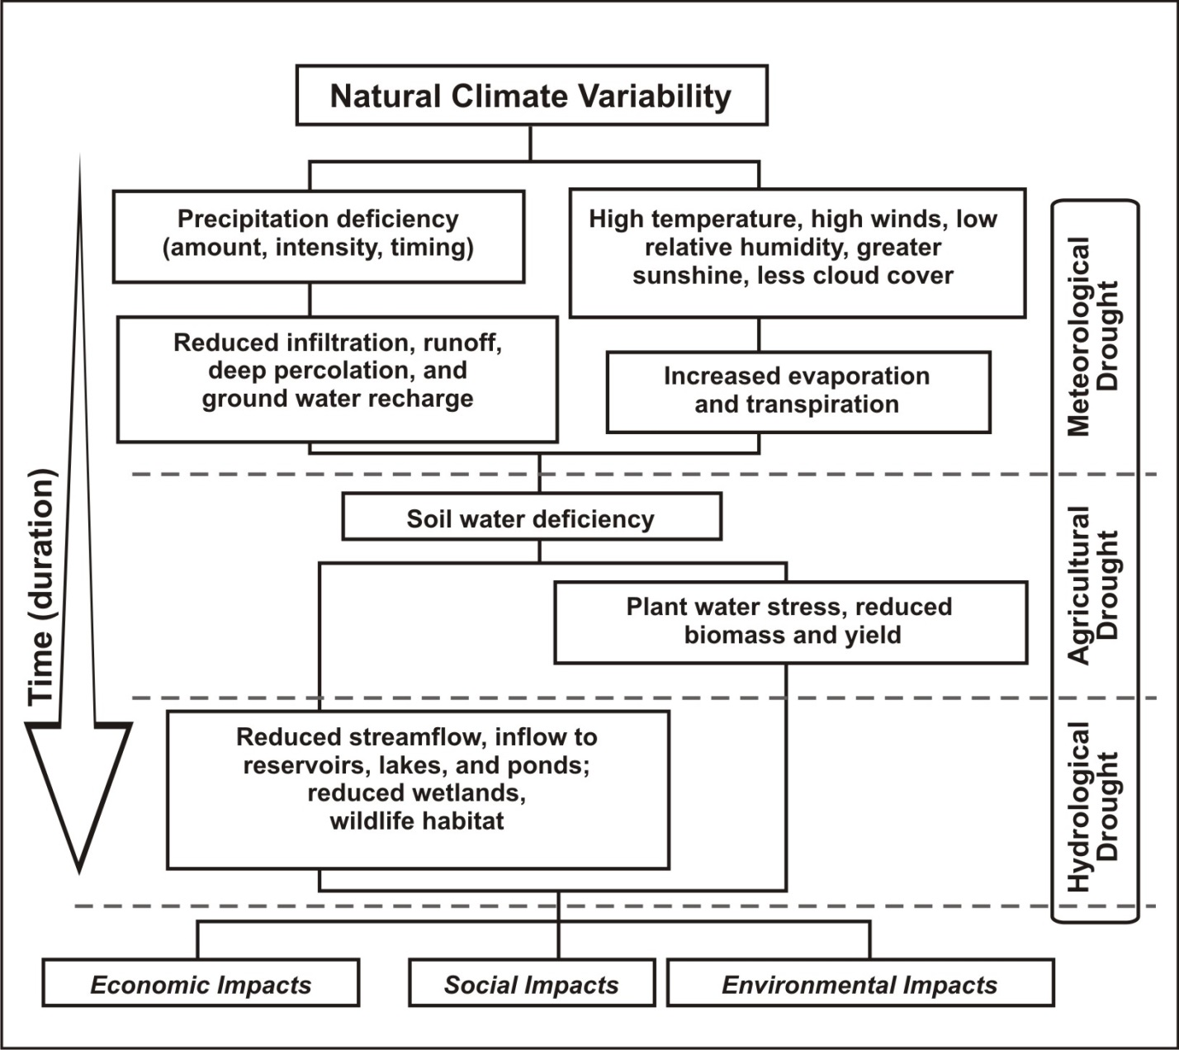
  - Figure 22: Sequence of Drought Occurrence and Impacts for Commonly Accepted Drought Types

Drought History

  - Figure 23: Duval County Drought History

Drought history is recorded at the County level. However, the data is measured by the percentage of the County affected by drought. Although no specific data regarding drought’s occurrences in the individual cities is available, it’s possible to use the data in Figure 23 to infer when the participating jurisdictions previously experienced drought conditions due to the fact that the conditions impacted 100% of the county. According to the data, Duval County and the participating jurisdictions have regularly experienced drought conditions since 2000, especially between 2005 – 2007, 2008 – 2010, and 2011 – 2015.
According to the Duval County 2013 CHAMPS Report, drought conditions on July 1, 1989 caused $34,521,564 in crop damages adjusted to $2018. There are no recorded injuries or deaths due to drought in Duval County or the participating jurisdictions.
The Duval County Conservation and Reclamation District determined that the history of impacts of drought have been negligible (or non-existent), therefore it is expected that future impacts will be negligible as well, and isn’t addressing the hazard.

Likelihood of Future Events
Based on historical drought in Texas and Duval County, it is likely that a future drought will affect Duval County and the participating jurisdictions, meaning an event affecting any or all of the participating jurisdictions is probable in the next three years, and a major drought every 20 years.

Extent
Since 2000, Duval County has regularly experienced county-wide droughts classified as periods ranging from abnormal dryness to exceptional drought. At multiple times, the entire County, including all participating jurisdictions, has been in exceptional drought, the most severe drought category.
The Palmer Drought Index is used to measure the extent of drought by measuring the duration and intensity of long‐term drought‐inducing circulation patterns. Long‐term drought is cumulative, with the intensity of drought during the current month dependent upon the current weather patterns plus the cumulative patterns of previous months. The hydrological impacts of drought (e.g., reservoir levels, groundwater levels, etc.) take longer to develop.
Table 41: Palmer Drought Index
Drought Index | Drought Conditions Classifications
 | Extreme | Severe | Moderate | Normal | Mostly Moist | Very Moist | Extremely Moist
Z Index | -2.75 and below | -2.00 to -2.74 | -1.25 to -1.99 | -1.24 to +.99 | +1.00 to +2.49 | +2.50 to +3.49 | n/a
Meteorological | -4.00 and below | -3.00 to -3.99 | -2.00 to -2.99 | -1.99 to +1.99 | +2.00 to +2.00 | +3.00 to +3.00 | +4.00 and above
Hydrological | -4.00 and below | -3.00 to -3.99 | -2.00 to -2.99 | -1.99 to +1.99 | +2.00 to +2.00 | +3.00 to +3.00 | +4.00 and above

Table 42: Palmer Drought Category Descriptions
Category | Description | Possible Impacts | Palmer Drought Index
D0 | Abnormally Dry | Going into drought: short‐term dryness slowing planting, growth of crops or pastures; fire risk above average. Coming out of drought: some lingering water deficits; pastures or crops not fully recovered. | -1.0 to -1.9
D1 | Moderate Drought | Some damage to crops, pastures; fire risk high; streams, reservoirs, or wells low, some water shortages developing or imminent, voluntary water use restrictions requested. | -2.0 to -2.9
D2 | Severe Drought | Crop or pasture losses likely; fire risk very high; water shortages common; water restrictions imposed. | -3.0 to -3.9
D3 | Extreme Drought | Major crop/pasture losses; extreme fire danger; widespread water shortages or restrictions. | -4.0 to -4.9
D4 | Exceptional Drought | Exceptional and widespread crop/pasture losses; exceptional fire risk; shortages of water in reservoirs, streams, and wells, creating water emergencies. | -5.0 or less

Drought is monitored nationwide by the National Drought Mitigation Center (NDMC). Indicators are used to describe broad scale drought conditions across the U.S. Indicators correspond to the intensity of drought.
Based on the historical occurrences of drought, Duval County and all participating jurisdictions should anticipate experiencing droughts ranging from abnormally dry to exceptional drought or D0 to D4 based on the Palmer Drought Category. Given varying conditions, droughts may start on the low end of the Palmer Drought Category, but will intensify with duration and an ongoing lack of precipitation.
Duval County recorded its worst drought in recent history between July 2011 and July 2013. Between July 2011 and July 2013, the percentage of the County considered abnormally dry or worse never dropped below 100% except during 5 months spread throughout that time period. From July 2011 until May 2012, between 20% - 100% of the County was in exceptional drought.
According to the Duval County 2013 CHAMPS Report, since 1977, the worst droughts in Duval County and the participating jurisdictions have inflicted up to $28,703 in property damages and $34,521,564 in crop damages.
Future drought events may meet previous worst-case D4 droughts in terms of intensity, duration, and total damage dollars inflicted.

Location and Impact

Location
Drought has no distinct geographic boundary. Drought can occur across all participating jurisdictions.

Impact
General impacts may include water shortage, risk to public safety due to wildfire risk increases, respiratory impacts to the public due to affected air quality, and degradation of fish and wildlife habitat.
Economic impacts may include: increased prices for food, unemployment for farm workers and ranch hands, livestock mortality from limited grazing availability, and reduced tax revenues because of reduced supplies of agriculture products and livestock that are dependent on rainfall.
The Duval County Conservation and Reclamation District adopted its current Drought Contingency Plan in April 2019. The plan describes five stages of water restrictions ranging from voluntary conservation to a prohibition of activities. Each stage is triggered by changes in the level of water demand relative to the safe operating capacity of the District’s water supply facilities or the occurrence of a water supply emergency.
The Freer Water Control & Improvement District adopted its current Drought Contingency Plan in September 2000. The plan describes five stages of water restrictions ranging from voluntary conservation to a prohibition of activities. Each stage is triggered by changes in the level of water demand relative to the safe operating capacity of the District’s water supply facilities or the occurrence of a water supply emergency.
The San Diego Municipal Utility District adopted its current Drought Contingency Plan in October 2013. The plan describes three stages of water restrictions ranging from voluntary conservation to a prohibition of activities. Each stage is triggered by changes in the level of water demand relative to the safe operating capacity of the District’s water supply facilities or the occurrence of a water supply emergency.

Vulnerability
Because drought has the potential to impact every jurisdiction equally, all improved property and the entire population is exposed to this hazard. Foundations of all buildings are vulnerable; however, older structures or those built under less stringent foundation code requirements are most vulnerable. Critical infrastructure like water and wastewater lines, roads, and railroads are also vulnerable. Lower income populations who may not have the resources to buy large quantities of bottled water in the event of a shortage may be more vulnerable than other populations.

Population
As described in Section 3 of Chapter 3 above, Duval County and the participating jurisdictions are home to many vulnerable residents. Increased vulnerability may be due to many factors including but not limited to: age, physical ability, financial means, housing type, and housing condition. Many of these vulnerabilities often overlap.
The jurisdictions recognize that vulnerable populations may need additional help preparing for and recovering from a drought.
Lower income populations who may not have the resources to buy large quantities of bottled water in the event of a shortage may be more vulnerable than other populations.
Residents of sub-standard structures are also of particular concern. Structures in sub-standard condition ahead of a drought may be more likely to suffer additional damages, including irreparable damage to building foundations as soils shift and shrink. Depending on their financial means, these residents may require additional assistance recovering from drought-caused damages.

Critical Facilities
In addition to triggering various components of participating jurisdictions’ Drought Contingency plans, drought conditions may affect local critical facilities. Area fire departments may see increased demand for controlling wildland fire due to dry conditions. Drought is likely to require increased output from the local power company, in order to keep up with electrical demand. Depending on factors like time of year, temperature, and duration, increased electrical demand may cause brownouts that would impact critical facilities. Structural damage to all critical facilities, based on the rarity of previous instances of structural damage, is expected to be limited. However, in the worst cases such damage is possible, and may include cracked building foundations, damages to water and wastewater lines that serve the facilities, and in certain cases, these physical damages may create economic damages for the broader community.
Table 43: Critical Facilities Vulnerable to Drought and Potential Impacts
Critical Facilities | Potential Drought Impacts
 | Structural Damage | Increased Demand for Services | Economic Damages
Benavides Branch Library | x | x
Benavides City Hall / Police Station / VFD | x | x
Benavides Civic Center | x | x
Benavides EMS | x | x
Concepcion Civic Center | x | x
Duval County Courthouse | x | x
Duval County Pct. 1 Shop | x | x
Duval County Pct. 2 Shop - Concepcion | x | x
Duval County Pct. 2 Shop - San Diego | x | x
Duval County Pct. 3 Shop | x | x
Duval County Pct. 4 Shop - Freer | x | x
Duval County Sheriff's Department | x | x
Duval Freer Airport | x | x | x
Freer Branch Library | x | x
Freer City Hall / Police Department | x | x
Freer Civic Center | x | x
Freer VFD / EMS | x | x
Freer Water Control & Improvement District | x | x
Freer WCID Wastewater Treatment Plant | x | x | x
Freer WCID Water Treatment Plant | x | x | x
FWCID Ground Storage Tank | x | x | x
FWCID Well #10 | x | x | x
FWCID Well #14 | x | x | x
FWCID Well #16 | x | x | x
FWCID Well #19 | x | x | x
FWCID Well #21 | x | x | x
FWCID Well #22 | x | x | x
FWCID Well #23 | x | x | x
FWCID Well #24 | x | x | x
Realitos Civic Center | x | x
San Diego Branch Library | x | x
San Diego City Hall / Police Department | x | x
San Diego Civic Center | x | x
San Diego EMS | x | x
San Diego MUD - 4 A's Well | x | x | x
San Diego MUD - Briones Lift Station | x | x | x
San Diego MUD - Cadena Lift Station | x | x | x
San Diego MUD - City Well | x | x | x
San Diego MUD - Creek Lift Station | x | x | x
San Diego MUD - Everett Well | x | x | x
San Diego MUD - Hinojosa Well | x | x | x
San Diego MUD - Labbe Well | x | x | x
San Diego MUD - Luera Lift Station | x | x | x
San Diego MUD - Mauro Lift Station | x | x | x
San Diego MUD - Mi Tierra Lift Station | x | x | x
San Diego MUD - Nunez Well | x | x | x
San Diego MUD - Prison Lift Station | x | x | x
San Diego MUD - Prison Pump House | x | x | x
San Diego MUD - Prison Well | x | x | x
San Diego MUD - Rotary Lift Station | x | x | x
San Diego MUD - Salazar Lift Station | x | x | x
San Diego MUD - Sandoval Lift Station | x | x | x
San Diego MUD - Solis Well | x | x | x
San Diego MUD - Tovar Lift Station | x | x | x
San Diego MUD - Tower Well | x | x | x
San Diego MUD - Vic Lift Station | x | x | x
San Diego MUD Wastewater Treatment Plant | x | x | x
San Diego MUD Water Treatment Plant | x | x | x
San Diego Municipal Utility District Office | x | x
San Jose Civic Center | x | x

Vulnerable Parcels and Infrastructure
Given drought’s geographic reach, all parcels within the participating jurisdictions are equally vulnerable to the hazard. However, given the limited damages inflicted by previous droughts, future damages are expected to be similarly limited.
Table 44: Parcels Vulnerable to Drought
Jurisdiction | Estimated Parcel Count | Estimated Potential Damage Value
Duval County | 10,583 | $1,275,876,637
City of Benavides | 958 | $26,174,315
City of Freer | 1,721 | $52,024,280
City of San Diego | 2,190 | $58,698,302
Freer Water Control & Improvement District | 3 | $298,610
San Diego Municipal Utility District | 2 | $2,680

Agricultural Production
According to the USDA 2012 Census of Agriculture, the total market value of agricultural products sold, including direct sales, in Duval County was $14,803,000. Between 1995 and 2017, $26,641,984 in indemnities was paid to farmers in Duval County. That is roughly $13,320,992 per year. Although the proportion of indemnities paid to cover losses due to drought isn’t identifiable, given Duval County’s recent drought history, it is likely that at least some of the dollars paid were related to drought-caused damages.
Given agriculture’s role in the County, drought-caused losses will have impacts beyond any individual and may lead to contraction in the wider economy. However, because the data is recorded at the county level, there is no specific information regarding agricultural losses to due drought for the individual participating jurisdictions.
- Dam / Levee Failure
Dam failure is defined as a systematic failure of the dam structure resulting in the uncontrolled release of water, often resulting in floods that could exceed the 100-year flood plain boundaries. Dam failure can cause mass fatalities, mass structural damage and/or a cascading potential if a populated area is located below the dam structure.
- Dam / Levee Failure History
According to the best information available, there is no history of dam failure in Duval County or either participating jurisdiction. The jurisdictions elected to address this hazard because of the possibility that dam and / or levee failure may become a local issue within the current planning period.
- Likelihood of Future Occurrence
Given the lack of a prior dam or levee failure in the participating jurisdictions, dam / levee failure is considered unlikely, meaning that one is possible in the next 10 years.
- Extent
A way to consider the hazard extent is to use the storage capacity behind the dam to estimate the ground surface that would be covered with a foot of water.
An acre-foot is 325,851 gallons and would cover one acre of land with a foot of water. A 1,000-acre-foot body of water could cover 40 acres with an average depth of 25 feet, and the volume of 1,000 acre-feet is approximately 326 million gallons of water.
Hazard potential is also measured by the likelihood of dam / levee failure or negligent management to cause loss of human life. There are three levels of classification: High Hazard, Significant Hazard, and Low Hazard.
Table 45: Dam Failure Extent Classification
Hazard Potential Classification | Loss of Human Life | Dam Storage Capacity
Low | None Expected | Less than 10,000 acre-feet
Significant | Probable (1-6) | Between 10,000 – 100,000 acre-feet
High | Loss of Life Expected (7 or more) | 100,000 acre-feet or more
There are 23 Dams and one levee system in Duval County.
Twelve of the dams are privately owned. Of the privately-owned dams, none are primarily for flood control. All of the privately-owned dams have a storage capacity below 10,000 acre/ft.
There are eleven government-owned dams. Almost all of the government-owned dams are owned by the Agua Poquita Soil and Water Conservation District; all are primarily used for flood control; and all are under 10,000 acre/ft. The Duval County Commissioners’ Court is the owner of one dam, the Chiltipin – San Fernando Dam. It is used primarily for flood control and is under 10,000 acre/ft.
The levee system is the San Diego-San Diego Creek System. According to the National Levee Database, the San Diego-San Diego Creek System is 1.23 miles long, including the embankment and floodwall length. Part of the levee system is in Jim Wells County. There is no information about storage capacity for the levee system.
The dams in Duval County pose an unknown threat. All dams in Duval County are considered low hazard. They hold less than 10,000 acre-feet of water, and no loss of life is expected should any fail. However, given the right set of circumstances, dam failure in Duval County has the potential to be damaging. At this time, Duval County must claim a data deficiency at this time because they don’t have access to data showing expected inundation areas or peak discharge rates for any of the dams in the County.
- Location and Impact
- Location
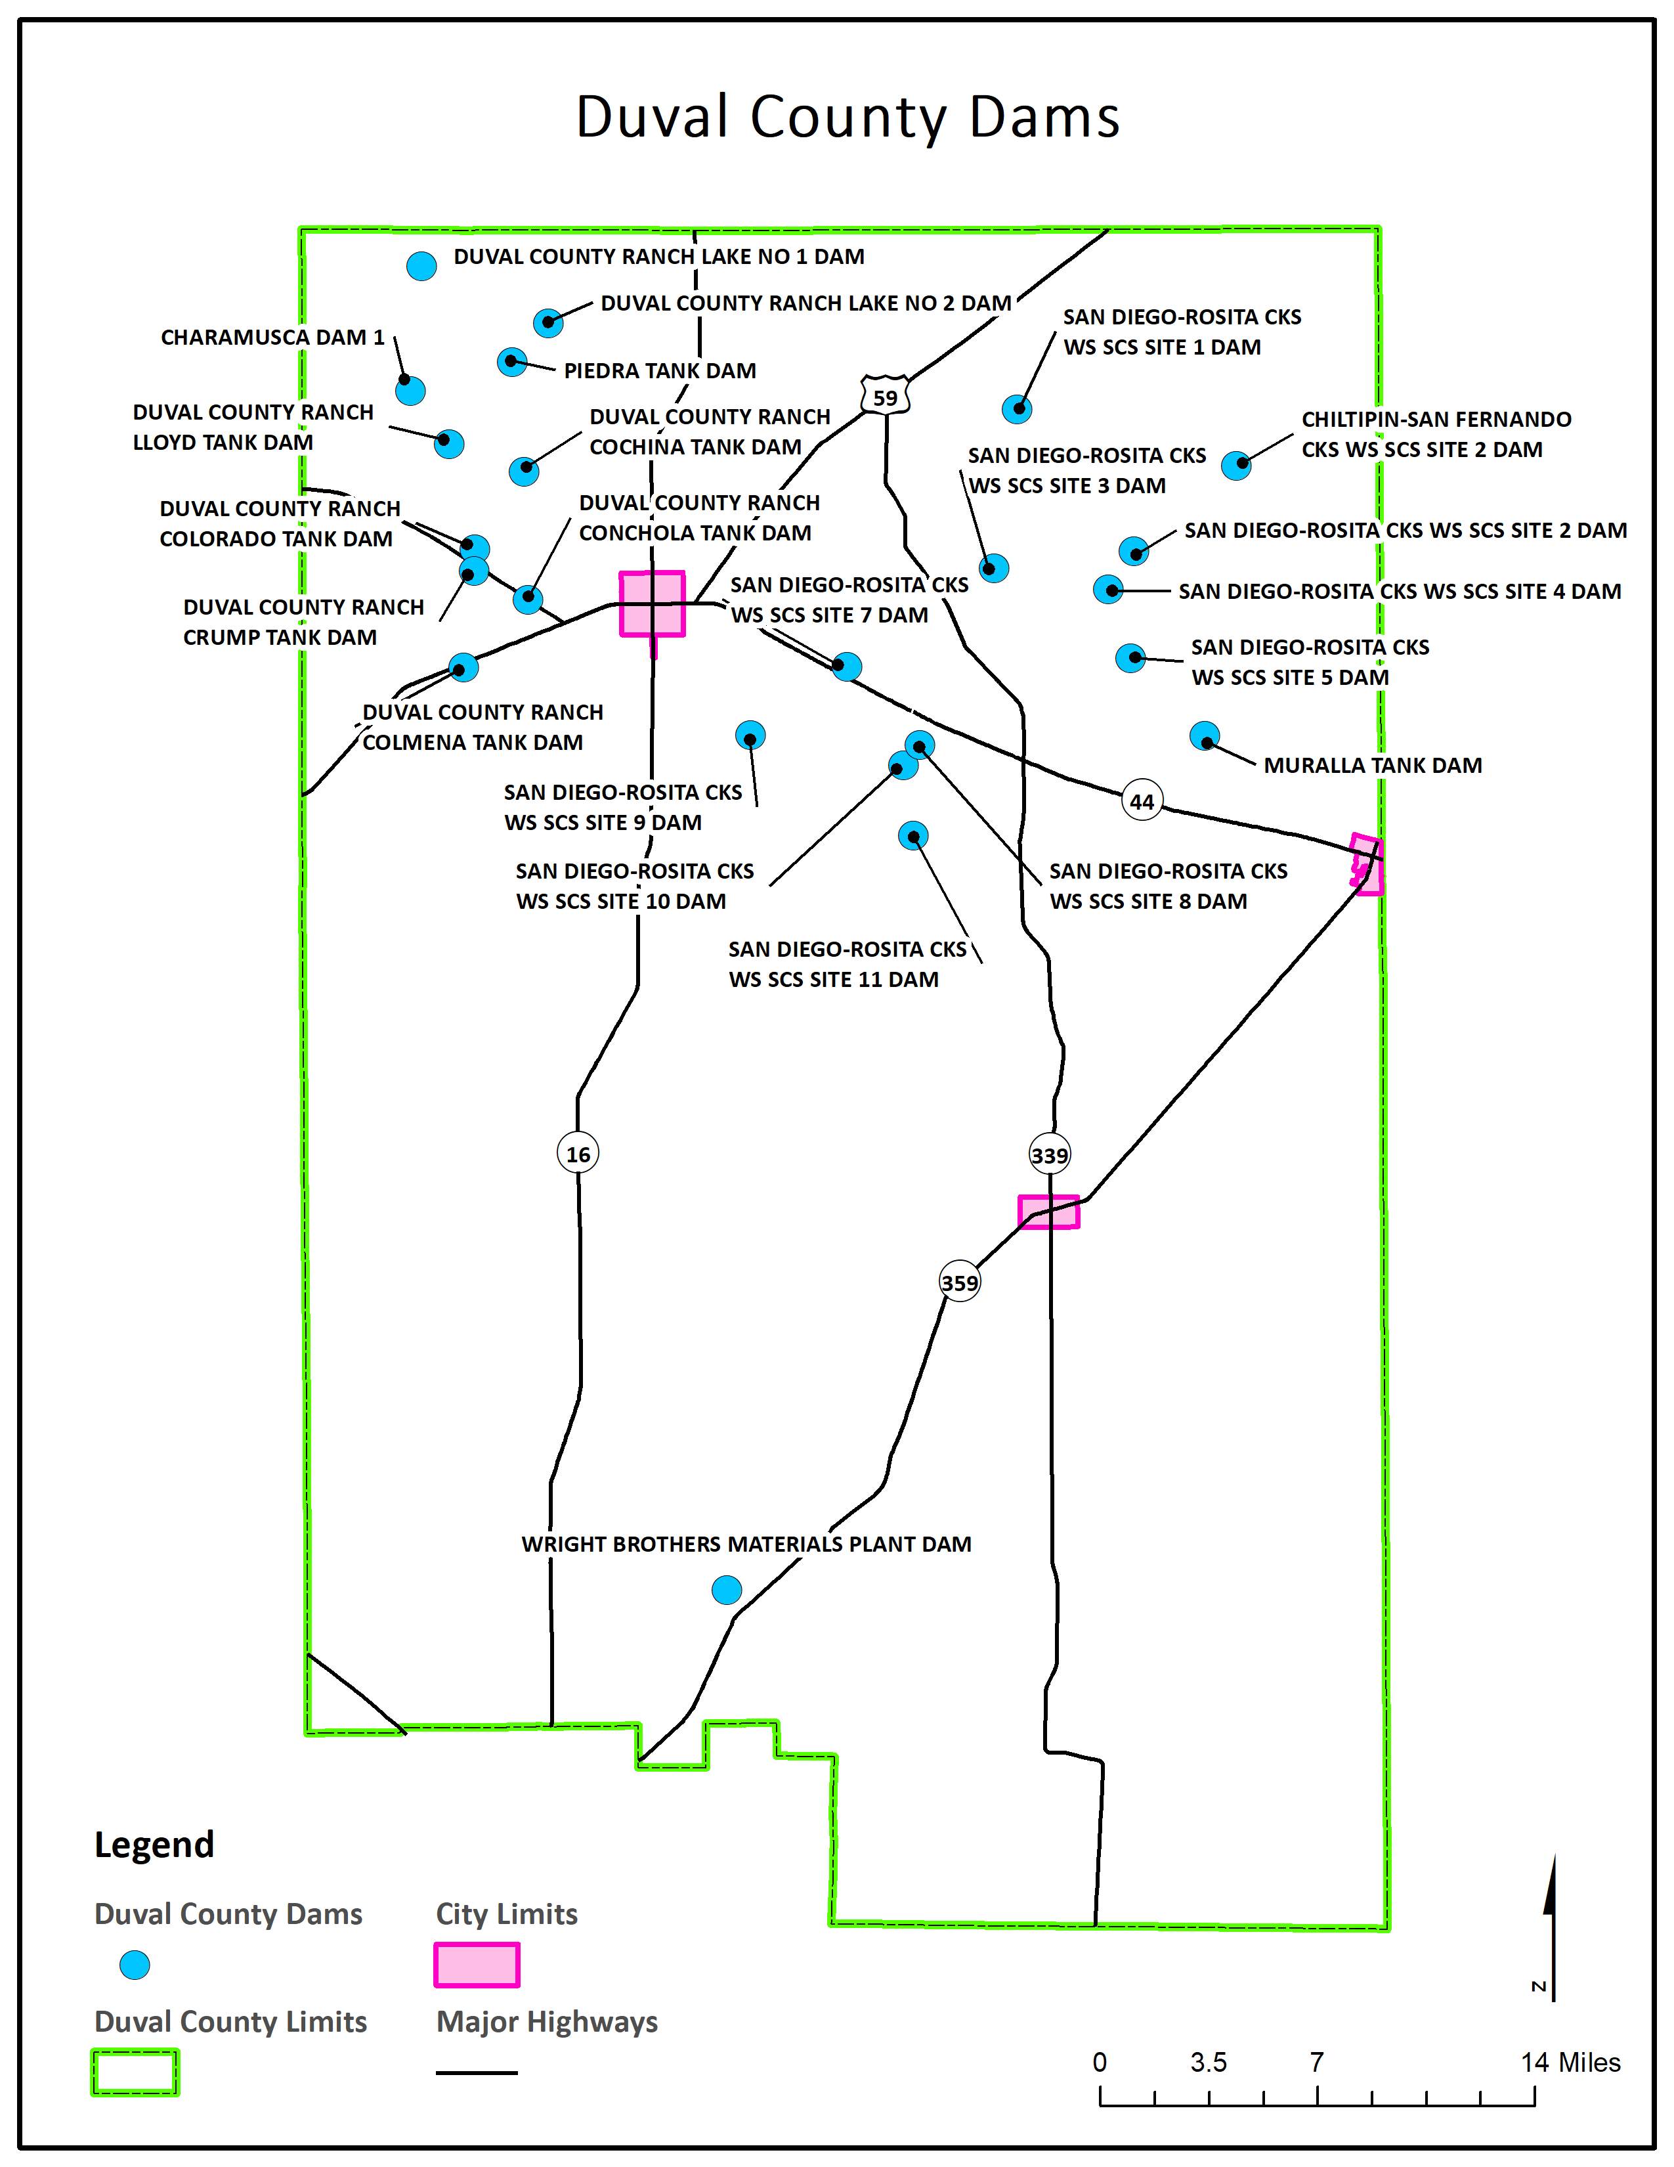
Figure 24: Duval County Dam Locations

Given the low hazard status of both dams and levees, to determine potential downstream flooding, all census blocks within a one-mile radius of each dam were considered to be at risk of inundation during a dam or levee failure.
- Impact
Structures at risk of dam failure may be flooded, damaged by floodborne contaminants, damaged by debris flow, or even completely washed away.
Additionally, the remainder of the County may experience indirect impacts from a dam failure including but not limited to: increased demand for public assistance, the need to establish temporary shelters, interruptions to the local economy, as well as negative health impacts due to increased stress brought on by traumatic events.

Extreme Heat
Extreme heat is defined as summertime temperatures that are substantially hotter and/or more humid than average for a given location at that time of year. Humid conditions, which add to the discomfort of high temperatures, occur when a "dome" of high atmospheric pressure traps hazy, damp air near the ground.
Although heat can damage buildings and facilities, it presents a more significant threat to the safety and welfare of citizens. The major human risks associated with severe summer heat include: heat cramps; sunburn; dehydration; fatigue; heat exhaustion; and heat stroke. The most vulnerable population to heat casualties are children and the elderly or infirm, who frequently live on low fixed incomes and cannot afford to run air‐conditioning on a regular basis. This population is sometimes isolated, with no immediate family or friends to look out for their wellbeing.
Severe summer heat is an invisible killer. Although a heat wave does not happen with the spectacle of other hazards such as tornados and floods, the National Center for Environmental Health reports that extreme heat caused 7,415 heat-related deaths in the United States from 1999 to 2010. Extreme heat kills more people than hurricanes, floods, tornados and lightning combined, according to the National Weather Service. In 2001, 300 deaths were caused by excessive heat exposure.

Extreme Heat History

  - Figure 25: Maximum Recorded Daily Temperature 2000-2018

Between January 2000 and January 2018, Duval County and the jurisdictions addressing the hazard experienced 734 days with a maximum temperature of 100˚F or hotter and 836 days where the combination of humidity and moderate-to-high temperatures likely warranted a heat advisory, if not an extreme heat warning.
Extreme heat data is recorded at the county level. However, given the nature of extreme heat and the proximity of the jurisdictions addressing the hazard to each other, they all experienced the same extreme heat events. On July 1, 1980, an extreme heat event in Duval County caused one injury, $16,273.34 in property damage, and $1,627,295.15 in crop damages.
The Duval County Conservation and Reclamation District determined that the history of impacts of extreme heat have been negligible (or non-existent), therefore it is expected that future impacts will be negligible as well, and isn’t addressing the hazard.

Likelihood of Future Events
Based on historic weather data, extreme heat in Duval County and the jurisdictions addressing the hazard is highly likely, meaning an event affecting any or all of them is probable in the next year.

Extent
The magnitude or intensity of an extreme heat event is measured according to temperature in relation to the percentage of humidity. According to the National Oceanic Atmospheric Administration (NOAA), this relationship is referred to as the “Heat Index,” and is depicted in Figure 26. This index measures how hot it feels outside when humidity is combined with high temperatures.
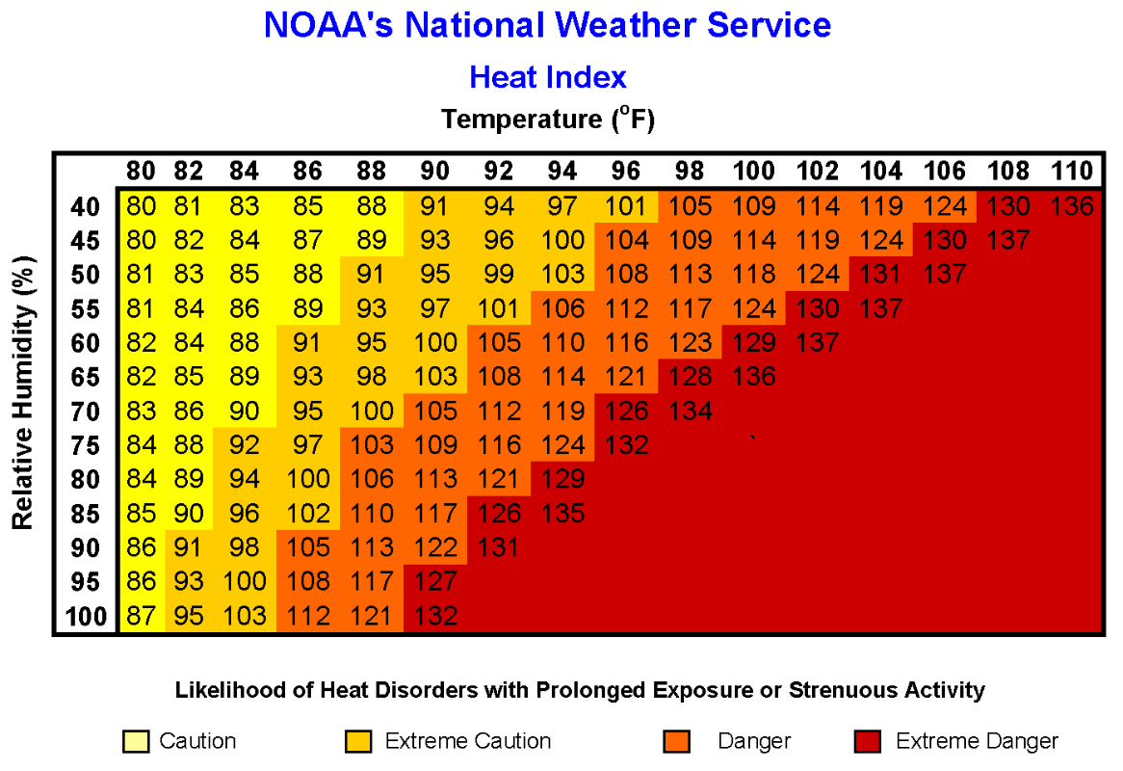
  - Figure 26: NOAA's NWS Heat Index Chart

The extent scale in Figure 26 displays varying degrees of caution depending on the relative humidity combined with the temperature. For example, when the temperature is below 90˚F, caution should be exercised if the humidity level is at or above 40 percent.
The shaded zones on the chart indicate varying symptoms or disorders that could occur depending on the magnitude or intensity of the event. “Caution” is the first level of intensity where fatigue due to heat exposure is possible. “Extreme Caution” indicates that sunstroke, muscle cramps or heat exhaustion are possible, whereas a “Danger” level means that these symptoms are likely. “Extreme Danger” indicates that heat stroke is likely.
The National Weather Service (NWS) initiates alerts based on the Heat Index as shown in Table 46.
Table 46: Heat Intensity
Intensity | Description
Heat Advisory | Extreme heat index making it feel hot, typically between 105˚F to 110˚F for 3 hours or more during the day and at or above 75˚F at night.
Excessive Heat Warning | Extreme heat index making it feel very hot, typically above 105˚F for 3 hours or more during the day and at or above 80˚F at night.

Given an estimated daily average relative humidity level of 76%, highs as low as 89˚F can produce a heat index temperature of 106˚F. The combination of high humidity and moderate temperatures creates an environment that reaches the Danger Zone on NOAA’s Heat Index Chart, and may trigger an NWS Heat Advisory.
Between 2000 and 2018, Duval County and the jurisdictions addressing the hazard experienced 836 days with highs of 89˚F or hotter and overnight lows of 75˚F or hotter. Based on the NWS descriptions in Table 46 above, and the average daily humidity level, these days likely warranted a heat advisory.
The hottest temperature recorded in Duval County in the recent past, 112˚F, was reached on May 11th, 2006. Based on the NWS descriptions in Table 46 above, at least 33 of the 836 heat advisory days warranted an excessive heat warning based on daytime highs, the average daily humidity level, and overnight lows not falling below 80˚F.
According to the Duval County 2013 CHAMPS Report, the worst extreme heat event occurred in 1980. The 1980 event caused one injury, $16,273.34 in property damage, and $1,627,295.15 in crop damages.
Future extreme heat events may meet the heat index requirements for issuing an Excessive Heat Warning as described in the Heat Intensity scale in Table 46 above. The hottest temperatures in Duval County and the participating jurisdictions may meet the current record temperature of 112˚F. Future extreme heat events may meet previous worst-case extreme heat events in terms of injuries, crop damages, property damages, or even death.

Location and Impact

Location – All Jurisdictions
Extreme heat has no distinct geographic boundary. Extreme heat can occur across the entire planning area and uniformly affect the jurisdictions addressing the hazard.

Impact – All Jurisdictions
The potential impact of excessive summer heat is normally minor, resulting in few, if any, injuries. No property or crop damage specifically tied to extreme heat events has been recorded in any of the participating jurisdictions since 1980. No deaths related to extreme heat have ever been reported in the participating jurisdictions. However, based on the hazard’s potential, in the worst cases, especially if combined with drought conditions, the hazard may inflict property or crop damages, and it can even be deadly. Any shutdown of facilities due to extreme heat is expected to be temporary.

Vulnerability

Population
As described in Section 3 of Chapter 3 above, Duval County and the jurisdictions addressing the hazard are home to many vulnerable residents. Vulnerable populations may feel greater impacts from extreme heat due to these populations’ limited ability to properly address the hazard due to deficiencies including but not limited to: lack of air conditioning in their homes or vehicles, lack of access to air-conditioned public spaces during the hottest part of the day, insufficient numbers of box or ceiling fans, or lack of access to other means of cooling. The consequences for these populations’ exposure to extreme heat can include but are not limited to: heat cramps, sunburn, dehydration, fatigue, heat exhaustion, heat stroke, or death.

Critical Facilities
While all of the jurisdictions addressing the hazard are exposed to extreme temperatures, existing buildings, infrastructure, and critical facilities are not considered vulnerable to damages significant enough to interrupt or stop normal operations. Therefore, any estimated property losses associated with the hazard are anticipated to be minimal across the area.

Hailstorm
Early in the developmental stages of a hailstorm, ice crystals form within a low‐pressure front due to the rapid rising of warm air into the upper atmosphere and subsequent cooling of the air mass. Frozen droplets gradually accumulate into ice crystals until they fall as precipitation that is round or irregularly shaped masses of ice. The size of hailstones is a direct result of the size and severity of the storm.
High velocity updraft winds are required to keep hail in suspension in thunderclouds. The strength of the updraft is a byproduct of heating on the Earth’s surface. Higher temperature gradients above Earth’s surface result in increased suspension time and hailstone size.
Texas officials estimate that up to 40 percent of all homeowners’ insurance claims in the state result from hail damage.

Hailstorm History
The following hailstorm histories for each jurisdiction reflect the most current hailstorm data available. No hailstorms are known to have occurred in any participating jurisdiction more recently than those listed below.

Duval County
Location | Date Range | Number of Hailstorms | Hail  Diameter  in inches | Fatalities | Injuries | Property Damage  $2018 | Crop Damage  $2018
Duval County | 5/26/1970 - 6/7/2013 | 38 | Up to 2.75" | 0 | 0 | $136,933 | $181

City of Benavides
Location | Date Range | Number of Hailstorms | Hail  Diameter  in inches | Fatalities | Injuries | Property Damage  $2018 | Crop Damage  $2018
Benavides | 5/10/1999 - 4/18/2016 | 9 | Up to 4.25" | 0 | 1 | $5,708,162 | $0

City of Freer
Location | Date Range | Number of Hailstorms | Hail  Diameter  in inches | Fatalities | Injuries | Property Damage  $2018 | Crop Damage  $2018
Freer | 4/28/1994 - 5/20/2017 | 22 | Up to 2.75" | 0 | 0 | $1,153,924 | $13,471

City of San Diego
Location | Date Range | Number of Hailstorms | Hail  Diameter  in inches | Fatalities | Injuries | Property Damage  $2018 | Crop Damage  $2018
San Diego | 4/11/1995 - 4/17/2009 | 9 | Up to 1.75" | 0 | 0 | $0 | $0

The Duval County Conservation and Reclamation District determined that the history of impacts of hailstorms have been negligible (or non-existent), therefore it is expected that future impacts will be negligible as well, and isn’t addressing the hazard.

Likelihood of Future Events
The hailstorm history in Duval County and the participating jurisdictions suggests that a hailstorm in the County and participating jurisdictions is likely, meaning that an event is probable within the next three years.

Extent
The severity of hail events ranges based on the size of the hail, wind speed, and the number and types of structures in the path of the hail storm. Storms that produce high winds in addition to hail are most damaging and can result in numerous broken windows and damaged siding.
When hail breaks windows, water damage from accompanying rains can also be significant. A major hailstorm can easily cause damage running into the millions of dollars. Nationwide hail is responsible for over $1 billion in property and crop damages per year. The scale showing intensity categories in Table 47 was developed by combining data from National Centers for Environmental Information (NCEI) – formerly the National Climatic Data Center – and the Tornado and Storm Research Organization (TORRO).
Table 47: Hailstorm Intensity,
Size Code | Intensity Category | Size (Diameter in inches) | Descriptive Term | Typical Damage
H0 | Hard Hail | Up to 0.33 | Pea | No damage
H1 | Potentially Damaging | 0.33-.060 | Mothball | Slight damage to plants and crops
H2 | Significant | .060-.080 | Penny | Significant damage to fruit, crops, and vegetation
H3 | Severe | 0.80-1.20 | Nickel – Half dollar | Severe damage to fruit and crops, damage to glass and plastic structures, paint and wood scored
H4 | Severe | 1.2-1.6 | Half dollar – Ping pong ball | Widespread glass damage and vehicle bodywork damage
H5 | Destructive | 1.6-2.0 | Ping pong ball – hen egg | Wholesale destruction of glass, damage to tiled roofs, and significant risk of injuries
H6 | Destructive | 2.0-2.4 | Hen egg – tennis ball | Bodywork of grounded aircraft dented and brick walls pitted
H7 | Destructive | 2.4-3.0 | Tennis ball – Baseball | Severe roof damage and risk of serious injuries
H8 | Destructive | 3.0-3.5 | Hockey puck | Severe damage to aircraft bodywork
H9 | Super Hailstorms | 3.5-4.0 | Softball | Extensive structural damage could cause fatal injuries
H10 | Super Hailstorms | 4.0+ | Greater than softball-sized | Extensive structural damage could cause fatal injuries

According to NCEI data, the worst hailstorms in Duval County and the jurisdictions addressing the hazard have produced hail up to 2.75” in diameter, H7 on the Hailstorm Intensity Scale, and have inflicted over $5,624,000 in reported property damages, over $8,420 in reported crop damages, and one injury. No participating jurisdiction has ever reported any deaths caused by hail.
Future hailstorms may meet previous worst-case H7 storms in terms of hailstone size, damage dollars inflicted, and the number of residents injured or killed.

Location and Impact

Location
Hailstorms vary in terms of size, location, intensity and duration but are considered frequent occurrences in the planning area. Each jurisdiction addressing the hazard is uniformly exposed to hail events just as each is uniformly exposed to the thunderstorms that typically produce the hail events.

Impact
The severity of a hailstorm’s impact is considered to be limited since they generally result in injuries treatable with first aid, shut down critical facilities and services for 24 hours or less, and less than ten percent of affected properties are destroyed or suffer major damage. All existing and future buildings, facilities, and populations are in the participating jurisdictions are considered to be exposed to this hazard and could potentially be impacted.

Vulnerability

Population
As described in Section 3 of Chapter 3 above, Duval County and the jurisdictions addressing hailstorms are home to many vulnerable residents. Increased vulnerability may be due to many factors including but not limited to: age, physical ability, financial means, housing type, and housing condition. Many of these vulnerabilities often overlap.
Since hailstorms arise with little to no warning, the participating jurisdictions recognize that vulnerable populations may primarily need additional help recovering from a hailstorm.
Residents of sub-standard structures are of particular concern. Structures in sub-standard condition ahead of a hailstorm, whether due to structural damages, missing windows or doors, holes in exterior walls or the roof, may sustain more damages than structures in standard condition.
Existing weaknesses, especially those related to the condition of a structure’s roof, due to housing type or existing damages, may lead to compounded damages, injuries, or loss of life.

Critical Facilities
Due to the presence of structures with flat roofs and the increased vulnerability a flat roof creates, the presence of older structures that have not been hardened against hailstorms, and / or the presence of metal buildings that may be more susceptible to hail, the following critical facilities were determined to be especially vulnerable to hailstorms:
Table 48: Critical Facilities Vulnerable to Hailstorms and Potential Impacts
Critical Facilities | Potential Hailstorm Impacts
 | Damaged or Destroyed Roof | Damaged Windows | Water damage due to Physical Damages
Benavides Branch Library | x | x | x
Benavides City Hall / Police Station / VFD |  | x | x
Benavides Civic Center | x | x | x
Benavides EMS |  |  | x
Concepcion Civic Center | x |  | x
Duval County Courthouse | x | x | x
Duval County Pct. 1 Shop | x |  | x
Duval County Pct. 2 Shop - Concepcion | x | x | x
Duval County Pct. 2 Shop - San Diego | x |  | x
Duval County Pct. 3 Shop | x |  | x
Duval County Pct. 4 Shop - Freer | x |  | x
Duval County Sheriff's Department | x | x | x
Duval Freer Airport | x
Freer Branch Library | x | x | x
Freer City Hall / Police Department |  |  | x
Freer Civic Center | x | x | x
Freer VFD / EMS | x
Freer Water Control & Improvement District | x | x | x
Freer WCID Wastewater Treatment Plant
Freer WCID Water Treatment Plant |  |  | x
FWCID Ground Storage Tank
FWCID Well #10
FWCID Well #14
FWCID Well #16
FWCID Well #19
FWCID Well #21
FWCID Well #22
FWCID Well #23
FWCID Well #24
Realitos Civic Center | x | x | x
San Diego Branch Library | x |  | x
San Diego City Hall / Police Department | x | x | x
San Diego Civic Center | x |  | x
San Diego EMS | x | x | x
San Diego MUD - 4 A's Well
San Diego MUD - Briones Lift Station
San Diego MUD - Cadena Lift Station |  |  | x
San Diego MUD - City Well
San Diego MUD - Creek Lift Station |  |  | x
San Diego MUD - Everett Well
San Diego MUD - Hinojosa Well |  |  | x
San Diego MUD - Labbe Well
San Diego MUD - Luera Lift Station |  |  | x
San Diego MUD - Mauro Lift Station
San Diego MUD - Mi Tierra Lift Station
San Diego MUD - Nunez Well
San Diego MUD - Prison Lift Station
San Diego MUD - Prison Pump House
San Diego MUD - Prison Well
San Diego MUD - Rotary Lift Station
San Diego MUD - Salazar Lift Station
San Diego MUD - Sandoval Lift Station
San Diego MUD - Solis Well
San Diego MUD - Tovar Lift Station
San Diego MUD - Tower Well |  |  | x
San Diego MUD - Vic Lift Station
San Diego MUD Wastewater Treatment Plant |  |  | x
San Diego MUD Water Treatment Plant |  |  | x
San Diego Municipal Utility District Office | x | x | x
San Jose Civic Center | x | x | x

Vulnerable Structures
Although every structure is vulnerable to damage from hail, due to often having flat roofs and the increased exposure that flat roofs create, the County’s commercial buildings are expected to sustain more damages than other infrastructure.
Table 49: Parcels Vulnerable to Hailstorms
Jurisdiction | Estimated Parcel Count | Estimated Potential Damage Value
Duval County | 10,583 | $1,275,876,637
City of Benavides | 958 | $26,174,315
City of Freer | 1,721 | $52,024,280
City of San Diego | 2,190 | $58,698,302
Freer Water Control & Improvement District | 3 | $298,610
San Diego Municipal Utility District | 2 | $2,680

Severe Winter Storm
A severe winter storm is defined by extreme cold and heavy concentrations of snowfall or ice. Texas is disrupted more severely by severe winter storms than are regions that experience severe winter weather more frequently.
The types of severe winter storms which Texans are most familiar with are snowstorms, blizzards, cold waves and ice storms.
Snowfall with an accumulation of four or more inches in a 12-hour period is considered a heavy snowfall. Snowfall of any amount is rare south of a line from Del Rio to Port Arthur, and it is this rarity of event, coupled with a lack of preparedness for such an event, that creates a severe weather condition.
Blizzards are the most perilous of all winter storms, characterized by low temperatures and strong winds in excess of 35 mph, bearing large amounts of blowing or drifting snow. Blizzards take a terrible toll on livestock and people caught in the open. In Texas, blizzards are most likely to occur in the Panhandle and South Plains Regions.
The passage of a winter cold front with a drastic drop in temperature heralds the arrival of a cold wave, usually referred to as a “blue north’er.”
An ice storm occurs when rain falls out of the warm and moist upper layers of the atmosphere into a cold and dry layer near the ground. The rain freezes on contact with the cold ground and accumulates on exposed surfaces. If a half inch of rain freezes on trees and utility wires, damage can occur, especially if accompanied by high winds, thus half an inch is used as the criteria before an icing event is categorized as an “ice storm.”

Severe Winter Storm History

  - Figure 27: Minimum Recorded Daily Temperature, 2000-2018

Between 2000 and 2018, Duval County experienced 273 days with a minimum temperature of 32˚F or colder. At least four of those days had a maximum temperature of 32˚F or below.
During the same timeframe, the coldest temperature recorded was 17˚F on January 8th, 2017.
Table 50: Duval County Severe Winter Weather Hazard History
Location | Date Range | Number of Severe Winter Storms | Winter Storm Types | Fatalities | Injuries | Property Damage  $2018 | Crop Damage  $2018
Duval County | 1/9/1962 - 12/7/2017 | 18 | Frost/Freeze, Heavy Snow, Ice Storm, Winter Weather | 0 | 0 | $3,430,585 | $4,861,220

Severe winter weather data is recorded at the county level. However, given the nature of severe winter weather and the proximity of all jurisdictions to each other, every jurisdiction experienced the same severe winter weather events. According to NCEI data, the last severe winter weather event reported was on December 7, 2017; it was a heavy snow event that did not cause any crop damage, property damage, injuries, or deaths.
The Duval County Conservation and Reclamation District determined that the history of impacts of severe winter storms have been negligible (or non-existent), therefore it is expected that future impacts will be negligible as well, and isn’t addressing the hazard.
The Freer Water Control and Improvement District determined that the history of impacts of severe winter storms have been negligible (or non-existent), therefore it is expected that future impacts will be negligible as well, and isn’t addressing the hazard.
The San Diego Municipal Utility District determined that the history of impacts of severe winter storms have been negligible (or non-existent), therefore it is expected that future impacts will be negligible as well, and isn’t addressing the hazard.

Likelihood of Future Events
Because it is likely that more winter storms have occurred than have been officially reported, the likelihood of winter storms occurring in Duval County and the participating jurisdictions is occasional, meaning an event affecting any or all of the participating jurisdictions is possible in the next five years.

Extent
Table 51 below displays the magnitude of severe winter storms. The wind‐chill factor is further described in Figure 28. The wind chill index was developed by the National Weather Service. It neither addresses temperatures above 40°F nor wind speeds below 5 mph.
Table 51: Winter Weather Extent Scale
Frost Advisory* | Issued when nighttime minimum temperatures are expected to range from 33°F to 36°F in the growing season.
Freeze Warning* | Issued when nighttime minimum temperatures are expected to reach 32°F or lower in the growing season. They are usually issued to highlight the first few freezes of the fall or unusually late freezes in the spring. A Freeze Watch is issued when these conditions may be met 12 to 48 hours in the future.
Snow Advisory | Issued when accumulating snow of 2 to 4 inches is expected. An advisory may still be warranted if lesser accumulations will produce travel difficulties, especially early in the winter season.
Blowing Snow Advisory | Issued when blowing snow is expected to occasionally reduce visibilities to 1/4 mile or less with winds generally 25 to 34 mph. The event should last at least 3 hours.
Snow and Blowing Snow Advisory | Issued when winds of 25 to 34 mph are expected to be accompanied by falling snow and blowing snow, occasionally reducing the visibility to 1/4 mile or less. The event should last at least 3 hours
Freezing Rain / Drizzle Advisory | Issued for freezing rain when ice accumulations are expected to cause travel problems, but not exceed 1/4".
Sleet Advisory | Issued for accumulating sleet of 1/4" to 1". Because sleet usually occurs with other precipitation types, a winter weather advisory will almost always be used in such cases.
Winter Weather Advisory | Issued for a winter weather event in which there is more than one hazard present, but all precipitation is expected to remain below warning criteria. For example, it would be issued if 2 inches of snow were expected with a small amount of sleet mixing in at times.
Wind Chill Advisory | Issued when wind chill temperatures are expected to be a significant inconvenience to life with prolonged exposure, and, if caution is not exercised, could lead to hazardous exposure.
Wind Chill Warning | Issued when wind chill temperatures are expected to be hazardous to life within several minutes of exposure.
Ice Storm Warning | Issued when a period of freezing rain is expected to produce ice accumulations of 1/4" or greater, or cause significant disruptions to travel or utilities.
Heavy Sleet Warning | Issued when a period of sleet is expected to produce ice accumulations of 1" or greater, or cause significant disruptions to travel or utilities.
Heavy Snow Warning | Issued when snow is expected to accumulate 4 inches or more in 12 hours, or 6 inches or more in 24 hours.
Winter Storm Warning | Issued for a winter weather event in which there is more than one hazard present, and one of the warning criteria listed above is expected to be met. For example, it would be issued if 5 inches of snow were expected in 12 hours, with some sleet mixing in at times. It is commonly issued for heavy snow with strong winds of 25-34 mph that will cause blowing and drifting of the snow. A Winter Storm Watch is issued when these conditions may be met 12 to 48 hours in the future.
Blizzard Warning | Issued for sustained wind or frequent gusts greater than or equal to 35 mph accompanied by falling and/or blowing snow, frequently reducing visibility to less than 1/4 mile for three hours or more. A Blizzard Watch is issued when these conditions may be met 12 to 48 hours in the future.
* - Non-precipitation watch / warning / advisory
  - Figure 28: NWS Wind Chill Index

According to the Duval County 2013 CHAMPS Report, the most damaging winter storms have inflicted over $2 million in property damages and crop damages respectively. The most recent winter storm to inflict damages in the County occurred in 1989. Property damages for that storm totaled $3,229,438. Severe winter weather isn’t known to have caused any injuries or deaths in any jurisdiction in Duval County.
Future winter storm events in Duval County and the participating jurisdictions may see temperatures meet the lowest recently recorded temperature, 18˚F, see snow accumulation of 6.0”, or see ice accumulation of 1/4”. Additionally, these future events may meet previous ones in terms of duration and the number of residents injured or worse.

Location and Impact

Location – All Jurisdictions
Severe winter weather has no distinct geographic boundary. Severe winter weather can occur across the entire planning area and uniformly affect all participating jurisdictions.

Impact – All Jurisdictions
The potential impact of a severe winter storm is normally minor, resulting in few, if any, injuries. Because of the rarity of winter storm events in Duval County and the participating jurisdictions, drivers, especially those unfamiliar with or unable to drive in icy conditions, may be at the highest risk of crashing their vehicle and sustaining injuries.
Beyond accidents caused by icy conditions, severe winter weather has the potential to cause widespread power outages. Trees and other vegetation that grow along or near power lines and utility lines can become overburdened by ice and snow accumulation. Falling limbs or trees can easily take down power and utility lines. Neglected vegetation is especially at risk of failure due to increased weight loads. Power outages can create a cascading effect depending on residents’ ability to heat their homes without electricity, especially for those young, elderly, and low-income residents as identified in Section 3 of Chapter 3 above. Although no deaths related to severe winter storms have been reported in the participating jurisdictions, in the worst cases, the hazard has the potential to be deadly.
Severe winter storms will likely cause only minor property damage and minimal disruption to the quality of life in the participating jurisdictions.
Depending on when the event happens, a severe winter storm may damage or destroy crops.

Vulnerability
While all of the participating jurisdictions are exposed to extreme temperatures, existing buildings, infrastructure, and critical facilities are not considered vulnerable to significant damage caused by severe winter storm events. This determination was made based on the expectation that most roofs can support 20 lbs. / square foot of snow. The worst snow storm in any participating jurisdiction dropped 6.0”. Although it’s not impossible for that much snow to cause structural damage, given that the snow weight is well below the threshold where damage is likely, structural damages are not expected. Additionally, 1” of ice is roughly equivalent in weight per square foot to 10” of snow. Considering the worst ice storms in the participating jurisdictions cause ice accumulations of 1/4”, it’s unlikely, but not impossible, that an ice storm causing structural ice accumulations of less than 4” will cause significant structural damages.
Therefore, estimated property losses associated are anticipated to be minimal across the area. Areas with concentrations of young, elderly, and low-income residents identified in Section 3 of Chapter 3 above, may feel greater impacts from severe winter weather due to those populations’ limited ability to properly address the hazard.
Any shutdown of critical facilities due to severe winter weather is expected to be temporary. However, based on the proximity of trees and powerlines on their properties, the following critical facilities may be at a higher risk of losing power due to falling limbs.
Table 52: Critical Facilities Vulnerable to Winter Storms
Critical Facilities | Potential Severe Winter Storm Impacts
 | Falling Tree Limbs
Benavides Branch Library | x
Benavides City Hall / Police Station / VFD | x
Duval County Courthouse | x
Duval County Pct. 2 Shop - Concepcion | x
Duval County Pct. 2 Shop - San Diego | x
Duval County Sheriff's Department | x
Freer Branch Library | x
Freer City Hall / Police Department | x
Freer Civic Center | x
Freer VFD / EMS | x
Freer Water Control & Improvement District | x
Freer WCID Water Treatment Plant | x
FWCID Ground Storage Tank | x
Realitos Civic Center | x
San Diego Branch Library | x
San Diego City Hall / Police Department | x
San Diego Civic Center | x
San Diego EMS | x
San Diego MUD - Briones Lift Station | x
San Diego MUD - Cadena Lift Station | x
San Diego MUD - Luera Lift Station | x
San Diego MUD - Prison Lift Station | x
San Diego MUD - Salazar Lift Station | x
San Diego MUD - Sandoval Lift Station | x
San Diego MUD - Tovar Lift Station | x
San Diego Municipal Utility District Office | x

Windstorm
A windstorm is classified as any wind that is strong enough to cause at least light damage to trees and buildings, and may or may not be accompanied by precipitation. Wind speeds during a windstorm typically exceed 41 knots. Damage can be attributed to gusts or longer periods of sustained winds.
Windstorms may last for just a few minutes when caused by downbursts from thunderstorms, or they may last for hours (and even several days) when they result from large-scale weather systems. A windstorm that travels in a straight line and is caused by the gust front (the boundary between descending cold air and warm air at the surface) of an approaching thunderstorm is called a derecho. Derechos are capable of causing widespread damage and landscape devastation.

Windstorm History
The following windstorm histories for each jurisdiction reflect the most current windstorm data available. No windstorms are known to have occurred in any participating jurisdiction more recently than those listed below. Although no specific data regarding windstorm damages for Duval County Conservation and Reclamation District, Freer Water Control & Improvement District, or San Diego Municipal Utility District are available, all are vulnerable to physical damages during windstorms.

Duval County
Location | Date Range | Windstorm Events | Windspeed Range  Knots | Fatalities | Injuries | Property Damage  $2018 | Crop Damage  $2018
Duval County | 10/15/1956 - 5/11/2015 | 33 | Up to 87 | 0 | 1 | $2,282,550 | $77,478

City of Benavides
Location | Date Range | Windstorm Events | Windspeed Range  Knots | Fatalities | Injuries | Property Damage  $2018 | Crop Damage  $2018
Benavides | 4/15/1994 - 3/18/2016 | 5 | Up to 65 | 0 | 0 | $178,422 | $8,420

City of Freer
Location | Date Range | Windstorm Events | Windspeed Range  Knots | Fatalities | Injuries | Property Damage  $2018 | Crop Damage  $2018
Freer | 8/9/1994 - 10/24/2015 | 17 | Up to 70 | 0 | 0 | $48,062 | $0

City of San Diego
Location | Date Range | Windstorm Events | Windspeed Range  Knots | Fatalities | Injuries | Property Damage  $2018 | Crop Damage  $2018
San Diego | 5/9/1997 - 5/29/2017 | 7 | Up to 78 | 0 | 0 | $63,886 | $0

Likelihood of Future Events
Duval County and the participating jurisdictions have experienced a damaging windstorm roughly once every two to three years. Given the frequency of past events in all jurisdictions, a damaging windstorm in the future is likely, meaning that an event is probable in the next three years.
The San Diego Municipal Utility District (SDMUD), the Duval County Conservation and Reclamation District (DCCRD), and the Freer Water Control & Improvement District’s (FWCID) vulnerability to windstorms is expected to be similar to those of the County and participating cities. Therefore, a windstorm affecting all of the jurisdictions is likely, meaning that an event is probable within the next three years.

Extent
The generally accepted extent scale for wind events is the Beaufort Wind Scale. The following table lists categories, measurement, classification, and appearance descriptions.
Table 53: Beaufort Wind Scale
Beaufort Wind Scale
Force | Wind (Knots) | WMO Classification | Appearance of Wind Effects
 |  |  | On the Water | On Land
0 | Less than 1 | Calm | Sea surface smooth and mirror-like | Calm, smoke rises  vertically
1 | 1-3 | Light Air | Scaly ripples, no foam crests | Smoke drift indicates  wind direction, still wind  vanes
2 | 4-6 | Light Breeze | Small wavelets, crests glassy, no breaking | Wind felt on face, leaves  rustle, vanes begin to move
3 | 7-10 | Gentle Breeze | Large wavelets, crests begin to break, scattered whitecaps | Leaves and small twigs constantly moving, light flags extended
4 | 11-16 | Moderate Breeze | Small waves 1-4 feet becoming longer, numerous whitecaps | Dust, leaves, and loose paper lifted, small tree branches move
5 | 17-21 | Fresh Breeze | Moderate waves 4-8 feet taking longer form, many whitecaps, some spray | Small trees in leaf begin to sway
6 | 22-27 | Strong Breeze | Larger waves 8-13 feet, whitecaps common, more spray | Larger tree branches moving, whistling in wires
7 | 28-33 | Near Gale | Sea heaps up, waves 13-20 feet, white foam streaks off breakers | Whole trees moving, resistance felt walking against wind
8 | 34-40 | Gale | Moderately high (13-20 feet) waves of greater length, edges of crests begin to break into spindrift, foam blown in streaks | Whole trees in motion, resistance felt walking against wind
9 | 41-47 | Strong Gale | High waves (20 feet), sea begins to roll, dense streaks of foam, spray may reduce visibility | Slight structural damage occurs, slate blows off roofs
10 | 48-55 | Storm | Very high waves (20-30 feet) with overhanging crests, sea white with densely blown foam, heavy rolling, lowered visibility | Seldom experienced on land, trees broken or uprooted, "considerable structural damage"
11 | 56-63 | Violent Storm | Exceptionally high (30-45 feet) waves, foam patches cover sea, visibility more reduced
12 | 64+ | Hurricane | Air filled with foam, waves over 45 feet, sea completely white with driving spray, visibility greatly reduced

The worst windstorms in Duval County and the jurisdictions addressing the hazard have ranged up to a 12 on the Beaufort Wind Scale.
Adjusted for inflation to $2018, the most devastating windstorms have inflicted up to $1,347,767 in property damages and $42,261 in agricultural damages.
No windstorm in any of the participating jurisdictions has caused any injuries or deaths.
Future windstorms may meet previous worst-case Force 12 events in terms of wind speed, damage dollars inflicted, and residents injured or killed.

Location and Impact

Location
Windstorms are not constrained by any distinct geographic boundary. Windstorms can occur across all jurisdictions addressing the hazard.

Impact
Impacts from a windstorm may include but are not limited to damaged or destroyed personal property including vehicles, damaged or destroyed agricultural, residential, commercial, and industrial buildings. Crops may be damaged or destroyed. Pets and livestock may be injured or killed by flying debris. Pets and livestock may escape due to damaged or destroyed structures and fences.
In the worst cases, windstorms may cause injuries and/or be deadly.

Vulnerability
Windstorms have the potential to impact all jurisdictions addressing the hazard. Therefore, each jurisdiction is equally exposed to the hazard. Improved property, critical facilities, critical infrastructure, and the entire population of each jurisdiction addressing the hazard are considered vulnerable to windstorms.
Based on windstorm data collected for the participating jurisdictions, windstorms primarily damage physical structures. However, there is no uniformity with respect to the type of structures that have been damaged by windstorms in any of the participating jurisdictions. Windstorm damages can be directly caused by the wind itself, flying debris, and falling trees, or indirectly by damages like power outages.

Population
As described in Section 3 of Chapter 3 above, Duval County and the jurisdictions addressing windstorms are home to many vulnerable residents. Increased vulnerability may be due to many factors including but not limited to: age, physical ability, financial means, housing type, and housing condition. Many of these vulnerabilities often overlap.
The participating jurisdictions recognize that vulnerable populations may need additional help preparing for and recovering from a windstorm.
Residents of mobile / manufactured homes are of particular concern. These structures may not be safe during a windstorm.
Residents of sub-standard structures are also of particular concern. Structures in sub-standard condition ahead of a windstorm, whether due to structural damages, missing windows or doors, holes in exterior walls or the roof, may be less safe during a windstorm than structures in standard condition.
Existing structural weaknesses, due to housing type or existing damages, may lead to compounded damages, injuries, or loss of life.

Critical Facilities
Similar to hurricanes and tornados, certain critical facilities and infrastructure in each jurisdiction may be particularly vulnerable to windstorms. These facilities have been identified for reasons including: the number of people who use the facility or infrastructure, the facility’s role in providing basic services to begin the cleanup process and get the jurisdictions running again, and the facility’s ability to offer goods and materials residents will need to resume normalcy as quickly as possible. The selected critical facilities are built from a variety of materials with varying levels of resistance to wind damages. Additionally, their varying ages mean they weren’t constructed to uniform building standards. Given wind’s potentially violent nature, these facilities may experience increased levels of vulnerability to the hazards. Damage to any of these facilities may have a disproportionately negative impact on each jurisdiction’s recovery from a windstorm if that damage affects the facility’s ability to reopen and resume normal business right away.
Table 54: Critical Facilities Vulnerable to Windstorms and Potential Impacts
 | Potential Windstorm Impacts
 | Loss of Power | Flying Debris | Uprooted Trees | Flooding | Flooding Due to Physical Damages | Damaged or Destroyed Roofs | Damaged or Broken Windows | Wind Damage | Injuries | Death
Benavides Branch Library | x | x | x |  | x | x | x | x | x | x
Benavides City Hall / Police Station / VFD | x | x | x |  | x |  | x |  | x | x
Benavides Civic Center | x | x |  |  | x | x | x |  | x | x
Benavides EMS | x | x |  |  | x |  |  | x | x | x
Concepcion Civic Center | x | x |  |  | x | x |  | x | x | x
Duval County Conservation and Reclamation District Office | x | x | x |  | x |  |  | x | x | x
Duval County Courthouse | x | x | x |  | x | x | x | x | x | x
Duval County Pct. 1 Shop | x | x |  |  | x | x |  | x | x | x
Duval County Pct. 2 Shop - Concepcion | x | x | x |  | x | x | x | x | x | x
Duval County Pct. 2 Shop - San Diego | x | x | x |  | x | x |  | x | x | x
Duval County Pct. 3 Shop | x | x |  |  | x | x |  | x | x | x
Duval County Pct. 4 Shop - Freer | x | x |  |  | x | x |  | x | x | x
Duval County Sheriff's Department | x | x | x |  | x | x | x | x | x | x
Duval Freer Airport | x | x |  |  |  | x |  | x | x | x
Freer Branch Library | x | x | x |  | x | x | x | x | x | x
Freer City Hall / Police Department | x | x | x |  | x |  |  | x | x | x
Freer Civic Center | x | x | x |  | x | x | x | x | x | x
Freer VFD / EMS | x | x | x |  |  | x |  | x | x | x
Freer Water Control & Improvement District | x | x | x |  | x | x | x | x | x | x
Freer WCID Wastewater Treatment Plant |  |  |  |  |  |  |  |  | x | x
Freer WCID Water Treatment Plant | x | x | x |  | x |  |  | x | x | x
FWCID Ground Storage Tank | x | x | x |  |  |  |  |  | x | x
FWCID Well #10 | x |  |  |  |  |  |  |  | x | x
FWCID Well #14 | x |  |  |  |  |  |  |  | x | x
FWCID Well #16 | x |  |  |  |  |  |  |  | x | x
FWCID Well #19 | x |  |  |  |  |  |  |  | x | x
FWCID Well #21 | x |  |  |  |  |  |  |  | x | x
FWCID Well #22 | x |  |  |  |  |  |  |  | x | x
FWCID Well #23 | x |  |  |  |  |  |  |  | x | x
FWCID Well #24 | x |  |  |  |  |  |  |  | x | x
Realitos Civic Center | x | x | x |  | x | x | x | x | x | x
San Diego Branch Library | x | x | x |  | x | x |  | x | x | x
San Diego City Hall / Police Department | x | x | x | x | x | x | x | x | x | x
San Diego Civic Center | x | x | x |  | x | x |  | x | x | x
San Diego EMS | x | x | x | x | x | x | x | x | x | x
San Diego MUD - 4 A's Well | x |  |  |  |  |  |  |  | x | x
San Diego MUD - Briones Lift Station | x | x | x |  |  |  |  |  | x | x
San Diego MUD - Cadena Lift Station | x | x | x | x | x |  |  |  | x | x
San Diego MUD - City Well | x |  |  |  |  |  |  |  | x | x
San Diego MUD - Creek Lift Station | x |  |  | x | x |  |  |  | x | x
San Diego MUD - Everett Well | x |  |  |  |  |  |  |  | x | x
San Diego MUD - Hinojosa Well | x |  |  | x | x |  |  |  | x | x
San Diego MUD - Labbe Well | x |  |  |  |  |  |  |  | x | x
San Diego MUD - Luera Lift Station | x | x | x | x | x |  |  |  | x | x
San Diego MUD - Mauro Lift Station | x |  |  |  |  |  |  |  | x | x
San Diego MUD - Mi Tierra Lift Station | x |  |  |  |  |  |  |  | x | x
San Diego MUD - Nunez Well | x |  |  |  |  |  |  |  | x | x
San Diego MUD - Prison Lift Station | x | x | x |  |  |  |  |  | x | x
San Diego MUD - Prison Pump House | x |  |  |  |  |  |  |  | x | x
San Diego MUD - Prison Well | x |  |  |  |  |  |  |  | x | x
San Diego MUD - Rotary Lift Station | x |  |  |  |  |  |  |  | x | x
San Diego MUD - Salazar Lift Station | x | x | x |  |  |  |  |  | x | x
San Diego MUD - Sandoval Lift Station | x | x | x |  |  |  |  |  | x | x
San Diego MUD - Solis Well | x |  |  |  |  |  |  |  | x | x
San Diego MUD - Tovar Lift Station | x | x | x |  |  |  |  |  | x | x
San Diego MUD - Tower Well | x |  |  | x | x |  |  |  | x | x
San Diego MUD - Vic Lift Station | x |  |  |  |  |  |  |  | x | x
San Diego MUD Wastewater Treatment Plant | x | x |  |  | x |  |  |  | x | x
San Diego MUD Water Treatment Plant | x |  |  | x | x |  |  |  | x | x
San Diego Municipal Utility District Office | x | x | x | x | x | x | x | x | x | x
San Jose Civic Center | x | x |  |  | x | x | x | x | x | x

Vulnerable Parcels
Table 55: Parcels Vulnerable to Windstorms
Jurisdiction | Estimated Parcel Count | Estimated Potential Damage Value
County | 10,583 | $1,275,876,637
City of Benavides | 958 | $26,174,315
City of Freer | 1,721 | $52,024,280
City of San Diego | 2,190 | $58,698,302
Duval County Conservation and Reclamation District | 2 | $152,660
Freer Water Control & Improvement District | 3 | $298,610
San Diego Municipal Utility District | 2 | $2,680

Lightning
Lightning is a massive electrostatic discharge between electrically charged regions within clouds, or between a cloud and the Earth's surface.
Lightning damage can result in electrocution of humans and animals; vaporization of materials along the path of the strike; fire caused by the high temperature produced by the strike; and sudden power surges that can damage electrical and electronic equipment. Millions of dollars of direct and indirect damages result from lightning strikes on electric utility substations and distribution lines. While property damage is the major hazard associated with lightning, it should be noted that lightning strikes kill nearly 50 people each year in the United States.

Lightning History
The last time Duval County or any of the jurisdictions addressing the hazard recorded a lightning event was in 2010. That event inflicted $57,222 in damages adjusted to $2018.
Table 56: Duval County Lightning History
Location | Date Range | Number of Lightning Events | Fatalities | Injuries | Property Damage  $2018 | Crop Damage  $2018
Duval County | 12/3/1973 - 5/8/1980 | 2 | 1 | 0 | $894 | $0

Table 57: City of Freer Lightning History
Location | Date Range | Number of Lightning Events | Fatalities | Injuries | Property Damage  $2018 | Crop Damage  $2018
Freer | 4/15/2010 | 1 | 0 | 0 | $57,222 | $0

No lightning-inflicted property or crop damage dollars have been recorded in the other participating jurisdictions addressing this hazard.

Likelihood of Future Events
Lightning is especially associated with thunderstorms. Despite the lack of officially reported instances of lightning-caused damages, a lightning event is highly likely, meaning an event affecting any or all of the participating jurisdictions is probable in the next year.
According to information from VAISALA, Duval County and the participating jurisdictions can expect to see between 3 and 12 lightning flashes per square mile per year.

Extent
The extent for lightning can be expressed in terms of the number of strikes within an interval. Given the lack of lightning history data, it is expected that Duval County and all participating jurisdictions may experience lightning events between LAL 1 and LAL 5. Dry thunderstorms, LAL 6, are not expected.
Table 58: Lightning Activity Levels
Lightning Activity Level (LAL)
Activity levels are valuable guidance tools to aid in the preparation for possible fire initiation from cloud-to-ground lightning.
LAL | Cloud and Storm Development | Lightning Strikes per 15 Minutes
1 | No thunderstorms. | -
2 | Cumulus clouds are common but only a few reach the towering cumulus stage. A single thunderstorm must be confirmed in the observation area. The clouds produce mainly virga, but light rain will occasionally reach the ground. Lightning is very infrequent. | 1-8
3 | Towering cumulus covers less than two-tenths of the sky. Thunderstorms are few, but two to three must occur within the observation area. Light to moderate rain will reach the ground, and lightning is infrequent. | 9-15
4 | Towering cumulus covers two to three-tenths of the sky. Thunderstorms are scattered and more than three must occur within the observation area. Moderate rain is common and lightning is frequent. | 16-25
5 | Towering cumulus and thunderstorms are numerous. They cover more than three-tenths and occasionally obscure the sky. Rain is moderate to heavy and lightning is frequent and intense. | 25+
6 | Similar to LAL 3 except thunderstorms are dry.

The worst lightning events to affect Duval County and the participating jurisdictions have inflicted up to $58,116 in property damages. No jurisdiction has recorded any injuries or deaths caused by lightning.
Future events may meet previous intensity levels, damage dollars inflicted, and the number of residents injured or worse.

Location and Impact

Location
Lightning strikes have no distinct geographic boundary. Lightning can affect each jurisdiction addressing the hazard.

Impact
Impacts from lightning in the participating jurisdictions may include but are not limited to loss of power due to electrical surges, damaged or destroyed personal property including computers and other electronics, damaged or destroyed agricultural, residential, commercial, and industrial buildings. Crops may be damaged or destroyed. Livestock may be injured or killed by lightning. In the worst cases, lightning may cause injuries or even loss of life.

Vulnerability
According to the Lightning Protection Institute, it is a myth that lightning always strikes the tallest objects. Given lightning’s indiscriminate nature, it is impossible to identify buildings that are at an increased risk of being struck by lightning. All existing and future buildings, critical facilities, critical infrastructure, improved property, and the population in the jurisdictions addressing the hazard are exposed to lightning. However, structures without adequate lightning protection and those with large concentrations of electronic equipment like computers, servers, and printers, are most vulnerable, as are locations that may have outside crowds during a lightning event.

Critical Facilities
Table 59: Critical Facilities Vulnerable to Lightning and Potential Impacts
Critical Facilities | Potential Lightning Impacts
 | Physical Damage | Electrical Damage | Data Damage or Loss | Fire
Benavides Branch Library | x | x | x | x
Benavides City Hall / Police Station / VFD | x | x | x | x
Benavides Civic Center | x | x | x | x
Benavides EMS | x | x | x | x
Concepcion Civic Center | x | x | x | x
Duval County Conservation and Reclamation District Office | x | x | x | x
Duval County Courthouse | x | x | x | x
Duval County Pct. 1 Shop | x | x | x | x
Duval County Pct. 2 Shop - Concepcion | x | x | x | x
Duval County Pct. 2 Shop - San Diego | x | x | x | x
Duval County Pct. 3 Shop | x | x | x | x
Duval County Pct. 4 Shop - Freer | x | x | x | x
Duval County Sheriff's Department | x | x | x | x
Duval Freer Airport | x | x | x | x
Freer Branch Library | x | x | x | x
Freer City Hall / Police Department | x | x | x | x
Freer Civic Center | x | x | x | x
Freer VFD / EMS | x | x | x | x
Freer Water Control & Improvement District | x | x | x | x
Freer WCID Wastewater Treatment Plant | x | x | x | x
Freer WCID Water Treatment Plant | x | x | x | x
FWCID Ground Storage Tank | x | x | x | x
FWCID Well #10 | x | x | x | x
FWCID Well #14 | x | x | x | x
FWCID Well #16 | x | x | x | x
FWCID Well #19 | x | x | x | x
FWCID Well #21 | x | x | x | x
FWCID Well #22 | x | x | x | x
FWCID Well #23 | x | x | x | x
FWCID Well #24 | x | x | x | x
Realitos Civic Center | x | x | x | x
San Diego Branch Library | x | x | x | x
San Diego City Hall / Police Department | x | x | x | x
San Diego Civic Center | x | x | x | x
San Diego EMS | x | x | x | x
San Diego MUD - 4 A's Well | x | x | x | x
San Diego MUD - Briones Lift Station | x | x | x | x
San Diego MUD - Cadena Lift Station | x | x | x | x
San Diego MUD - City Well | x | x | x | x
San Diego MUD - Creek Lift Station | x | x | x | x
San Diego MUD - Everett Well | x | x | x | x
San Diego MUD - Hinojosa Well | x | x | x | x
San Diego MUD - Labbe Well | x | x | x | x
San Diego MUD - Luera Lift Station | x | x | x | x
San Diego MUD - Mauro Lift Station | x | x | x | x
San Diego MUD - Mi Tierra Lift Station | x | x | x | x
San Diego MUD - Nunez Well | x | x | x | x
San Diego MUD - Prison Lift Station | x | x | x | x
San Diego MUD - Prison Pump House | x | x | x | x
San Diego MUD - Prison Well | x | x | x | x
San Diego MUD - Rotary Lift Station | x | x | x | x
San Diego MUD - Salazar Lift Station | x | x | x | x
San Diego MUD - Sandoval Lift Station | x | x | x | x
San Diego MUD - Solis Well | x | x | x | x
San Diego MUD - Tovar Lift Station | x | x | x | x
San Diego MUD - Tower Well | x | x | x | x
San Diego MUD - Vic Lift Station | x | x | x | x
San Diego MUD Wastewater Treatment Plant | x | x | x | x
San Diego MUD Water Treatment Plant | x | x | x | x
San Diego Municipal Utility District Office | x | x | x | x
San Jose Civic Center | x | x | x | x

Vulnerable Parcels
Table 60: Parcels Vulnerable to Lightning
Jurisdiction | Estimated Parcel Count | Estimated Potential Damage Value
County | 10,583 | $1,275,876,637
City of Benavides | 958 | $26,174,315
City of Freer | 1,721 | $52,024,280
City of San Diego | 2,190 | $58,698,302
Duval County Conservation and Reclamation District | 2 | $152,660
Freer Water Control & Improvement District | 3 | $298,610
San Diego Municipal Utility District | 2 | $2,680

Mitigation Strategy

Capability Assessment
The planning team reviewed existing regulatory capabilities and opportunities for establishing new capabilities and enhancing existing ones. At this time, all jurisdictions could improve their hazard mitigation capabilities through the following efforts: creating and adopting regularly updated comprehensive plans, budgeting for mitigation actions and support, passing policies and procedures to implement mitigation actions, adopting and implementing stricter mitigation regulations, approving the hiring and training of staff for mitigation activities, and approving mitigation updates and additions to existing plans as new needs are recognized.
Table 61: Capability Assessment by Jurisdiction
Duval County
Administrative, Financial, Regulatory, and Technical Abilities
Floodplain Management
Emergency Management
Economic Development
Road and Bridge Management
Tax Collection
Grant Writing
General Budgeting
CIP Funding
CDBG Funding
State and Federal Grant Funding

City of Benavides
Administrative, Financial, Regulatory, and Technical Abilities
Floodplain management
Emergency Management
Subdivision
Zoning
Building Code Enforcement
Nuisance Abatement
Substandard Structures Abatement
Water Conservation Planning
Drought Contingency Planning
Comprehensive Planning
Economic Development
Tax Collection
Grant Writing
General Budgeting
CIP Funding
CDBG Funding
State and Federal Grant Funding

City of Freer
Administrative, Financial, Regulatory, and Technical Abilities
Emergency Management
Comprehensive Planning
Tax Collection
Grant Writing
General Budgeting
CIP Funding
State and Federal Grant Funding

City of San Diego
Administrative, Financial, Regulatory, and Technical Abilities
Emergency Management
Drought Contingency Planning
Tax Collection
Grant Writing
General Budgeting
CIP Funding
State and Federal Grant Funding

Duval County Conservation and Reclamation District
Administrative, Financial, Regulatory, and Technical Abilities
Emergency Management
Drought Contingency Planning
Tax Collection
Grant Writing
General Budgeting
CIP Funding
State and Federal Grant Funding

Freer Water Control and Improvement District
Administrative, Financial, Regulatory, and Technical Abilities
Emergency Management
Drought Contingency Planning
Tax Collection
Grant Writing
General Budgeting
CIP Funding
State and Federal Grant Funding

San Diego Municipal Utility District
Administrative, Financial, Regulatory, and Technical Abilities
Emergency Management
Drought Contingency Planning
Tax Collection
Grant Writing
General Budgeting
CIP Funding
State and Federal Grant Funding

Goals and Objectives Overview
The hazard analysis has shown that Duval County and the participating jurisdictions are at risk of multiple natural hazards. The following goals and objectives take a broad approach to improving outcomes before, during, and after these anticipated natural hazard events.
The mitigation actions the County and participating jurisdictions have selected are designed to address specific hazard-related issues in support of achieving the desired goals and objectives.

Long-term vision
The hazard mitigation plan must strike a balance between identifying long-term goals and objectives and prioritized mitigation actions that may be addressed sooner, depending on funding availability and local priorities. The result is that certain goals and objectives don’t have a corresponding mitigation action. Instead, by taking the long view, the local planning team has created a framework that can be developed as the plan is updated over time.

Goals

Goal 1: To reduce loss of life and injury to persons

Objective 1.1
Improve the delivery and effectiveness of warning messages

Objective 1.2
Preserve public and private emergency response capability (9-1-1, law enforcement, fire services, emergency medical services, hospitals).

Objective 1.3
Utilize available mitigation measures to prevent or reduce life-threatening impacts of natural hazards.

Objective 1.4
Reduce obstacles to timely and safe evacuation of flood hazard areas.

Objective 1.5
Reduce vulnerability of individuals living in mobile homes / manufactured housing.

Objective 1.6
Reduce life or health threatening impacts on individuals with special physical care requirements.

Objective 1.7
Reduce secondary impacts to health and safety from cascading effects.

Goal 2: To reduce disruptions to essential public services and infrastructure

Objective 2.1
Minimize disruption to and enhance rapid restoration of utilities.

Objective 2.2
Minimize disruption to and enhance rapid restoration of essential transportation infrastructure.

Objective 2.3
Minimize disruption to governmental, educational, and other institutions providing services to the public.

Goal 3: To reduce economic impacts to individuals, businesses, and area institutions

Objective 3.1
Increase home and business owner investment in available mitigation measures for private property.

Objective 3.2
Increase home and business owner participation in appropriate insurance programs.

Objective 3.3
Increase public and private sector development and use of operations continuity strategies.

Objective 3.4
Utilize available mitigation measures to prevent or reduce economic losses from natural hazards.

Objective 3.5
Reduce vulnerability of existing development by encouraging property owners to participate in buy-out or flood-proofing opportunities.

Objective 3.6
Reduce vulnerability of future development by utilizing available planning and structural standards.

Goal 4: To reduce losses to civic, cultural, and environmental resources

Objective 4.1
Protect public investment in community-owned facilities and infrastructure through appropriate structural, non-structural, and financial methods.

Objective 4.2
Reduce future losses to the non-profit sector through participation in available mitigation opportunities.

Objective 4.3
Reduce vulnerability of historically or culturally significant structures.

Objective 4.4
Minimize environmental impacts from cascading effects.

Mitigation Action Plan

Mitigation Action Prioritization
The planning team members have identified at least two mitigation actions per natural hazard. Action items were identified and prioritized in consideration of the following criteria:
- Life safety and property protection improvements
- Cost effectiveness – do the action’s future benefits exceed its implementation costs
- Technical feasibility – is the action reasonable given its technical requirements
- Political acceptability
- Administrative capabilities and legal authorities for implementation
- Funding availability
- The action’s environmental impacts
- The action’s social acceptability
- The action’s ability to reduce risk to more than one hazard
- The ease of implementation
- The availability of a local champion
- The action’s relationship to other community objectives
In addition to considering an action’s cost effectiveness as described above, the planning team considered TDEM’s Cost-Effectiveness, Environmental Soundness and Technical Feasibility requirements as they relate to construction projects. Mitigation actions relating to physical infrastructure will meet the State’s standards as outlined below:
- Any state government construction project, regardless of potential funding source, has to be cost effective, technically feasible and meet all of the appropriate federal, state, and local environmental laws and regulations before it is started.
- State government projects funded by Federal Mitigation Grant Programs administered by TDEM have to meet specific criteria related to cost effectiveness, environmental soundness and technical feasibility. These are outlined in the applicable FEMA grant program guidance for that particular funding program.

Incorporation and Integration of Existing Capabilities and Hazard Mitigation
As previously outlined, the planning team reviewed a range of codes, ordinances, and planning studies that have been adopted by the participating jurisdictions. The planning team’s goal was to understand how these existing capabilities might affect mitigation actions in terms of implementation and enforcement.
Each jurisdiction has its own established process for integrating new actions, codes, ordinances, plans, and studies into its existing capabilities. The planning team will ensure that each jurisdiction’s various departments continue to integrate hazard mitigation actions into their day-to-day processes.
Table 62: Plan Integration
Department | All Departments | Commissioners' Court, Road and Bridge, Mayor's Office, Council, Public Works, Board of Directors | Planning, Zoning, Economic Development, Public Works, Mayor's Office, Floodplain Manager | Commissioners' Court, Road and Bridge, Mayor's Office, Council, Public Works, Board of Directors | Office of Emergency Management, Mayor's Office, Board of Directors, Council | Commissioners' Court, Road and Bridge, Mayor's Office, Council, Public Works, Board of Directors | Floodplain Manager, Mayor's Office
Activity | Annual Budget | Capital Improvement Projects | Comprehensive Master Plan | Public Involvement | Emergency Operations | Grant Application | Floodplain Management
Time Frame | Quarterly/ Annual workshops | Bi-annually | Every 10 Years | As Needed | Annually | Annual Funding Cycles | Annually
Integration Process | Discuss integration of medium and high priority actions with Commissioners' Court, Council, or Board of Directors (as appropriate) concerning feasibility, potential funding sources, and a preliminary cost benefit review. | Discuss inclusion of mitigation actions with CIPs. Ensure CIPs are consistent with mitigation actions, NFIP compliance, and any new land use development. | Review existing floodplain and land use controls to ensure that long term goals are consistent with actions in the HMAP. | Utilize jurisdictional web sites, social media, and other forms of advertising to make announcements of any periodic review activities concerning potential amendments or updating of the HMAP | Review prevention and protection projects for continued relevance. Ensure appropriate actions and information are included in the Emergency Operation Plan. | Review and update mitigation actions as necessary based on funding opportunities available through FEMA FMA, FEMA PDM, FEMA HMGP, and other grant funding sources. | Update and maintain floodplain information including but not limited to: maps, construction practices, permitting, and NFIP compliance.
Jurisdiction
Duval County | x | x |  | x | x | x | x
City of Benavides | x | x | x | x | x | x | x
City of Freer | x | x | x | x | x | x | x
City of San Diego | x | x | x | x | x | x | x
Duval County Conservation and Reclamation District | x | x |  | x | x | x
Freer Water Control & Improvement District | x | x |  | x | x | x
San Diego Municipal Utility District | x | x |  | x | x | x

Each new mitigation action below outlines the following requirements: the identified responsible department head or delegate will research all relevant information to confirm the action’s feasibility and prioritization, will formulate a plan of action, and will confirm funding sources and identify any fiscal liabilities associated with the mitigation action.
As part of each jurisdiction’s commitment to transparency, all relevant information, including but not limited to that described above and in each action’s description, will be presented to the public before the action is formally adopted for implementation. After public notification, the integration process will resemble the one outlined in Table 63 below.
Table 63: Integration Process
Jurisdiction | Integration Process
Duval County | After considering integrating mitigation actions with the activities outlined in Table 62 above, mitigation actions will be presented, considered, and formally adopted by the County Commissioners’ Court and County Judge.  Duval County will also use the Duval County Hazard Mitigation Plan as a technical reference and data source for identified and future mitigation actions, as well as future planning processes.
City of Benavides | After considering integrating mitigation actions with the activities outlined in Table 62 above, mitigation actions will be presented, considered, and formally adopted by the council and mayor.  The City of Benavides will also use the Duval County Hazard Mitigation Plan as a technical reference and data source for identified and future mitigation actions, as well as future planning processes.
City of Freer | After considering integrating mitigation actions with the activities outlined in Table 62 above, mitigation actions will be presented, considered, and formally adopted by the council and mayor.  The City of Freer will also use the Duval County Hazard Mitigation Plan as a technical reference and data source for identified and future mitigation actions, as well as future planning processes.
City of San Diego | After considering integrating mitigation actions with the activities outlined in Table 62 above, mitigation actions will be presented, considered, and formally adopted by the council and mayor.  The City of San Diego will also use the Duval County Hazard Mitigation Plan as a technical reference and data source for identified and future mitigation actions, as well as future planning processes.
Duval County Conservation and Reclamation District | After considering integrating mitigation actions with the activities outlined in Table 62 above, mitigation actions will be presented, considered, and formally adopted by the board of directors and manager.  The DCCRD will also use the Duval County Hazard Mitigation Plan as a technical reference and data source for identified and future mitigation actions, as well as future planning processes.
Freer Water Control & Improvement District | After considering integrating mitigation actions with the activities outlined in Table 62 above, mitigation actions will be presented, considered, and formally adopted by the board of directors and manager.  The FWCID will also use the Duval County Hazard Mitigation Plan as a technical reference and data source for identified and future mitigation actions, as well as future planning processes.
San Diego Municipal Utility District | After considering integrating mitigation actions with the activities outlined in Table 62 above, mitigation actions will be presented, considered, and formally adopted by the board of directors and manager.  The SDMUD will also use the Duval County Hazard Mitigation Plan as a technical reference and data source for identified and future mitigation actions, as well as future planning processes.

Mitigation Actions by Jurisdiction and by Hazard
Each jurisdiction has selected actions that were identified as high or medium priority and that are in line with TDEM’s recommended mitigation actions. However, many of the mitigation actions below are dependent upon outside grant funding for implementation. For all actions likely to require grant funding, potential sources have been identified. However, grant funding is awarded on a competitive basis, so applying for funding doesn’t guarantee that funds will be received. Duval County and the participating jurisdictions have a successful history of applying for and receiving grant funding to implement physical infrastructure actions. Budget constraints will remain the determining factor for how and when each action is implemented.

Duval County

Multi-Hazard Actions
Mitigation Action | Educational Outreach
Objective | This action will create a program to educate the public about specific mitigation actions for all hazards, including but not limited to participation in Wildfire Fuels Reduction, Tornado Saferooms, Structural Hardening, etc.
Hazard | Flood, Hurricane/Tropical Storm, Wildfire, Tornado, Drought, Dam/Levee Failure, Extreme Heat, Hailstorm, Severe Winter Storm, Windstorm, Lightning
Priority | High
Estimated Cost | Less than $10,000 per hazard
Potential Funding Source (s) | Duval County, FEMA PDM, FEMA HMGP, FEMA FMA, TWDB
Responsible Department | Duval County Judge's Office, Duval County Commissioners' Court, Duval County Road and Bridge Precincts, Consulting Engineer, Duval County Emergency Management Coordinator
Implementation Schedule | 1 - 5 Years
Target | Existing and future population

Mitigation Action | Purchase Back Up Power Generators
Objective | Installing generators at critical facilities will help ensure physical safety for facility occupants and maintain electronic systems functionality during power outages. Portable generators will maintain additional systems functionality including but not limited to lift stations, pumps, and communications infrastructure.
Hazard | Hurricane/Tropical Storm, Extreme Heat, Hailstorm, Lightning
Priority | High
Estimated Cost | More than $100,000 Each for Fixed Generators, Including Associated Engineering Costs. Less than $100,000 Each for Portable Generators
Potential Funding Source (s) | Duval County, FEMA PDM, FEMA HMGP
Responsible Department | Duval County Judge's Office, Duval County Commissioners' Court, Duval County Road and Bridge Precincts, Consulting Engineer, Duval County Emergency Management Coordinator
Implementation Schedule | 5 Years
Target | Existing infrastructure

Mitigation Action | Create Drainage Master Plan
Objective | This action proposes creating a drainage master plan for Duval County that will provide the County with a comprehensive planning document that provides basic information and necessary guidance for the county-wide drainage system, including but not limited to an H&H study.
Hazard | Flood, Hurricanes/Tropical Storms
Priority | High
Estimated Cost | Less than $100,000
Potential Funding Source (s) | County, FEMA BRIC, FEMA FMA, FEMA HMGP, CDBG-MIT
Responsible Department | Duval County Judge's Office, Duval County Commissioners' Court, Duval County Road and Bridge Precincts, Consulting Engineer, Duval County Emergency Management Coordinator
Implementation Schedule | 5 Years
Target | Existing and future infrastructure

Mitigation Action | Harden Facilities
Objective | This action proposes hardening facilities. Hardening will include but is not limited to increasing thermal insulation, upgrading and/or adding shatter-resistant films to all glazing, installing impact and wind-resistant windows and doors, installing shutters, building protective walls around exposed gas tanks and cylinders, shielding roof-mounted equipment
Hazard | Hurricane/Tropical Storm, Tornado, Hailstorm, Windstorm
Priority | High
Estimated Cost | Greater than $100,000
Potential Funding Source (s) | Duval County, FEMA PDM, FEMA HMGP
Responsible Department | Duval County Judge's Office, Duval County Commissioners' Court, Duval County Road and Bridge Precincts, Consulting Engineer, Duval County Emergency Management Coordinator
Implementation Schedule | 5 Years
Target | Existing infrastructure

Mitigation Action | Construct Community Safe Rooms
Objective | The action's goal is to minimize local population vulnerability to Hurricanes/Tropical Storms and Tornados by providing public safe rooms.
Hazard | Hurricane/Tropical Storm, Tornado
Priority | High
Estimated Cost | Greater than $100,000
Potential Funding Source (s) | Duval County, FEMA PDM, FEMA HMGP
Responsible Department | Duval County Judge's Office, Duval County Commissioners' Court, Duval County Road and Bridge Precincts, Consulting Engineer, Duval County Emergency Management Coordinator
Implementation Schedule | 1 - 5 Years
Target | Existing and future population and infrastructure

Mitigation Action | Mandate Freeboard on Structures to Reduce Flooding Damage
Objective | Duval County will re-evaluate all existing floodplain construction restrictions to identify strengths and weaknesses in order to produce a new ordinance, update its existing flood damage prevention ordinance, and/or update its zoning code.
Hazard | Flood, Dam/Levee Failure
Priority | Medium
Estimated Cost | Less than $10,000
Potential Funding Source (s) | Duval County, FEMA PDM, FEMA HMGP
Responsible Department | Duval County Judge's Office, Duval County Commissioners' Court, Duval County Road and Bridge Precincts, Consulting Engineer, Duval County Emergency Management Coordinator
Implementation Schedule | Short Term – 1 - 5 Years
Target | Existing and future population and infrastructure

Mitigation Action | Restrict Development in High Hazard Areas
Objective | Duval County will re-evaluate all existing floodplain construction restrictions to identify strengths and weaknesses in order to produce a standalone floodplain development restriction ordinance, update its existing flood damage prevention ordinance, and/or update its zoning code.
Hazard | Flood, Dam/Levee Failure
Priority | Medium
Estimated Cost | Less than $10,000
Potential Funding Source (s) | Duval County, FEMA PDM, FEMA HMGP
Responsible Department | Duval County Judge's Office, Duval County Commissioners' Court, Duval County Road and Bridge Precincts, Consulting Engineer, Duval County Emergency Management Coordinator
Implementation Schedule | Short Term – 1 - 5 Years
Target | Existing and future population and infrastructure

Mitigation Action | Purchase Portable Digital Warning Signs
Objective | Warning signs will help limit local vulnerability to multiple hazards by providing residents with information they need where they're likely to see it.
Hazard | Flood, Hurricane/Tropical Storm, Wildfire, Tornado, Extreme Heat, Severe Winter Storm
Priority | High
Estimated Cost | $35,000 per device
Potential Funding Source (s) | Duval County, FEMA PDM, FEMA HMGP
Responsible Department | Duval County Judge's Office, Duval County Commissioners' Court, Duval County Road and Bridge Precincts, Consulting Engineer, Duval County Emergency Management Coordinator
Implementation Schedule | Short Term – 1 - 5 Years
Target | Existing and future population

Single-Hazard Actions
Mitigation Action | Construct Storm Drainage Infrastructure
Objective | This action proposes constructing new storm drainage infrastructure to reduce the potential impacts of future flood events.
Hazard | Flood
Priority | High
Estimated Cost | More than $1,000,000
Potential Funding Source (s) | Duval County, FEMA PDM, FEMA HMGP, FEMA FMA, TWDB
Responsible Department | Duval County Judge's Office, Duval County Commissioners' Court, Duval County Road and Bridge Precincts, Consulting Engineer, Duval County Emergency Management Coordinator
Implementation Schedule | 5 Years
Target | Existing infrastructure

Mitigation Action | Purchase Portable Pumps
Objective | This action proposes purchasing portable pumps that can be deployed as needed to reduce the potential impacts of future flood events.
Hazard | Flood
Priority | High
Estimated Cost | $250,000
Potential Funding Source (s) | Duval County, FEMA PDM, FEMA HMGP, FEMA FMA, TWDB
Responsible Department | Duval County Judge's Office, Duval County Commissioners' Court, Duval County Road and Bridge Precincts, Consulting Engineer, Duval County Emergency Management Coordinator
Implementation Schedule | 5 Years
Target | Existing infrastructure

Mitigation Action | Wildfire Fuels Reduction in WUI
Objective | This action will develop and implement a program to identify and prioritize lands in the Wildland Urban Interface in need of fuels reduction and then reduce or remove wildfire fuels through various methods as appropriate.
Hazard | Wildfire
Priority | High
Estimated Cost | $10,000 - $100,000
Potential Funding Source (s) | Duval County, FEMA PDM, FEMA HMGP
Responsible Department | Duval County Judge's Office, Duval County Commissioners' Court, Duval County Road and Bridge Precincts, Consulting Engineer, Duval County Emergency Management Coordinator
Implementation Schedule | Short Term – 1 - 5 Years
Target | Existing and future infrastructure

Mitigation Action | Install Warning Systems
Objective | Warning systems will help limit local vulnerability to tornados by giving residents an opportunity to take shelter before one occurs.
Hazard | Tornado
Priority | High
Estimated Cost | $1,000 - $15,000 per device
Potential Funding Source (s) | Duval County, FEMA PDM, FEMA HMGP
Responsible Department | Duval County Judge's Office, Duval County Commissioners' Court, Duval County Road and Bridge Precincts, Consulting Engineer, Duval County Emergency Management Coordinator
Implementation Schedule | Short Term – 1 - 5 Years
Target | Existing and future population

Mitigation Action | Develop and Implement a New Water Conservation Ordinance
Objective | Duval County will re-evaluate all existing water conservation and reduction measures to identify strengths and weaknesses in order to develop and enforce a new water conservation ordinance.
Hazard | Drought
Priority | Medium
Estimated Cost | Less than $10,000
Potential Funding Source (s) | Duval County, FEMA PDM, FEMA HMGP
Responsible Department | Duval County Judge's Office, Duval County Commissioners' Court, Duval County Road and Bridge Department, Consulting Engineer, Duval County Emergency Management Coordinator
Implementation Schedule | Short Term – 1 - 5 Years
Target | Existing and future population and infrastructure

Mitigation Action | Develop and Implement a Flood Damage Prevention Ordinance
Objective | Duval County will re-evaluate all existing flood damage prevention measures to identify strengths and weaknesses in order to develop and enforce a new flood damage prevention ordinance and identify a new floodplain manager, in compliance with the NFIP.
Hazard | Flood
Priority | High
Estimated Cost | Less than $10,000
Potential Funding Source (s) | Duval County
Responsible Department | Duval County Judge's Office, Duval County Commissioners' Court, Duval County Road and Bridge Department, Consulting Engineer, Duval County Emergency Management Coordinator
Implementation Schedule | 1-5 Years
Target | Existing and planned infrastructure

Mitigation Action | Replace Current Landscaping with Drought Resistant Plant Varieties
Objective | This action's goal is to limit water consumption at County-owned and maintained facilities by replacing existing landscaping with more drought resistant types.
Hazard | Drought
Priority | High
Estimated Cost | Less than $10,000
Potential Funding Source (s) | Duval County, FEMA PDM, FEMA HMGP
Responsible Department | Duval County Judge's Office, Duval County Commissioners' Court, Duval County Road and Bridge Precincts, Consulting Engineer, Duval County Emergency Management Coordinator
Implementation Schedule | 1 - 5 Years
Target | Existing and future infrastructure

Mitigation Action | Conduct Dam/Levee Failure Studies
Objective | Duval County will work with local dam/levee owners to conduct relevant studies to identify peak flow rates and expected inundations in the event of local dam failures.
Hazard | Dam/Levee Failure
Priority | Medium
Estimated Cost | $50,000 per study
Potential Funding Source (s) | Duval County, FEMA PDM, FEMA HMGP
Responsible Department | Duval County Judge's Office, Duval County Commissioners' Court, Duval County Road and Bridge Precincts, Consulting Engineer, Duval County Emergency Management Coordinator
Implementation Schedule | Short Term – 1 - 5 Years
Target | Existing and future population and infrastructure

Mitigation Action | Set up Cooling Centers in Existing Facilities
Objective | The action's goal is to increase extreme heat resilience by limiting vulnerable populations’ exposure to extreme heat.
Hazard | Extreme Heat
Priority | High
Estimated Cost | Less than $10,000
Potential Funding Source (s) | Duval County, FEMA PDM, FEMA HMGP
Responsible Department | Duval County Judge's Office, Duval County Commissioners' Court, Duval County Road and Bridge Precincts, Consulting Engineer, Duval County Emergency Management Coordinator
Implementation Schedule | 1 - 5 Years
Target | Existing and future population

Mitigation Action | Set up Warming Centers in Existing Facilities
Objective | The action's goal is to increase severe winter storm resilience by limiting vulnerable populations’ exposure to extreme cold.
Hazard | Severe Winter Storm
Priority | High
Estimated Cost | Less than $10,000
Potential Funding Source (s) | Duval County, FEMA PDM, FEMA HMGP
Responsible Department | Duval County Judge's Office, Duval County Commissioners' Court, Duval County Road and Bridge Precincts, Consulting Engineer, Duval County Emergency Management Coordinator
Implementation Schedule | 1 - 5 Years
Target | Existing and future population

Mitigation Action | Install Surge Protection to Protect Electronic Assets
Objective | This action will install surge protection at all Duval County facilities to prevent damage to critical electronic devices including but not limited to: computers, servers, audio/visual equipment, laboratory equipment, and appliances.
Hazard | Lightning
Priority | High
Estimated Cost | Greater than $10,000
Potential Funding Source (s) | Duval County, FEMA PDM, FEMA HMGP
Responsible Department | Duval County Judge's Office, Duval County Commissioners' Court, Duval County Road and Bridge Precincts, Consulting Engineer, Duval County Info Tech (IT), Duval County Emergency Management Coordinator
Implementation Schedule | 1 - 5 Years
Target | Existing infrastructure

Mitigation Action | Install Grounding Systems to Protect Electronic Assets
Objective | This action will install grounding systems including but not limited to: lightning arresters, grounding rods, and grounding electrodes at all Duval County facilities to prevent damage to critical electronic devices including but not limited to: computers, servers, audio/visual equipment, laboratory equipment, and appliances.
Hazard | Lightning
Priority | High
Estimated Cost | Greater than $10,000
Potential Funding Source (s) | Duval County, FEMA PDM, FEMA HMGP
Responsible Department | Duval County Judge's Office, Duval County Commissioners' Court, Duval County Road and Bridge Precincts, Consulting Engineer, Duval County Info Tech (IT), Duval County Emergency Management Coordinator
Implementation Schedule | 1 - 5 Years
Target | Existing infrastructure

City of Benavides

Multi-Hazard Actions
Mitigation Action | Educational Outreach
Objective | This action will create a program to educate City of Benavides employees and members of the public about specific mitigation actions for all hazards including but not limited to Wildfire Fuels Reduction, Tornado Saferooms, Structural Hardening, etc...
Hazard | Flood, Hurricane/ Tropical Storms, Wildfire, Tornado, Drought, Extreme Heat, Hailstorms, Severe Winter Storms, Windstorms, Lightning
Priority | High
Estimated Cost | Less than $10,000
Potential Funding Source (s) | City of Benavides, FEMA PDM, FEMA HMGP
Responsible Department | City of Benavides Mayor’s Office, City of Benavides City Coordinator’s Office, City of Benavides Finance Department
Implementation Schedule | 1-5 Years
Target | Existing and future population

Mitigation Action | Purchase Back Up Power Generators
Objective | Installing or generators at critical facilities will help ensure physical safety for facility occupants and maintain electronic systems functionality during power outages. Portable generators will maintain additional systems functionality including but not limited to lift stations, pumps, and communications infrastructure.
Hazard | Flood, Hurricane/ Tropical Storms, Wildfire, Tornado, Extreme Heat, Hailstorms, Severe Winter Storms, Windstorms, Lightning
Priority | High
Estimated Cost | More than $100,000 each for fixed generators, including associated engineering costs.  Less than $100,000 each for portable generators
Potential Funding Source (s) | City of Benavides, FEMA PDM, FEMA HMGP
Responsible Department | City of Benavides Mayor’s Office, City of Benavides Finance Department
Implementation Schedule | 5 Years
Target | Existing infrastructure

Mitigation Action | Harden Facilities
Objective | This action proposes hardening facilities. Hardening will include but is not limited to increasing thermal insulation, upgrading and/or adding shatter-resistant films to all glazing, installing impact and wind-resistant windows and doors, installing shutters, building protective walls around exposed gas tanks and cylinders, shielding roof-mounted equipment, etc.
Hazard | Hurricane/Tropical Storm, Wildfire, Tornado, Drought, Extreme Heat, Hailstorm, Severe Winter Storm, Windstorm, Lightning
Priority | High
Estimated Cost | Greater than $100,000
Potential Funding Source (s) | City of Benavides, FEMA PDM, FEMA HMGP
Responsible Department | City of Benavides Mayor's Office, City of Benavides Finance Department
Implementation Schedule | 5 Years
Target | Existing infrastructure

Mitigation Action | Install Warning Systems
Objective | Warning systems will help limit local vulnerability to hazards by giving residents an opportunity to take shelter before a hazard occurs.
Hazard | Tornado, Severe Winter Storm
Priority | High
Estimated Cost | $1,000 - $15,000 per device
Potential Funding Source (s) | City of Benavides, FEMA PDM, FEMA HMGP
Responsible Department | City of Benavides Mayor's Office, City of Benavides Police Department, City Coordinator, City of Benavides Finance Department
Implementation Schedule | Short Term – 1 - 5 Years
Target | Existing and future population

Mitigation Action | Implement a Tree Trimming Program
Objective | This action will develop and implement a tree trimming program to reduce wildfire fuels and minimize the amount of debris generated during natural hazard events. Projects may include but are not limited to trees along power lines within the city that are connected to critical facilities and creating firebreaks.
Hazard | Hurricane/Tropical Storm, Wildfire, Tornado, Hailstorm, Severe Winter Storm, Windstorm
Priority | High
Estimated Cost | $10,000 - $100,0000
Potential Funding Source (s) | City of Benavides, FEMA PDM, FEMA HMGP
Responsible Department | City of Benavides Mayor's Office, City of Benavides Maintenance Department, City Coordinator, City of Benavides Finance Department
Implementation Schedule | 1 - 5 Years
Target | Existing and future infrastructure

Mitigation Action | Install Warning Systems
Objective | Warning systems will help limit local vulnerability to hazards by giving residents an opportunity to take shelter before a hazard occurs.
Hazard | Hurricanes/Tropical Storms, Tornados
Priority | High
Estimated Cost | $1,000 – $15,000 per warning system
Potential Funding Source (s) | City of Benavides, FEMA PDM, FEMA HMGP
Responsible Department | City of Benavides, City of Benavides Police Department, City of Benavides Finance, City of Benavides Maintenance
Implementation Schedule | Short Term- 1-5 Years
Target | Existing and future infrastructure

Single-Hazard Actions
Mitigation Action | Construct Storm Drainage Infrastructure
Objective | This action proposes constructing new storm drainage infrastructure to reduce the potential impacts of future flood events.
Hazard | Flood
Priority | High
Estimated Cost | More than $100,000
Potential Funding Source (s) | City of Benavides, FEMA PDM, FEMA HMGP, FEMA FMA, TWDB
Responsible Department | City of Benavides Mayor's Office, City of Benavides Maintenance Department, City Coordinator, City of Benavides Finance Department
Implementation Schedule | Short Term 1-5 Years
Target | Existing and future infrastructure

Mitigation Action | Develop and Implement Fuels Reduction Ordinance
Objective | The City of Benavides will re-evaluate all existing ordinances addressing fuels reduction in the WUI to identify strengths and weaknesses in order to develop and enforce a new program for limiting wildfires through a more effective process.
Hazard | Wildfire
Priority | High
Estimated Cost | Less than $10,000
Potential Funding Source (s) | City of Benavides, FEMA PDM, FEMA HMGP
Responsible Department | City of Benavides Mayor's Office, City Coordinator, City of Benavides Police Department, City of Benavides Finance
Implementation Schedule | Short Term – 1 - 5 Years
Target | Existing and future infrastructure and population

Mitigation Action | Purchase Portable Digital Warning Signs
Objective | Warning signs will help limit local vulnerability to multiple hazards by providing residents with information they need where they're likely to see it.
Hazard | Flood, Hurricane/Tropical Storm, Wildfire, Tornado, Extreme Heat, Severe Winter Storm
Priority | High
Estimated Cost | $35,000 per device
Potential Funding Source (s) | City of Benavides, FEMA PDM, FEMA HMGP
Responsible Department | City of Benavides Mayor's Office, City Coordinator, City of Benavides Police Department, City of Benavides Finance
Implementation Schedule | Short Term – 1 - 5 Years
Target | Existing and future population

Mitigation Action | Develop and Implement a New Drought Contingency Plan
Objective | The City of Benavides will re-evaluate all existing drought control measures to identify strengths and weaknesses in order to develop and enforce a new drought contingency plan.
Hazard | Drought
Priority | High
Estimated Cost | Less than $1,000
Potential Funding Source (s) | City of Benavides, FEMA PDM, FEMA HMGP
Responsible Department | City of Benavides Mayor's Office, City Coordinator, City of Benavides Finance
Implementation Schedule | 1-5 Years
Target | Existing and future population and infrastructure

Mitigation Action | Develop and Implement a Flood Damage Prevention Ordinance
Objective | The City of Benavides will re-evaluate all existing flood damage prevention measures to identify strengths and weaknesses in order to develop and enforce a new flood damage prevention ordinance and identify a new floodplain manager, in compliance with the NFIP.
Hazard | Flood
Priority | High
Estimated Cost | Less than $10,000
Potential Funding Source (s) | City of Benavides
Responsible Department | City of Benavides Mayor's Office, City Coordinator, City of Benavides Finance
Implementation Schedule | 1-5 Years
Target | Existing and planned infrastructure

Mitigation Action | Replace Current Landscaping with Drought Resistant Plant Varieties
Objective | This action's goal is to limit water consumption at City of Benavides facilities by replacing existing landscaping with more drought resistant types.
Hazard | Drought
Priority | High
Estimated Cost | Less than $10,000
Potential Funding Source (s) | City of Benavides, FEMA PDM, FEMA HMGP
Responsible Department | City of Benavides Mayor's Office, City Coordinator, City of Benavides Finance, City of Benavides Maintenance
Implementation Schedule | 1 - 5 Years
Target | Existing and future infrastructure

Mitigation Action | Replace Water Fixtures with Low Flow Units
Objective | This action’s goal is to limit water consumption at City-owned and maintained facilities by replacing traditional water fixtures with low flow units.
Hazard | Drought
Priority | High
Estimated Cost | $10,000 - $100,000
Potential Funding Source (s) | City of Benavides, FEMA PDM, FEMA HMGP
Responsible Department | City of Benavides Mayor's Office, City Coordinator, City of Benavides Finance, City of Benavides Maintenance
Implementation Schedule | 1-5 Years
Target | Existing and Future infrastructure

Mitigation Action | Install Surge Protection to protect Electronic Assets
Objective | This action will install surge protection at all city facilities to prevent damage to critical devices including but not limited to: computers, servers, audio/visual equipment, laboratory equipment, and appliances.
Hazard | Lightning
Priority | High
Estimated Cost | $10,000-$100,000
Potential Funding Source (s) | City of Benavides, FEMA PDM, FEMA HMGP
Responsible Department | City of Benavides Mayor's Office, City Coordinator, City of Benavides Finance, City of Benavides Maintenance
Implementation Schedule | 1-5 Years
Target | Existing infrastructure

Mitigation Action | Install Grounding Systems to protect Electronic Assets
Objective | This action will install grounding systems including but not limited to: lightning arresters, grounding rods, and grounding electrodes at all city facilities to prevent damage to critical electronic devices including but not limited to: computers, servers, audio/visual equipment, laboratory equipment, and appliances
Hazard | Lightning
Priority | High
Estimated Cost | $10,000-$100,000
Potential Funding Source (s) | City of Benavides, FEMA PDM, FEMA HMGP
Responsible Department | City of Benavides Mayor's Office, City Coordinator, City of Benavides Finance, City of Benavides Maintenance
Implementation Schedule | 1-5 Years
Target | Existing Infrastructure

City of Freer

Multi-Hazard Actions
Mitigation Action | Educational Outreach
Objective | This action will create a program to educate City of Freer employees and members of the public about specific mitigation actions for all hazards, including but not limited to Wildfires Fuels reduction, Tornado Saferooms, Structural Hardening, Construction Techniques etc…
Hazard | Flood, Hurricane/ Tropical Storms, Wildfire, Tornado, Drought, Extreme Heat, Hailstorms, Severe Winter Storms, Windstorms, Lightning
Priority | High
Estimated Cost | Less than $10,000
Potential Funding Source (s) | City of Freer, FEMA PDM, FEMA HMGP
Responsible Department | City of Freer Mayor’s Office, City of Freer City Administrator’s Office, City of Freer Public Works
Implementation Schedule | 1-5 Years
Target | Existing and future population

Mitigation Action | Purchase or Upgrade Back Up Power Generators
Objective | Installing or upgrading generators at critical facilities will help ensure physical safety for facility occupants and maintain electronic systems functionality during power outages. Portable generators will maintain additional systems functionality including but not limited to City Hall, Public Works, WCID.
Hazard | Flood, Hurricane/ Tropical Storms, Wildfire, Tornado, Extreme Heat, Hailstorms, Severe Winter Storms, Windstorms, Lightning
Priority | High
Estimated Cost | More than $100,000 each for fixed generators, including associated engineering costs.  Less than $100,000 each for portable generators
Potential Funding Source (s) | City of Freer, FEMA PDM, FEMA HMGP
Responsible Department | City of Freer Mayor, City of Freer City Admins Office, City of Freer Public Works
Implementation Schedule | 5 Years
Target | Existing infrastructure

Mitigation Action | Install and Expand Warning Systems
Objective | Warning systems will help limit local vulnerability to hazards by giving residents an opportunity to take shelter before a hazard occurs.
Hazard | Flood, Hurricane/ Tropical Storms, Wildfire, Tornado, Drought, Extreme Heat, Hailstorms, Severe Winter Storms, Windstorms, Lightning
Priority | High
Estimated Cost | $1,000 – $15,000 per warning system
Potential Funding Source (s) | City of Freer, FEMA PDM, FEMA HMGP
Responsible Department | City of Freer Mayor, City of Freer City Admin’s Office, City of Freer Public Works
Implementation Schedule | Short Term- 1-5 Years
Target | Existing and future population

Single-Hazard Actions
Mitigation Action | Develop and Implement a New Drought Contingency Plan
Objective | The City of Freer will re-evaluate all existing drought control measures to identify strengths and weaknesses in order to develop and enforce a new drought contingency plan.
Hazard | Drought
Priority | High
Estimated Cost | Less than $10,000
Potential Funding Source (s) | City of Freer, FEMA PDM, FEMA HMGP
Responsible Department | City of Freer Mayor, City of Freer City Admins Office, City of Freer Public Works
Implementation Schedule | 1-5 Years
Target | Existing and future population and infrastructure

Mitigation Action | Replace Water Fixtures with Low Flow Units
Objective | This action’s goal is to limit water consumption at City-owned and maintained facilities by replacing traditional water fixtures with low flow units.
Hazard | Drought
Priority | High
Estimated Cost | $10,000 or less
Potential Funding Source (s) | City of Freer, FEMA PDM, FEMA HMGP
Responsible Department | City of Freer Mayor, City of Freer City Admins Office, City of Freer Public Works
Implementation Schedule | 1-5 Years
Target | Existing and Future infrastructure

Mitigation Action | Install Surge Protection to protect Electronic Assets
Objective | This action will install surge protection at all city facilities to prevent damage to critical devices including but not limited to: computers, servers, audio/visual equipment, laboratory equipment, and appliances.
Hazard | Lightning
Priority | High
Estimated Cost | $10,000-$100,000
Potential Funding Source (s) | City of Freer, FEMA PDM, FEMA HMGP
Responsible Department | City of Freer Mayor, City of Freer City Admin’s Office, City of Freer Public Works
Implementation Schedule | 1-5 Years
Target | Existing infrastructure

Mitigation Action | Install Grounding Systems to protect Electronic Assets
Objective | This action will install grounding systems including but not limited to: lightning arresters, grounding rods, and grounding electrodes at all city facilities to prevent damage to critical electronic devices including but not limited to: computers, servers, audio/visual equipment, laboratory equipment, and appliances
Hazard | Lightning
Priority | High
Estimated Cost | $10,000
Potential Funding Source (s) | City of Freer, FEMA PDM, FEMA HMGP
Responsible Department | City of Freer Mayor, City of Freer City Admin’s Office, City of Freer Public Works
Implementation Schedule | 1-5 Years
Target | Existing Infrastructure

City of San Diego

Multi-Hazard Actions
Mitigation Action | Educational Outreach
Objective | This action will create a program to educate City employees and members of the public about specific mitigation actions for all hazards, including but not limited to Wildfire Fuels Reduction, Tornado Saferooms, Structural Hardening, etc…
Hazard | Flood, Hurricane / Tropical Storm, Wildfire, Tornado, Drought, Extreme Heat, Hailstorm, Severe Winter Storm, Windstorm, Lightning
Priority | High
Estimated Cost | Less than $10,000 per hazard
Potential Funding Source(s) | City of San Diego, FEMA PDM, FEMA HMGP
Responsible Department(s) | City of San Diego
Implementation Schedule | 1 - 5 Years
Target | Existing and future population

Mitigation Action | Purchase Back Up Power Generators
Objective | Installing generators at critical facilities will help ensure physical safety for facility occupants and maintain electronic systems functionality during power outages. Portable generators will maintain additional systems functionality including but not limited to lift stations, pumps, and communications infrastructure.
Hazard | Hurricane / Tropical Storm, Extreme Heat, Hailstorm, Severe Winter Storm, Windstorm, Lightning
Priority | High
Estimated Cost | More than $100,000 Each for Fixed Generators, Including Associated Engineering Costs.  Less than $100,000 Each for Portable Generators
Potential Funding Source(s) | City of San Diego, FEMA PDM, FEMA HMGP
Responsible Department(s) | City of San Diego
Implementation Schedule | 5 Years
Target | Existing infrastructure

Mitigation Action | Harden Facilities
Objective | This action proposes hardening facilities. Hardening will include but is not limited to increasing thermal insulation, upgrading and/or adding shatter-resistant films to all glazing, installing impact and wind-resistant windows and doors, installing shutters, building protective walls around exposed gas tanks and cylinders, shielding roof-mounted equipment, etc.
Hazard | Hurricane / Tropical Storm, Tornado, Extreme Heat, Hailstorm, Severe Winter Storm, Windstorm
Priority | High
Estimated Cost | Greater than $100,000
Potential Funding Source(s) | City of San Diego, FEMA PDM, FEMA HMGP
Responsible Department(s) | City of San Diego
Implementation Schedule | 5 Years
Target | Existing infrastructure

Mitigation Action | Install and Expand Warning Systems
Objective | Warning systems will help limit local vulnerability to hazards by giving residents an opportunity to take shelter before an event occurs.
Hazard | Tornado, Severe Winter Storm
Priority | High
Estimated Cost | $1,000 - $15,000 per device
Potential Funding Source (s) | City of San Diego, FEMA PDM, FEMA HMGP
Responsible Department | City of San Diego
Implementation Schedule | Short Term - 1-5 Years
Target | Existing and future population

Mitigation Action | Implement a Tree Trimming Program
Objective | This action will develop and implement a tree trimming program to reduce wildfire fuels and minimize the amount of debris generated during natural hazard events. Projects may include but aren't limited to limbing trees along power lines connected to critical facilities and creating firebreaks.
Hazard | Hurricane / Tropical Storm, Wildfire
Priority | High
Estimated Cost | $10,000 - $100,0000
Potential Funding Source(s) | City of San Diego, FEMA PDM, FEMA HMGP
Responsible Department(s) | City of San Diego
Implementation Schedule | 1-5 Years
Target | Existing and future infrastructure

Mitigation Action | Construct Community Safe Rooms
Objective | The action's goal is to minimize local population vulnerability to Hurricanes / Tropical Storms and Tornados by providing public safe rooms.
Hazard | Hurricane / Tropical Storm, Tornado
Priority | High
Estimated Cost | Greater than $100,000
Potential Funding Source(s) | City of San Diego, FEMA PDM, FEMA HMGP
Responsible Department(s) | City of San Diego
Implementation Schedule | 1 - 5 Years
Target | Existing and future population and infrastructure

Mitigation Action | Purchase Portable Digital Warning Signs
Objective | Warning signs will help limit local vulnerability to multiple hazards by providing residents with information they need where they're likely to see it.
Hazard | Flood, Hurricane/Tropical Storm, Wildfire, Tornado, Extreme Heat, Severe Winter Storm
Priority | High
Estimated Cost | $35,000 per device
Potential Funding Source (s) | City of San Diego, FEMA PDM, FEMA HMGP
Responsible Department | City of San Diego
Implementation Schedule | Short Term – 1 - 5 Years
Target | Existing and future population

Single-Hazard Actions
Mitigation Action | Construct Storm Drainage Infrastructure
Objective | This action proposes constructing new storm drainage infrastructure to reduce the potential impacts of future flood events.
Hazard | Flood
Priority | High
Estimated Cost | More than $1,000,000
Potential Funding Source(s) | City of San Diego, FEMA PDM, FEMA HMGP, FEMA FMA, TWDB
Responsible Department(s) | City of San Diego
Implementation Schedule | 5 Years
Target | Existing infrastructure

Mitigation Action | Wildfire Fuels Reduction in WUI
Objective | This action will develop and implement a program to identify and prioritize lands in the Wildland Urban Interface in need of fuels reduction and then reduce or remove wildfire fuels through various methods as appropriate.
Hazard | Wildfire
Priority | High
Estimated Cost | $10,000 - $100,000
Potential Funding Source (s) | City of San Diego, FEMA PDM, FEMA HMGP
Responsible Department | City of San Diego
Implementation Schedule | Short Term – 1 - 5 Years
Target | Existing and future infrastructure

Mitigation Action | Develop and Implement a New Drought Contingency Plan
Objective | The City of San Diego will re-evaluate all existing drought control measures to identify strengths and weaknesses in order to develop and enforce a new drought contingency plan.
Hazard | Drought
Priority | High
Estimated Cost | Less than $10,000
Potential Funding Source (s) | City of San Diego, FEMA PDM, FEMA HMGP
Responsible Department | City of San Diego
Implementation Schedule | Short Term - 1-5 Years
Target | Existing and future population and infrastructure

Mitigation Action | Replace Current Landscaping with Drought Resistant Plant Varieties
Objective | This action's goal is to limit water consumption at City of San Diego facilities by replacing existing landscaping with more drought resistant types.
Hazard | Drought
Priority | High
Estimated Cost | Less than $10,000
Potential Funding Source(s) | City of San Diego, FEMA PDM, FEMA HMGP
Responsible Department(s) | City of San Diego
Implementation Schedule | 1 - 5 Years
Target | Existing and future infrastructure

Mitigation Action | Replace Water Fixtures with Low Flow Units
Objective | This action's goal is to limit water consumption at City-owned and maintained facilities by replacing traditional water fixtures with low flow units.
Hazard | Drought
Priority | High
Estimated Cost | $10,000 - $100,000
Potential Funding Source(s) | City of San Diego, FEMA PDM, FEMA HMGP
Responsible Department(s) | City of San Diego
Implementation Schedule | 1 - 5 Years
Target | Existing and future infrastructure

Mitigation Action | Set up Cooling Centers in Existing Facilities
Objective | The action's goal is to increase extreme heat resilience by limiting vulnerable populations’ exposure to extreme heat.
Hazard | Extreme Heat
Priority | High
Estimated Cost | $10,000 - $100,000
Potential Funding Source(s) | City of San Diego, FEMA PDM, FEMA HMGP
Responsible Department(s) | City of San Diego
Implementation Schedule | 1 - 5 Years
Target | Existing and future population

Mitigation Action | Set up Warming Centers in Existing Facilities
Objective | The action's goal is to increase severe winter storm resilience by limiting vulnerable populations’ exposure to extreme cold.
Hazard | Severe Winter Storm
Priority | High
Estimated Cost | $10,000 - $100,000
Potential Funding Source(s) | City of San Diego, FEMA PDM, FEMA HMGP
Responsible Department(s) | City of San Diego
Implementation Schedule | 1 - 5 Years
Target | Existing and future population

Mitigation Action | Install Surge Protection to Protect Electronic Assets
Objective | This action will install surge protection at all City facilities to prevent damage to critical electronic devices including but not limited to: computers, servers, audio/visual equipment, laboratory equipment, and appliances.
Hazard | Lightning
Priority | High
Estimated Cost | $10,000 - $100,000
Potential Funding Source(s) | City of San Diego, FEMA PDM, FEMA HMGP
Responsible Department(s) | City of San Diego
Implementation Schedule | 1 - 5 Years
Target | Existing infrastructure

Mitigation Action | Install Grounding Systems to Protect Electronic Assets
Objective | This action will install grounding systems including but not limited to: lightning arresters, grounding rods, and grounding electrodes at all City facilities to prevent damage to critical electronic devices including but not limited to: computers, servers, audio/visual equipment, laboratory equipment, and appliances.
Hazard | Lightning
Priority | High
Estimated Cost | $10,000 - $100,000
Potential Funding Source(s) | City of San Diego, FEMA PDM, FEMA HMGP
Responsible Department(s) | City of San Diego
Implementation Schedule | 1 - 5 Years
Target | Existing infrastructure

Mitigation Action | Develop and Implement a New Water Conservation Ordinance
Objective | The City of San Diego will re-evaluate all existing water conservation and reduction measures to identify strengths and weaknesses in order to develop and enforce a new water conservation ordinance.
Hazard | Drought
Priority | Medium
Estimated Cost | Less than $10,000
Potential Funding Source (s) | City of San Diego, FEMA PDM, FEMA HMGP
Responsible Department | City of San Diego
Implementation Schedule | Short Term – 1 - 5 Years
Target | Existing and future population and infrastructure

Duval County Conservation and Reclamation District

Multi-Hazard Actions
Mitigation Action | Purchase Back Up Power Generators
Objective | Installing generators at critical facilities will help ensure continued water supplies for all citizens of Benavides, Concepcion, and Realitos and maintain electronic systems functionality during power outages. Portable generators will maintain additional systems functionality including but not limited to lift stations, pumps, and communications infrastructure.
Hazard | Flood, Hurricane / Tropical Storm, Tornados, Windstorms Lightning
Priority | High
Estimated Cost | More than $100,000 Each for Fixed Generators, Including Associated Engineering Costs.  Less than $100,000 Each for Portable Generators
Potential Funding Source (s) | Duval County Conservation and Reclamation District, FEMA PDM, FEMA HMGP
Responsible Department | DCCRD President, Board of Directors, Duval County Emergency Management Coordinator
Implementation Schedule | 1 - 5 Years
Target | Existing water and wastewater infrastructure

Mitigation Action | Harden Facilities
Objective | This action proposes hardening facilities. Hardening will include but is not limited to reinforcing building foundations, elevating low-lying structures, upgrading and/or adding shatter-resistant films to all glazing, shielding roof-mounted equipment, and adding bracing and tie-down clips to building roofs.
Hazard | Flood, Hurricane / Tropical Storm, Tornados, Windstorms Lightning
Priority | High
Estimated Cost | Greater than $100,000
Potential Funding Source (s) | DCCRD, FEMA FMA, FEMA PDM, FEMA HMGP
Responsible Department | DCCRD President, Board of Directors
Implementation Schedule | 5 Years
Target | Existing water and wastewater infrastructure

Single-Hazard Actions
Mitigation Action | Install Surge Protection to Protect Electronic Assets
Objective | This action will install surge protection at all critical facilities to prevent damage to critical electronic devices including but not limited to: computers, servers, audio/visual equipment, laboratory equipment, and appliances.
Hazard | Lightning
Priority | High
Estimated Cost | $50,000 - $100,000
Potential Funding Source(s) | Duval County Conservation and Reclamation District, FEMA PDM, FEMA HMGP
Responsible Department(s) | DCCRD President, Board of Directors
Implementation Schedule | 1 - 5 Years
Target | Existing water and wastewater infrastructure

Freer Water Control & Improvement District

Multi-Hazard Actions
Mitigation Action | Purchase Back Up Power Generators
Objective | Installing generators at critical facilities will help ensure continued water supplies for all citizens of Freer and maintain electronic systems functionality during power outages. Portable generators will maintain additional systems functionality including but not limited to lift stations, pumps, and communications infrastructure.
Hazard | Flood, Hurricanes/Tropical Storms, Wildfire, Tornadoes, Drought, Extreme Heat, Hailstorms, Windstorms, and Lightning
Priority | High
Estimated Cost | More than $100,000 Each for Fixed Generators, Including Associated Engineering Costs.  Less than $100,000 Each for Portable Generators
Potential Funding Source (s) | FWCID, FEMA PDM, FEMA HMGP
Responsible Department | FWCID
Implementation Schedule | 1 - 5 Years
Target | Existing water and wastewater infrastructure

Mitigation Action | Harden Facilities
Objective | This action proposes hardening facilities. Hardening will include but is not limited to reinforcing building foundations, elevating low-lying structures, upgrading and/or adding shatter-resistant films to all glazing, upgrading thermal insulation, building protective walls around exposed gas tanks and cylinders, shielding roof-mounted equipment, and adding bracing and tie-down clips to building roofs.
Hazard | Flood, Hurricane / Tropical Storm, Wildfire, Tornado, Drought, Extreme Heat, Hailstorm, Windstorm, Lightning
Priority | High
Estimated Cost | Greater than $100,000
Potential Funding Source (s) | FWCID, FEMA FMA, FEMA PDM, FEMA HMGP
Responsible Department | FWCID
Implementation Schedule | 5 Years
Target | Existing infrastructure

San Diego Municipal Utility District

Multi-Hazard Actions
Mitigation Action | Educational Outreach
Objective | This action will create a program to educate SDMUD employees and members of the public about specific mitigation actions for all hazards, including but not limited to Wildfire Fuels Reduction, Tornado Saferooms, Structural Hardening, etc…
Hazard | Flood, Hurricane / Tropical Storm, Wildfire, Tornado, Drought, Extreme Heat, Hailstorm, Severe Winter Storm, Windstorm, Lightning
Priority | High
Estimated Cost | Less than $10,000 per hazard
Potential Funding Source(s) | SDMUD, FEMA BRIC, FEMA HMGP
Responsible Department(s) | SDMUD Administration
Implementation Schedule | 1 - 5 Years
Target | Existing and future population

Mitigation Action | Purchase Back Up Power Generators
Objective | Installing generators at critical facilities will help ensure physical safety for facility occupants and maintain electronic systems functionality during power outages. Portable generators will maintain additional systems functionality including but not limited to lift stations, pumps, and communications infrastructure.
Hazard | Hurricane / Tropical Storm, Extreme Heat, Hailstorm, Severe Winter Storm, Windstorm, Lightning
Priority | High
Estimated Cost | More than $100,000 Each for Fixed Generators, Including Associated Engineering Costs.  Less than $100,000 Each for Portable Generators
Potential Funding Source(s) | SDMUD, FEMA BRIC, FEMA HMGP
Responsible Department(s) | SDMUD Administration
Implementation Schedule | 5 Years
Target | Existing infrastructure

Mitigation Action | Harden Facilities
Objective | This action proposes hardening facilities. Hardening will include but is not limited to increasing thermal insulation, upgrading and/or adding shatter-resistant films to all glazing, installing impact and wind-resistant windows and doors, installing shutters, building protective walls around exposed gas tanks and cylinders, shielding roof-mounted equipment
Hazard | Hurricane / Tropical Storm, Tornado, Extreme Heat, Hailstorm, Severe Winter Storm, Windstorm
Priority | High
Estimated Cost | Greater than $100,000
Potential Funding Source(s) | SDMUD, FEMA BRIC, FEMA HMGP
Responsible Department(s) | SDMUD Administration
Implementation Schedule | 5 Years
Target | Existing infrastructure

Mitigation Action | Install and Expand Warning Systems
Objective | Warning systems will help limit local vulnerability to hazards by giving residents an opportunity to take shelter before one occurs.
Hazard | Tornado, Severe Winter Storm
Priority | High
Estimated Cost | $1,000 - $15,000 per device
Potential Funding Source (s) | SDMUD, FEMA BRIC, FEMA HMGP
Responsible Department | SDMUD Administration
Implementation Schedule | Short Term - 1-5 Years
Target | Existing and future population

Mitigation Action | Implement a Tree Trimming Program
Objective | This action will develop and implement a tree trimming program to reduce wildfire fuels and minimize the amount of debris generated during natural hazard events. Projects may include but aren't limited to limbing trees along power lines connected to critical facilities and creating firebreaks.
Hazard | Hurricane / Tropical Storm, Wildfire
Priority | High
Estimated Cost | $10,000 - $100,0000
Potential Funding Source(s) | SDMUD, FEMA BRIC, FEMA HMGP
Responsible Department(s) | SDMUD Administration
Implementation Schedule | 1-5 Years
Target | Existing and future infrastructure

Mitigation Action | Construct Community Safe Rooms
Objective | The action's goal is to minimize local population vulnerability to Hurricanes / Tropical Storms and Tornados by providing public safe rooms.
Hazard | Hurricane / Tropical Storm, Tornado
Priority | High
Estimated Cost | Greater than $100,000
Potential Funding Source(s) | SDMUD, FEMA BRIC, FEMA HMGP
Responsible Department(s) | SDMUD Administration
Implementation Schedule | 1 - 5 Years
Target | Existing and future population and infrastructure

Mitigation Action | Purchase Portable Digital Warning Signs
Objective | Warning signs will help limit local vulnerability to multiple hazards by providing residents with information they need where they're likely to see it.
Hazard | Flood, Hurricane/Tropical Storm, Wildfire, Tornado, Extreme Heat, Severe Winter Storm
Priority | High
Estimated Cost | $35,000 per device
Potential Funding Source (s) | SDMUD, FEMA BRIC, FEMA HMGP
Responsible Department | SDMUD Administration
Implementation Schedule | Short Term – 1 - 5 Years
Target | Existing and future population

Single-Hazard Actions
Mitigation Action | Construct Storm Drainage Infrastructure
Objective | This action proposes constructing new storm drainage infrastructure to reduce the potential impacts of future flood events.
Hazard | Flood
Priority | High
Estimated Cost | More than $1,000,000
Potential Funding Source(s) | SDMUD, FEMA BRIC, FEMA HMGP, FEMA FMA, TWDB
Responsible Department(s) | SDMUD Administration
Implementation Schedule | 5 Years
Target | Existing infrastructure

Mitigation Action | Wildfire Fuels Reduction in WUI
Objective | This action will develop and implement a program to identify and prioritize lands in the Wildland Urban Interface in need of fuels reduction and then reduce or remove wildfire fuels through various methods as appropriate.
Hazard | Wildfire
Priority | High
Estimated Cost | $10,000 - $100,000
Potential Funding Source (s) | SDMUD, FEMA BRIC, FEMA HMGP
Responsible Department | SDMUD Administration
Implementation Schedule | Short Term – 1 - 5 Years
Target | Existing and future infrastructure

Mitigation Action | Develop and Implement a New Drought Contingency Plan
Objective | The SDMUD will re-evaluate all existing drought control measures to identify strengths and weaknesses in order to develop and enforce a new drought contingency plan.
Hazard | Drought
Priority | High
Estimated Cost | Less than $10,000
Potential Funding Source (s) | SDMUD, FEMA BRIC, FEMA HMGP
Responsible Department | SDMUD Administration
Implementation Schedule | Short Term - 1-5 Years
Target | Existing and future population and infrastructure

Mitigation Action | Replace Current Landscaping with Drought Resistant Plant Varieties
Objective | This action's goal is to limit water consumption at SDMUD facilities by replacing existing landscaping with more drought resistant types.
Hazard | Drought
Priority | High
Estimated Cost | Less than $10,000
Potential Funding Source(s) | SDMUD, FEMA BRIC, FEMA HMGP
Responsible Department(s) | SDMUD Administration
Implementation Schedule | 1 - 5 Years
Target | Existing and future infrastructure

Mitigation Action | Replace Water Fixtures with Low Flow Units
Objective | This action's goal is to limit water consumption at SDMUD-owned and maintained facilities by replacing traditional water fixtures with low flow units.
Hazard | Drought
Priority | High
Estimated Cost | $10,000 - $100,000
Potential Funding Source(s) | SDMUD, FEMA BRIC, FEMA HMGP
Responsible Department(s) | SDMUD Administration
Implementation Schedule | 1 - 5 Years
Target | Existing and future infrastructure

Mitigation Action | Install Surge Protection to Protect Electronic Assets
Objective | This action will install surge protection at all SDMUD facilities to prevent damage to critical electronic devices including but not limited to: computers, servers, audio/visual equipment, laboratory equipment, and appliances.
Hazard | Lightning
Priority | High
Estimated Cost | $10,000 - $100,000
Potential Funding Source(s) | SDMUD, FEMA BRIC, FEMA HMGP
Responsible Department(s) | SDMUD Administration
Implementation Schedule | 1 - 5 Years
Target | Existing infrastructure

Mitigation Action | Install Grounding Systems to Protect Electronic Assets
Objective | This action will install grounding systems including but not limited to: lightning arresters, grounding rods, and grounding electrodes at all SDMUD facilities to prevent damage to critical electronic devices including but not limited to: computers, servers, audio/visual equipment, laboratory equipment, and appliances.
Hazard | Lightning
Priority | High
Estimated Cost | $10,000 - $100,000
Potential Funding Source(s) | SDMUD, FEMA BRIC, FEMA HMGP
Responsible Department(s) | SDMUD Administration
Implementation Schedule | 1 - 5 Years
Target | Existing infrastructure

Mitigation Action | Develop and Implement a New Water Conservation Ordinance
Objective | SDMUD will re-evaluate all existing water conservation and reduction measures to identify strengths and weaknesses in order to develop and enforce a new water conservation ordinance.
Hazard | Drought
Priority | Medium
Estimated Cost | Less than $10,000
Potential Funding Source (s) | SDMUD, FEMA BRIC, FEMA HMGP
Responsible Department | SDMUD Administration
Implementation Schedule | Short Term – 1 - 5 Years
Target | Existing and future population and infrastructure

44 CFR §201.6(d)(3)
Table S1401, 2013-2017 ACS, nursery school through high school totals, unless otherwise noted.
Table DP-1, 2010 Census, used to estimate current 65+ population
https://www.huduser.gov/portal/datasets/il/il2018/2018summary.odn - Family of 4 income ≤ $25,100 – For clarity and approximate alignment with ACS data rounded to nearest $1,000. Data from Table B19001, 2013-2017 ACS.
Table S0101, Age and Sex, 2013-2017 ACS 5-Year Estimates
Table S0101, Age and Sex, 2013-2017 ACS 5-Year Estimates
Table S1810, Disability Characteristics, 2013-2017 ACS 5-Year Estimates The U.S. Census defines a person as having a work disability if one or more of the following conditions are met: 1. Persons with a health problem or disability which prevents them from working or which limits the kind or amount of work they can do 2. Persons who have retired or left a job for health reasons 3 .Persons currently not in the labor force because of a disability. 4. Persons who did not work at all in the previous year because of illness or disability 5. Under 65 years old and covered by Medicare in previous year. 6. Under 65 years old and received Supplemental Security Income (SSI) in previous year. 7. Received VA disability income in previous year.
Table DP03, Selected Economic Characteristics, 2013-2017 ACS 5-Year Estimates. Percentage of all people whose income in the past 12 months is below the poverty level.
http://www.twdb.texas.gov/flood/resources/doc/FEMA_CommunityList.pdf
Incident date: 5/30/1987, NOAA Data, Adjusted for inflation to $2018
Incident date: 10/16/1971, Duval County 2013 CHAMPS Report, Adjusted for inflation to $2018
https://www.weather.gov/crp/flooding_severe_051115-051215
https://www.weather.gov/media/crp/Hurricane_Bret_Final_Summary.pdf
https://www.texaswildfirerisk.com
http://www.nwcg.gov/term/glossary/size-class-of-fire
https://www.usfa.fema.gov/downloads/pdf/statistics/rural.pdf
Texas State Hazard Mitigation Plan, 2013 Update.
Incident date: 9/8/1961. 2013 Duval County CHAMPS Report.
Source: National Drought Mitigation Center, University of Nebraska-Lincoln, http://drought.unl.edu/DroughtBasics/TypesofDrought.aspx
www.droughtmonitor.unl.edu
Event date: 5/1/1977, damage dollars adjusted to $2018
Event date: 7/1/1989, damage dollars adjusted to $2018
https://www.nass.usda.gov/Publications/AgCensus/2012/Full_Report/Volume_1,_Chapter_2_County_Level/Texas/txv1a.pdf
https://farm.ewg.org/cropinsurance.php?fips=48131&summpage=SUMMARY
http://www.bt.cdc.gov/disasters/extremeheat/heat_guide.asp
Source: National Climatic Data Center, https://www.ncdc.noaa.gov/cdo-web/datasets
Source: Duval County 2013 CHAMPS Report. Dollar amounts are in $2019 dollars.
http://www.nws.noaa.gov/om/heat/ht-images/heatindexchart.png
Used Corpus Christi Average, closest to County - https://www.currentresults.com/Weather/Texas/humidity-annual.php
Source: Duval County 2013 CHAMPS Report. Dollar amounts adjusted to $2019 dollars.
As of January 5, 2010, the national minimum size for severe hail increased from ¾” to 1”.
http://www1.ncdc.noaa.gov/pub/data/cmb/extremes/scec/reports/SCEC-Hail-Guide.pdf
http://www.torro.org.uk/hscale.php
Hail must be 1” or larger to be classified as severe
Incident date: 3/31/2013, NCEI Data, Adjusted for inflation to $2018
Incident date: 4/28/1994, NCEI, Adjusted for inflation to $2018
Incident date: 3/31/2013, NCEI Data
Source: National Climatic Data Center, https://www.ncdc.noaa.gov/cdo-web/datasets
Source: National Weather Service Weather Forecast Office; Norman, Oklahoma. http://www.srh.noaa.gov/oun/?n=spotter-wwa-definitions
https://www.osha.gov/dts/weather/winter_weather/windchill.html
https://www.osha.gov/dts/weather/winter_weather/windchill.html
Incident date: 12/22/1989. NCEI Data. Amount adjusted to $2018 dollars.
https://disastersafety.org/freezing-weather/prevent-roof-collapse-homes/
https://www.fema.gov/media-library-data/7d8c55d1c4f815edf3d7e7d1c120383f/FEMA957_Snowload_508.pdf - The weight of a foot a snow can vary widely based on how wet the snow is, between 3 and 21 lbs. per square foot. However, wet snow primarily affects the East Coast, Pacific Northwest, and southwestern Alaska.
https://www.britannica.com/science/windstorm
Source: www.spc.noaa.gov/faq/tornado/beaufort.html
Incident date: 8/10/1980, Duval County 2013 CHAMPS Report
Incident date: 11/22/1983, Duval County 2013 CHAMPS Report
http://www.lightningsafety.noaa.gov/victims.shtml
http://www.vaisala.com/VaisalaImages/Lightning/avg_fd_2005-2014_CONUS_2mi_grid.png
Source: http://www.prh.noaa.gov/hnl/pages/LAL.php
http://lightning.org/wp-content/uploads/2015/06/LPI_lightning_infographic_2015.jpg

